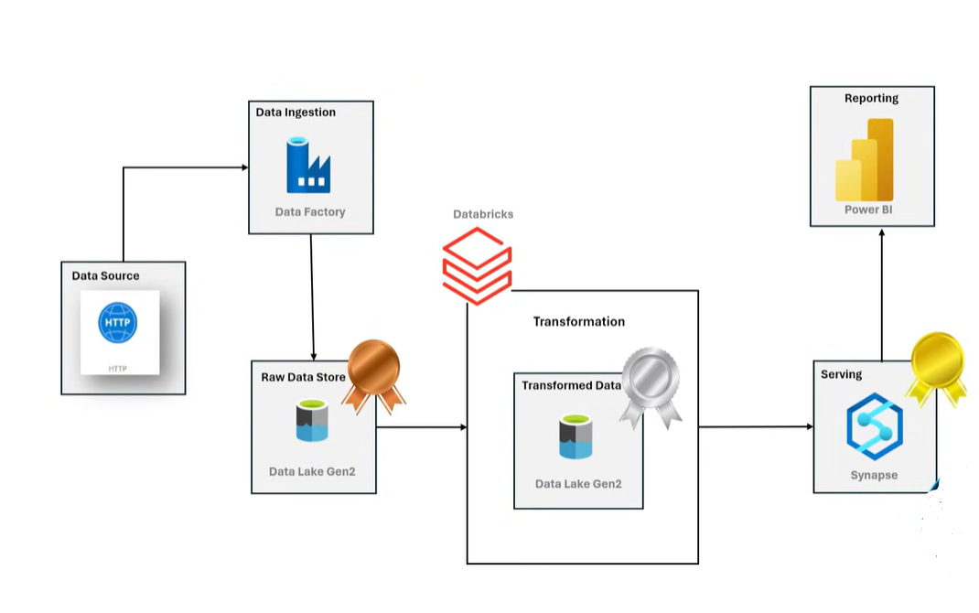

First you neeed to prepare data sets  
  
 Adventure works data sets then you can Go to Azure Data Factori  
  
Step:1  
Go to >> Go to Resource >> Search the Resource Group >> Create Resource G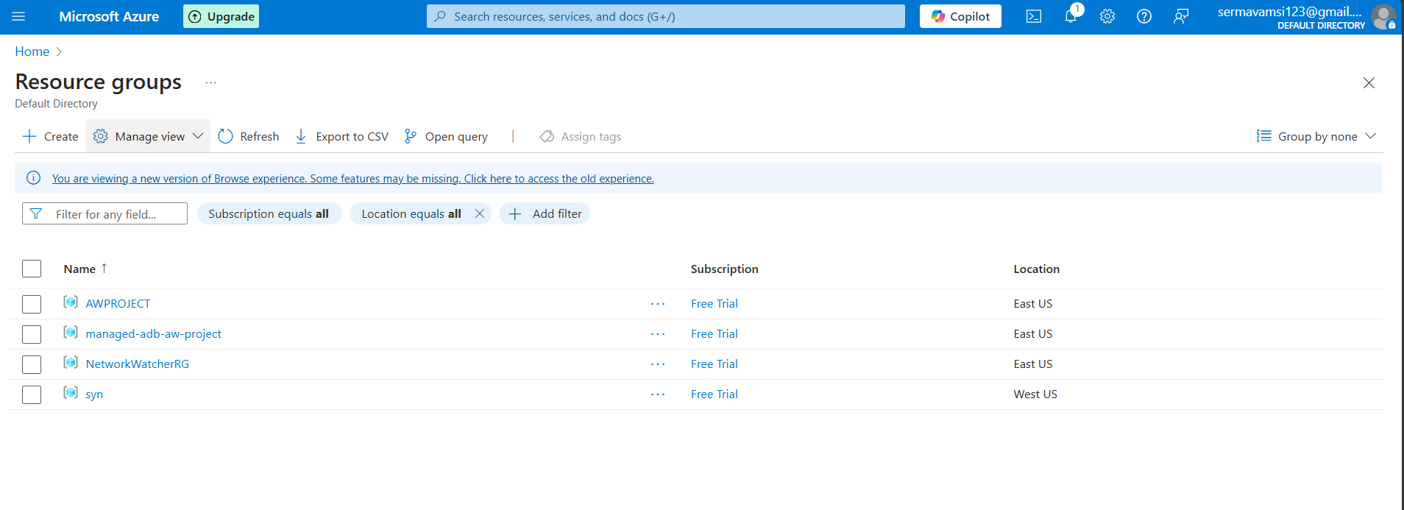  
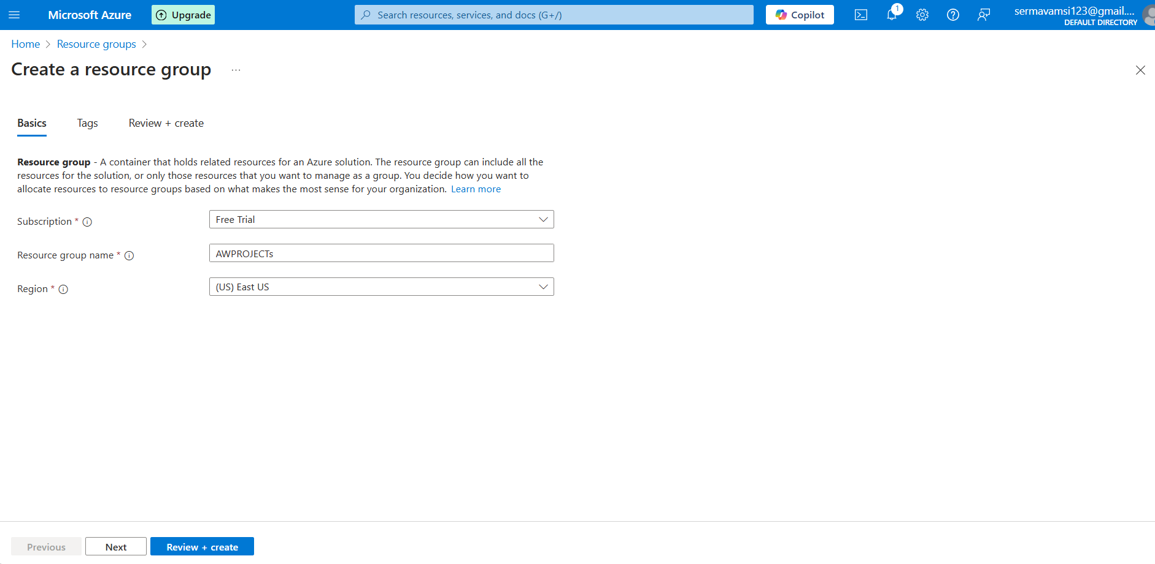

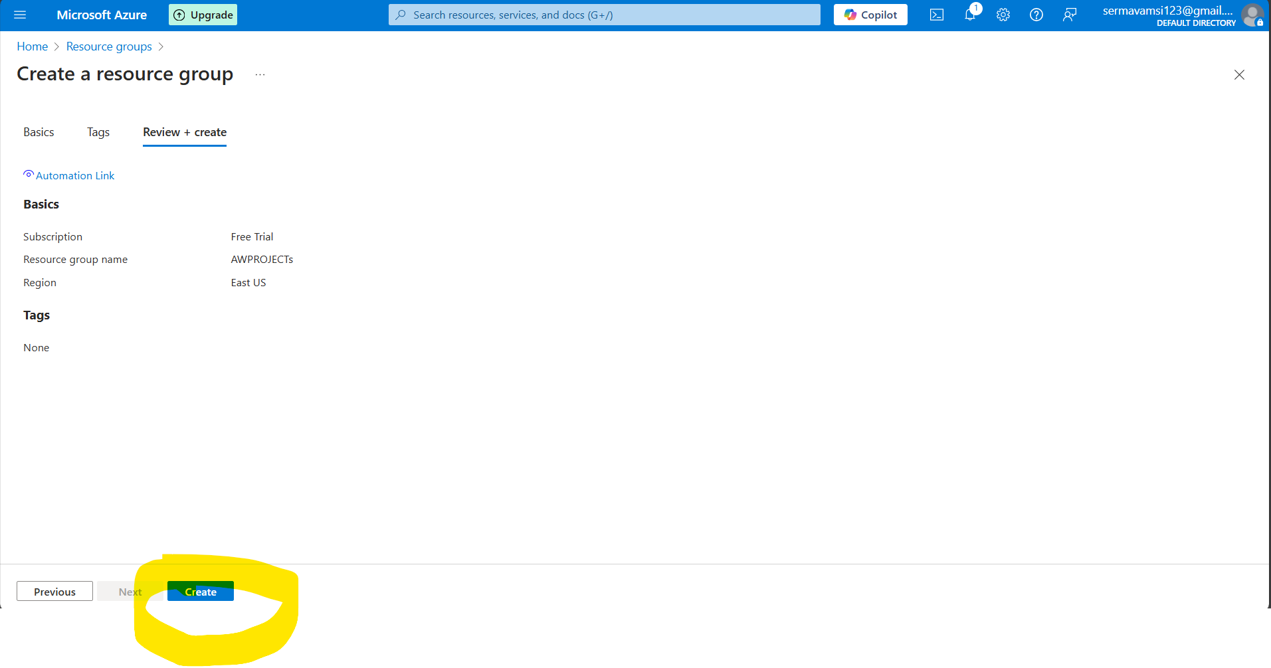

Then you need to type all the details and create the Resource group First.

Step:2

Goto>> Resource >> Search for the resource group >>> land the resource group

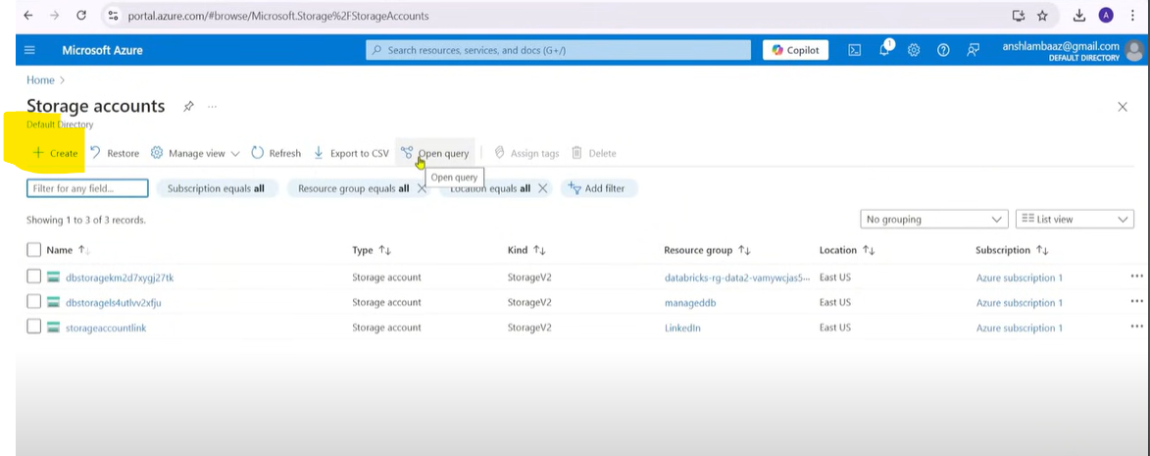

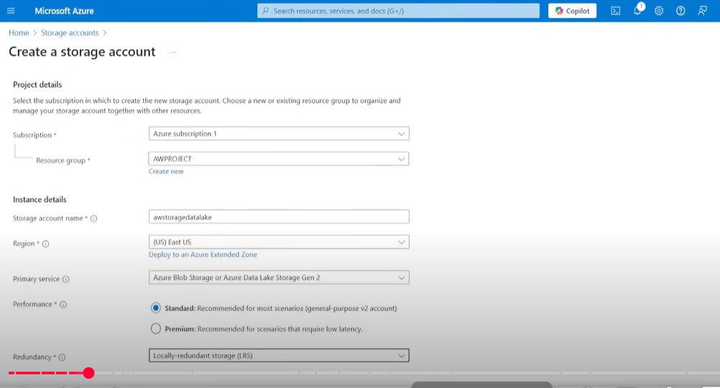

Click the Next and go to the Advanced tab and Enable the Hirarichal toggle button. And directly click on the review nd create button.

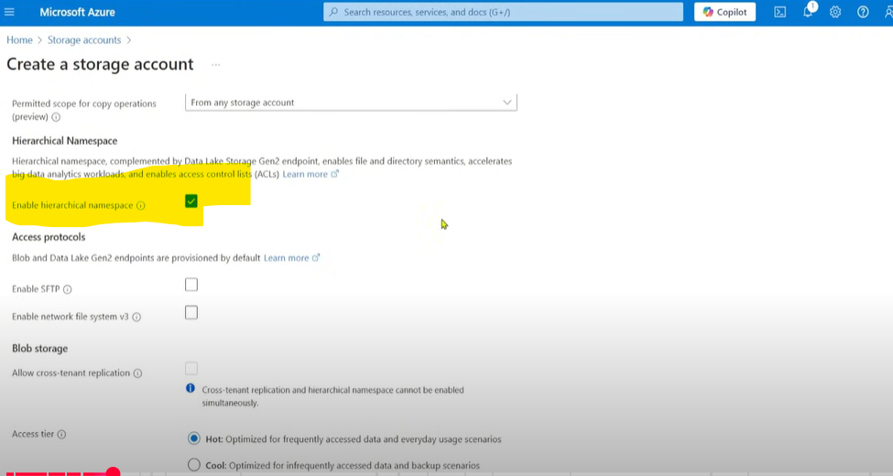

Step:3: You need to go to>> create resource>> Search for the Azure Data Factory

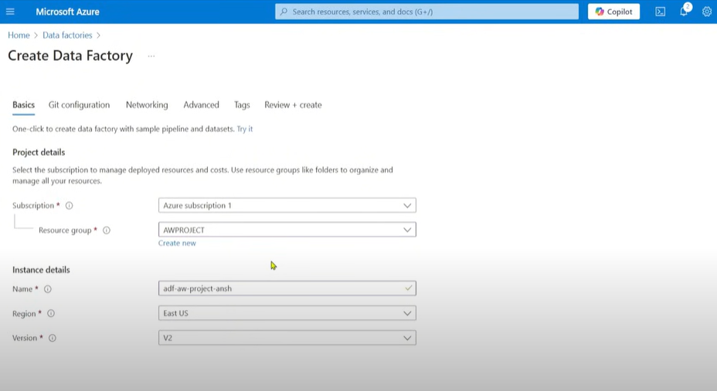

Then You need to click on the review & create   
then you need to go Azure Data Factory which you need to create then Launch the Azure Data Factory once lauch the Azure Data factory you can landed this below page.

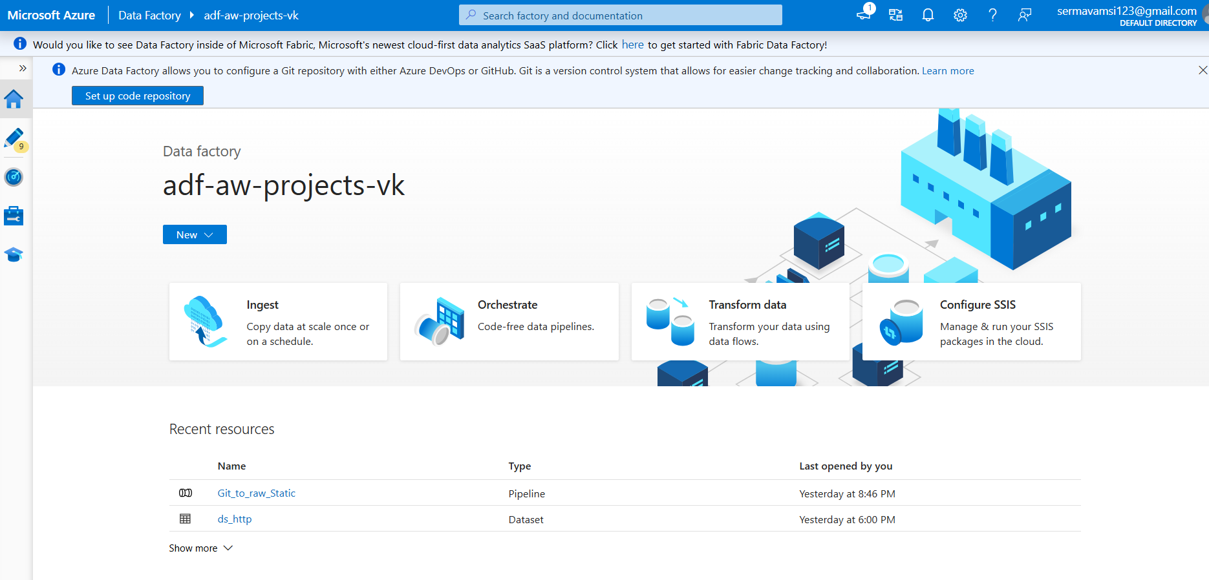

Click on the new pipeline and create name :Dynamic_Pipeline

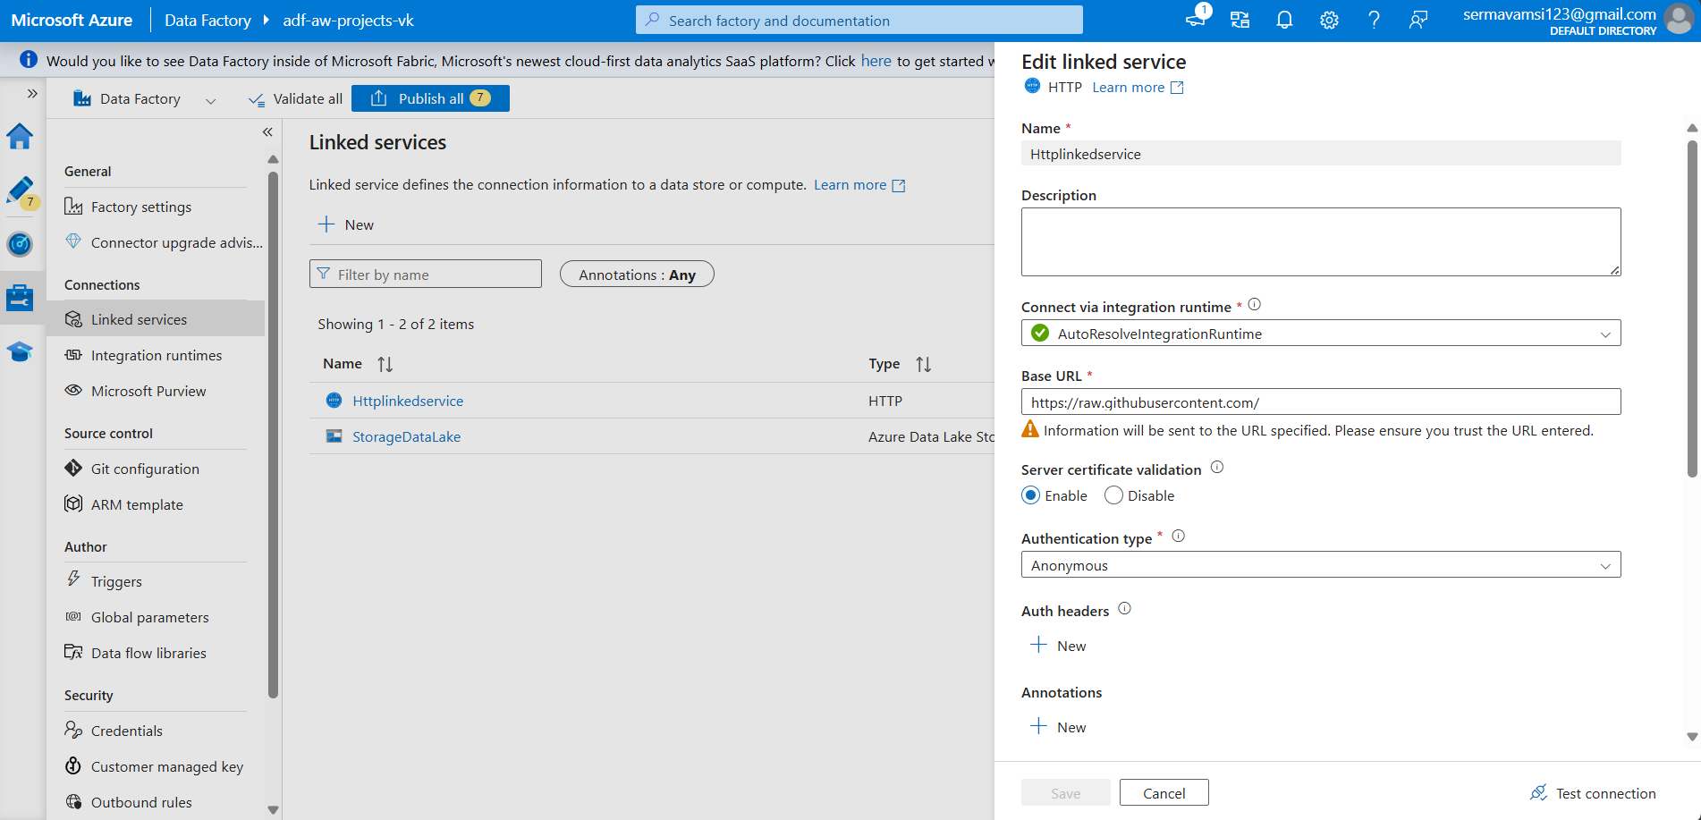 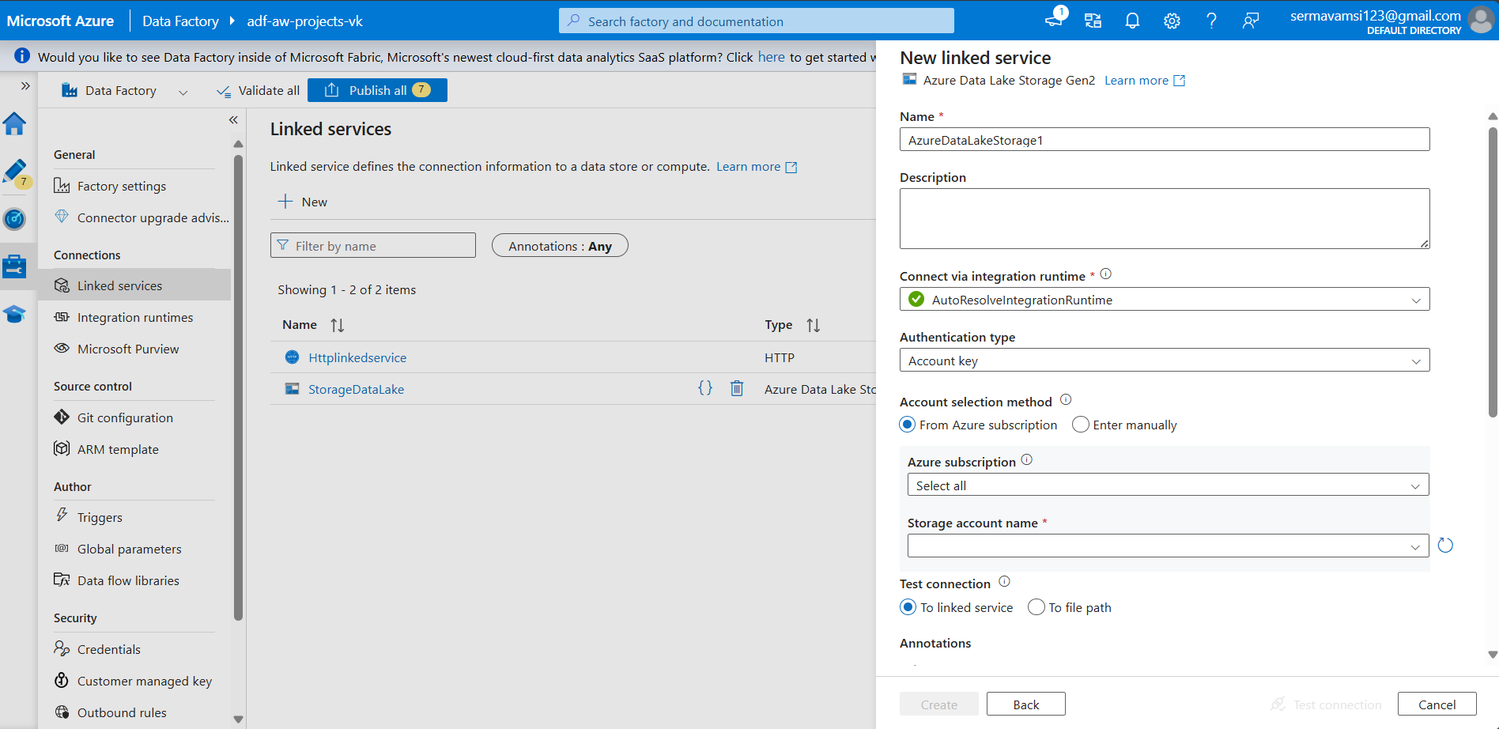

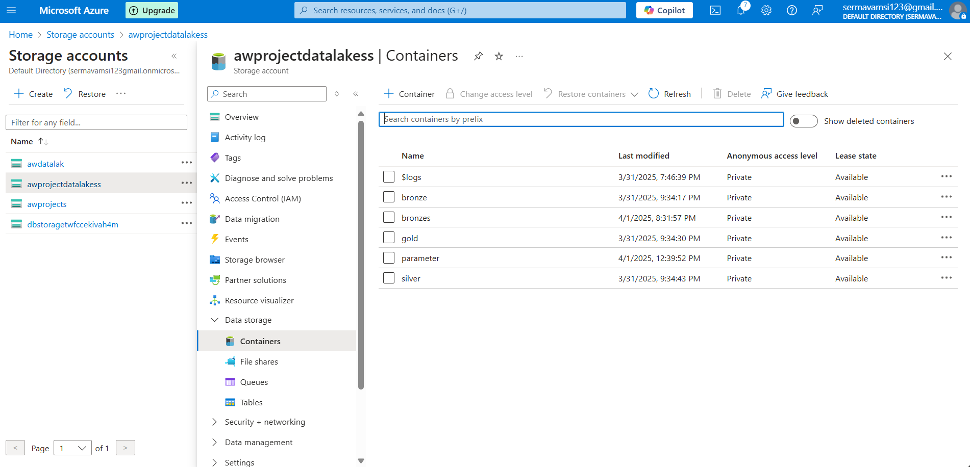

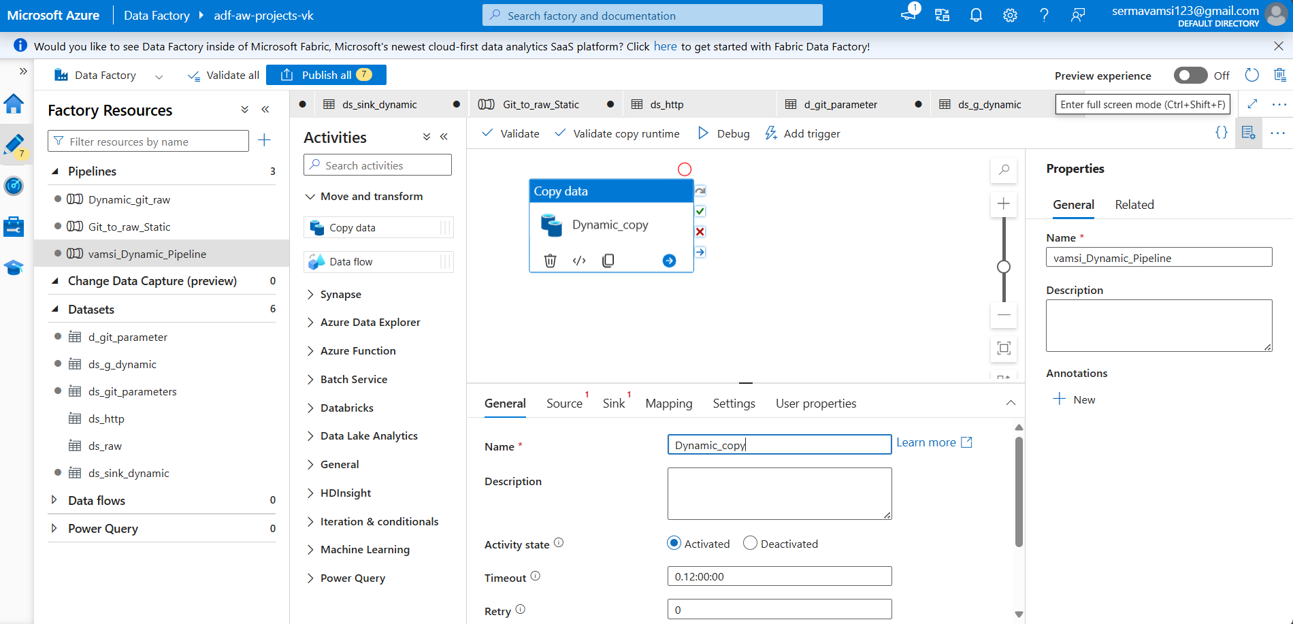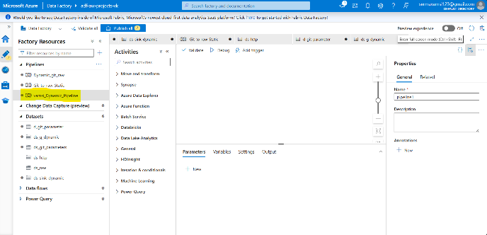  
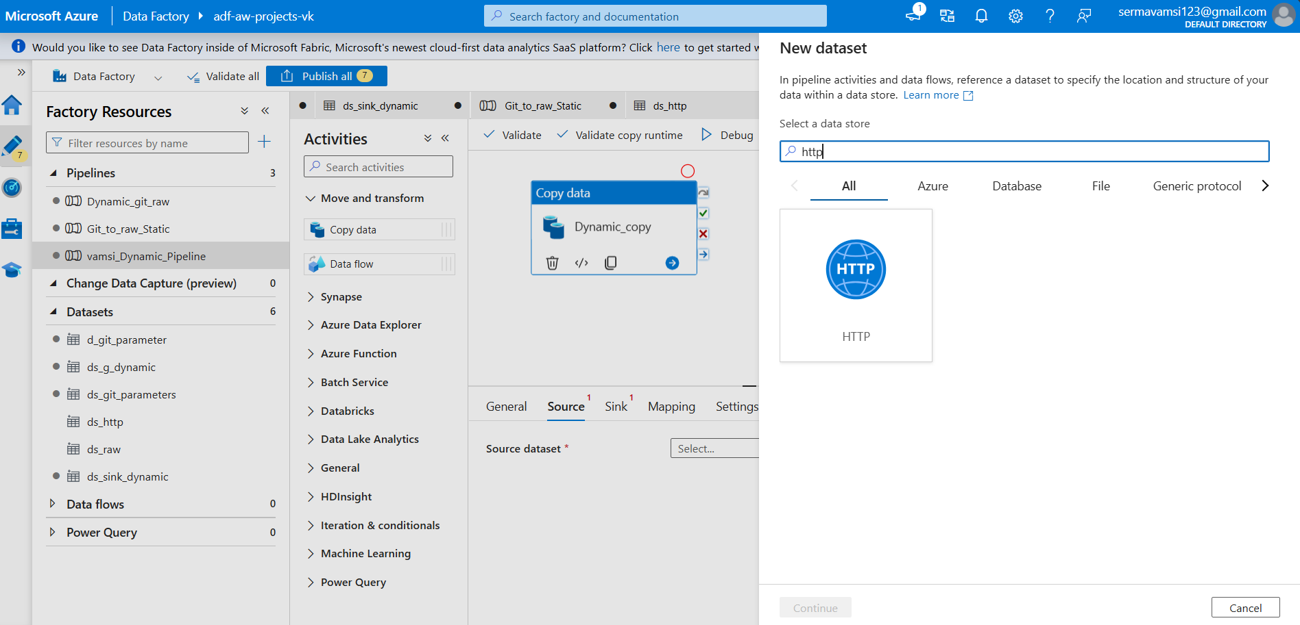 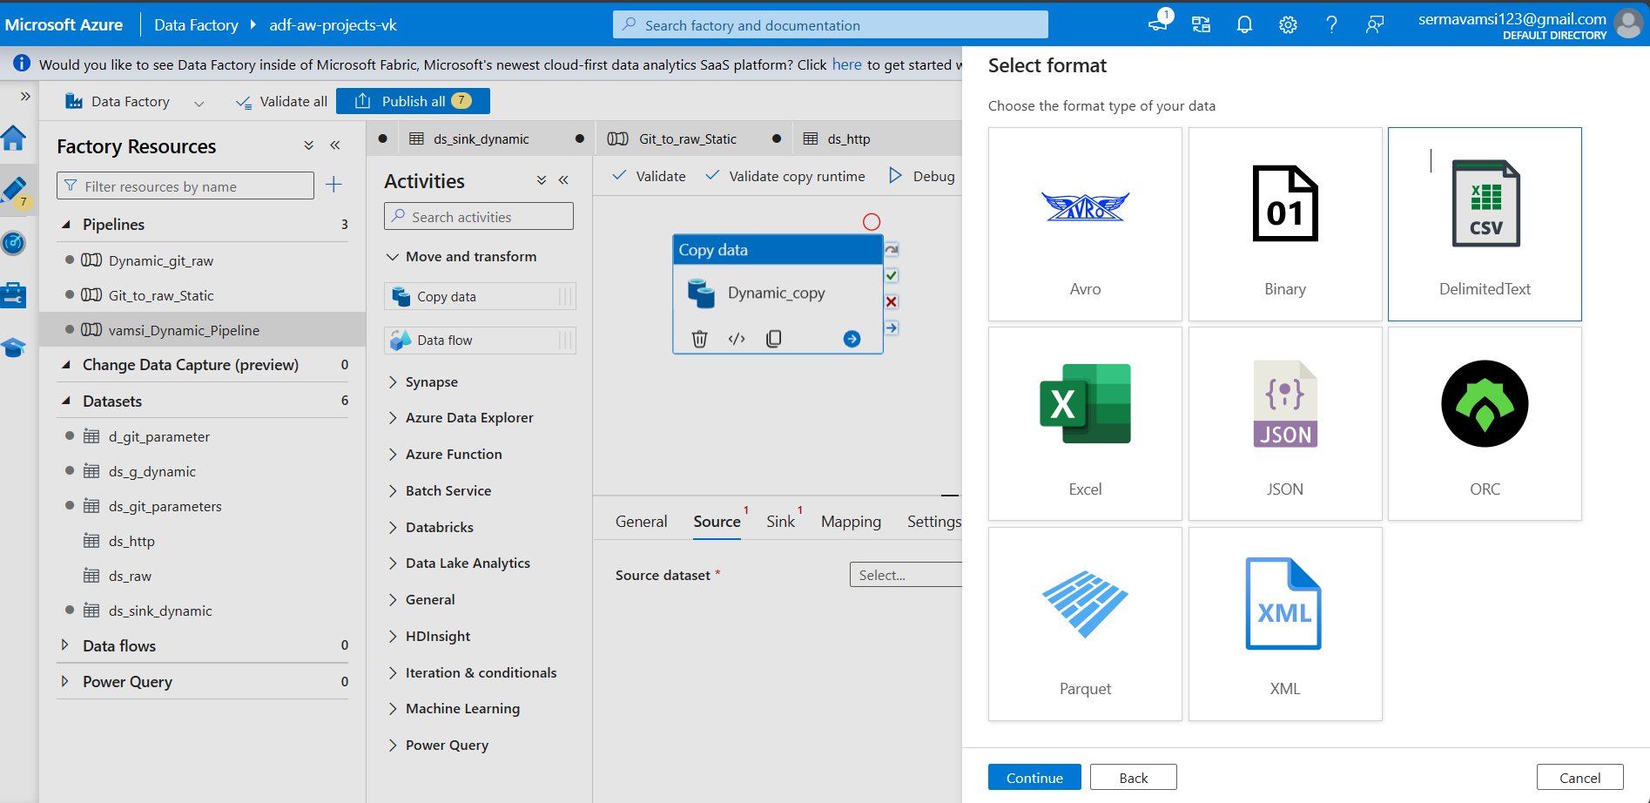

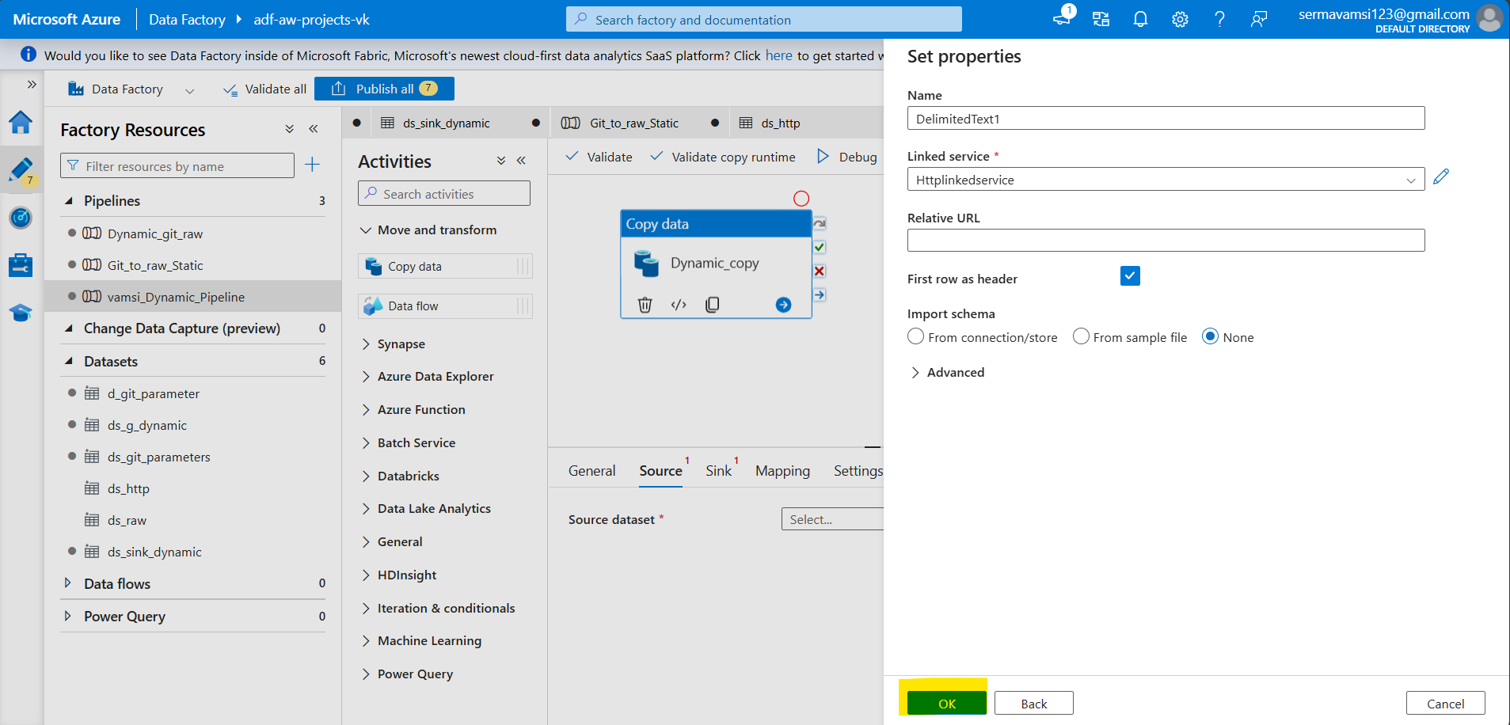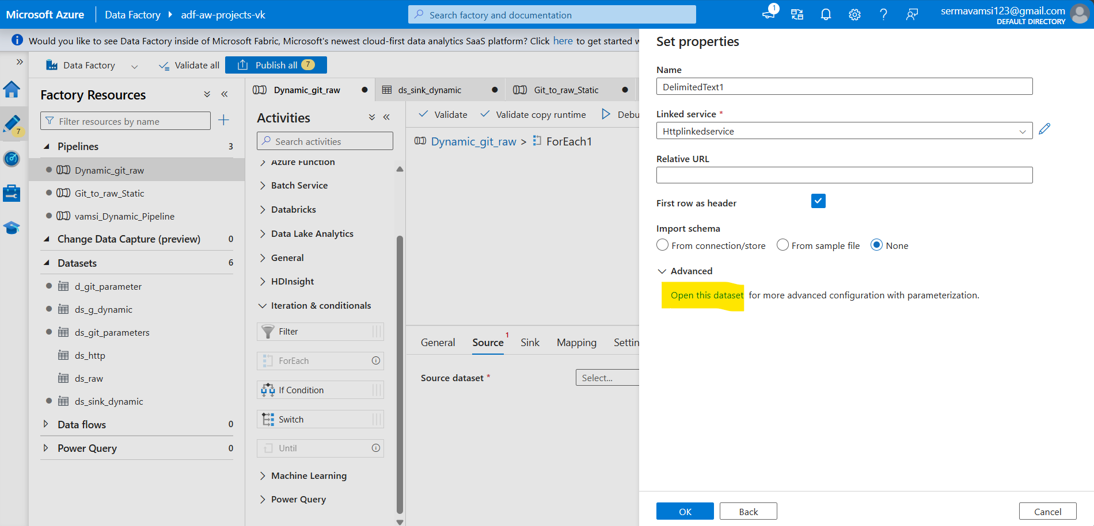

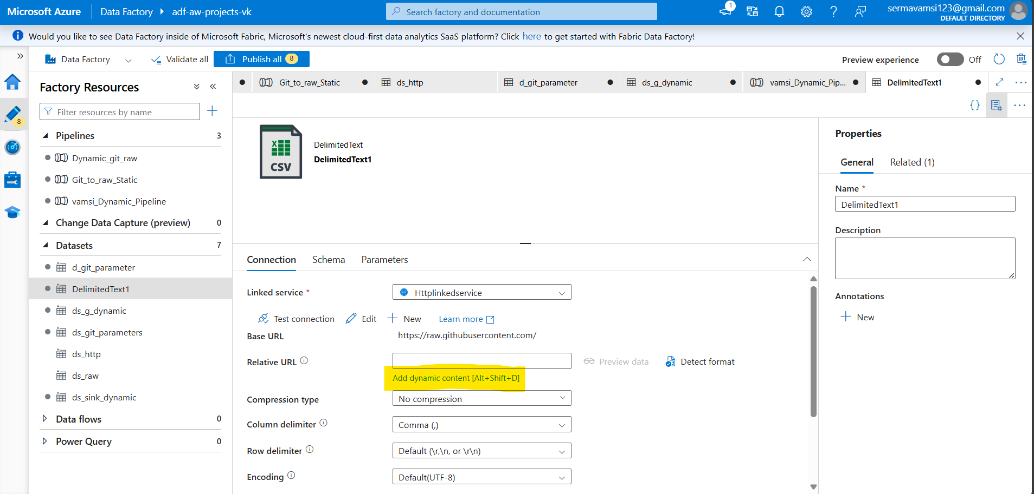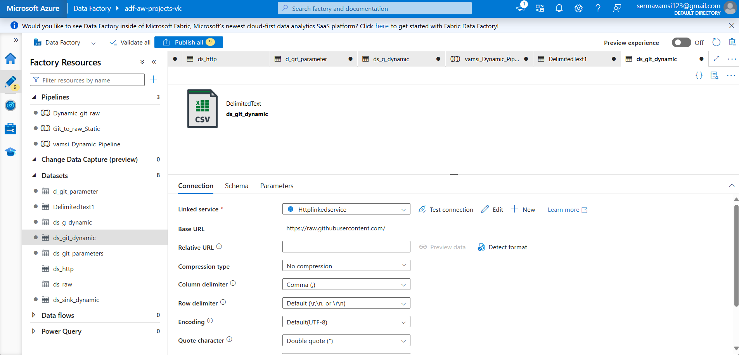  
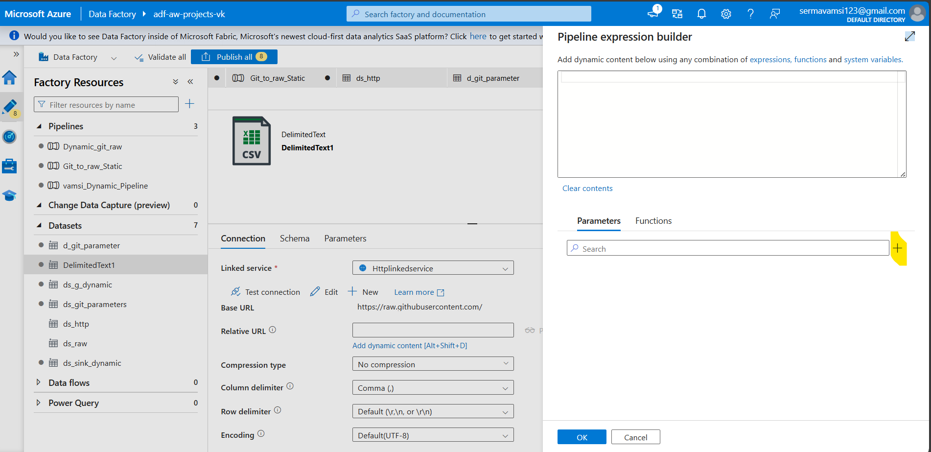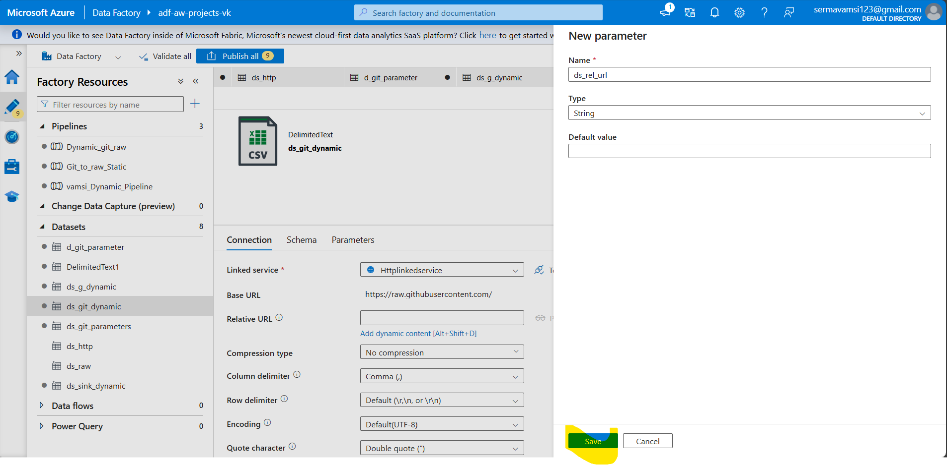  
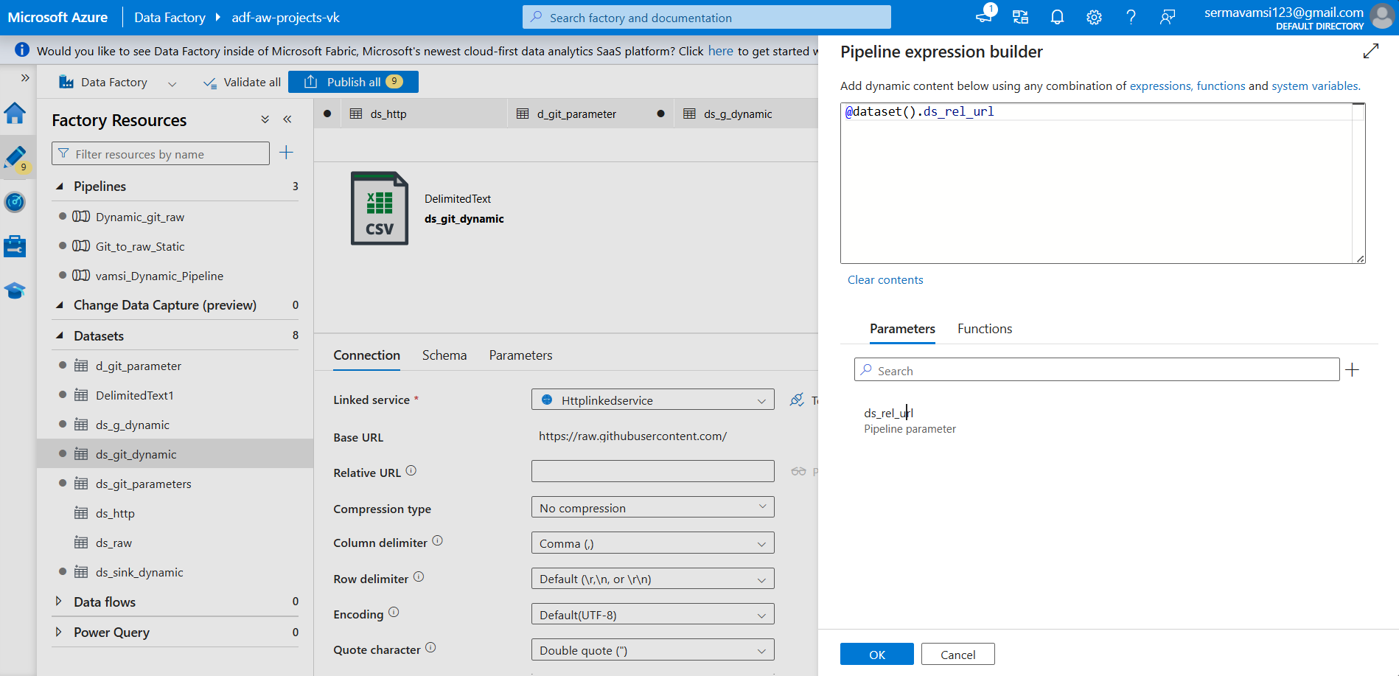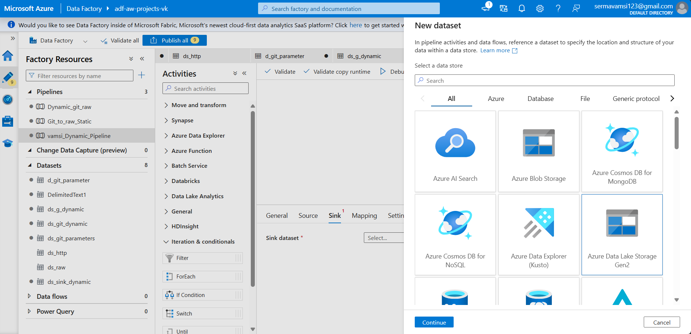

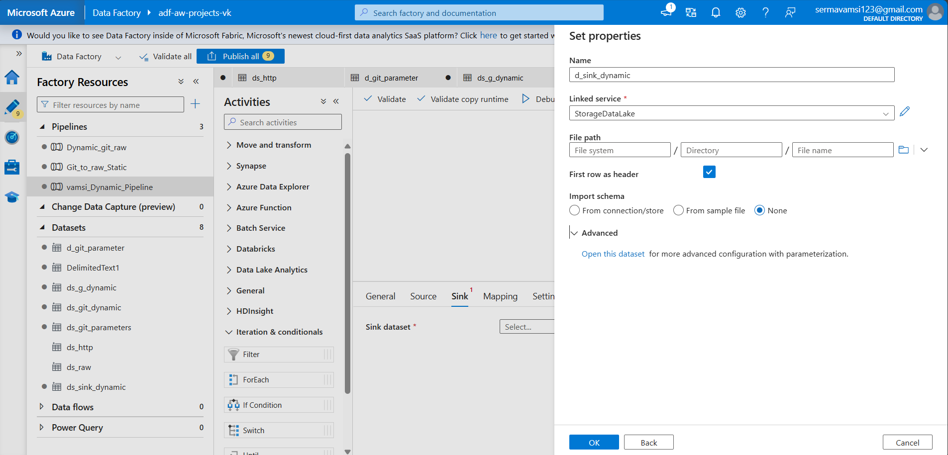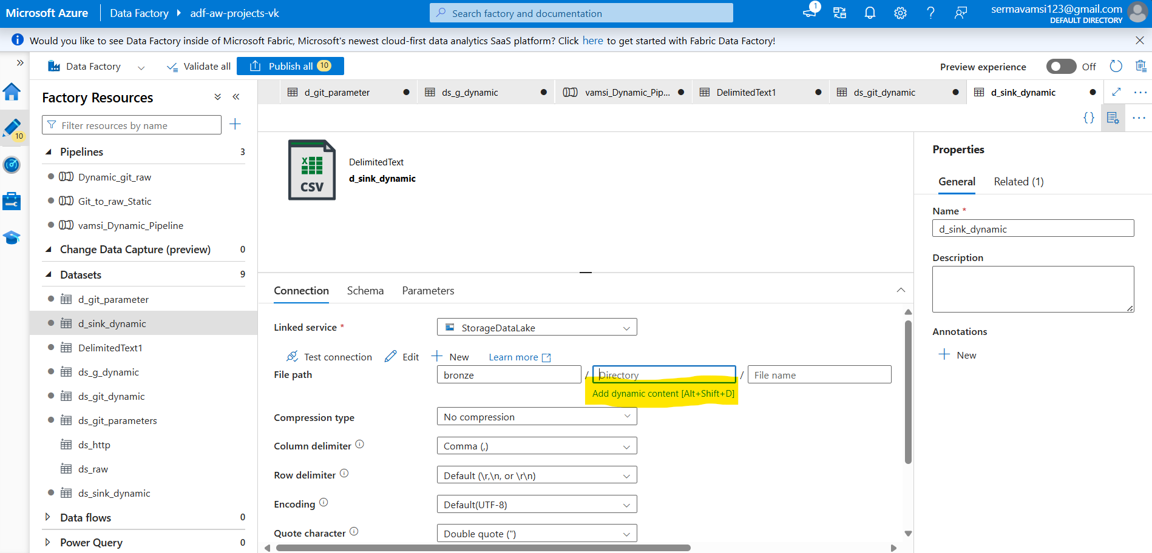

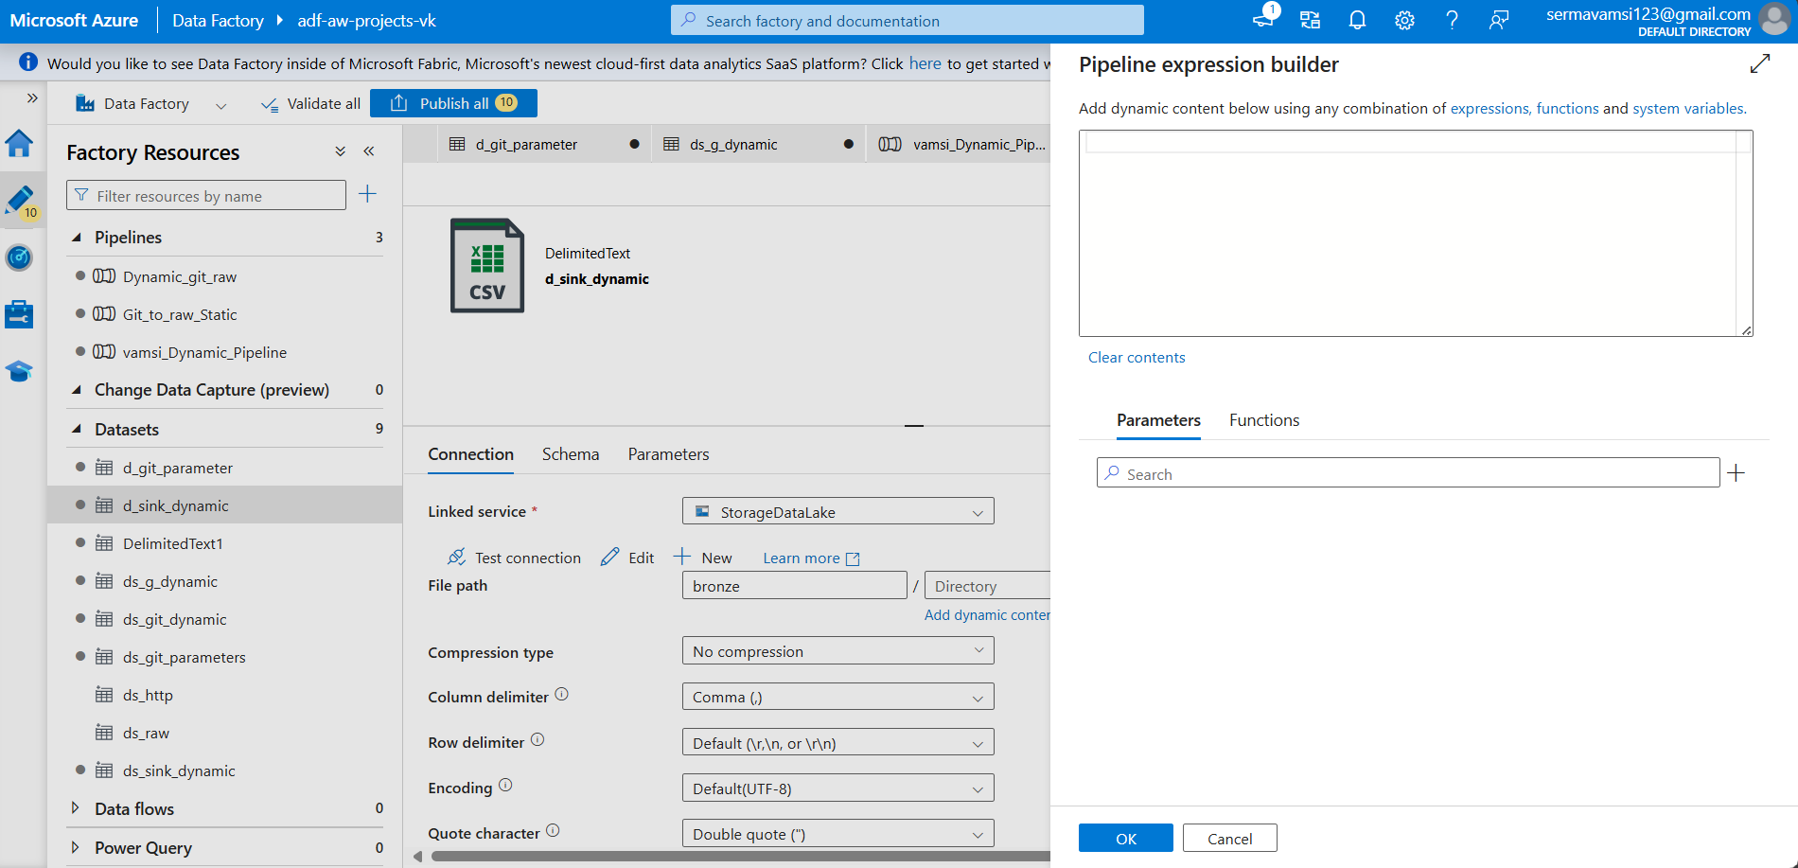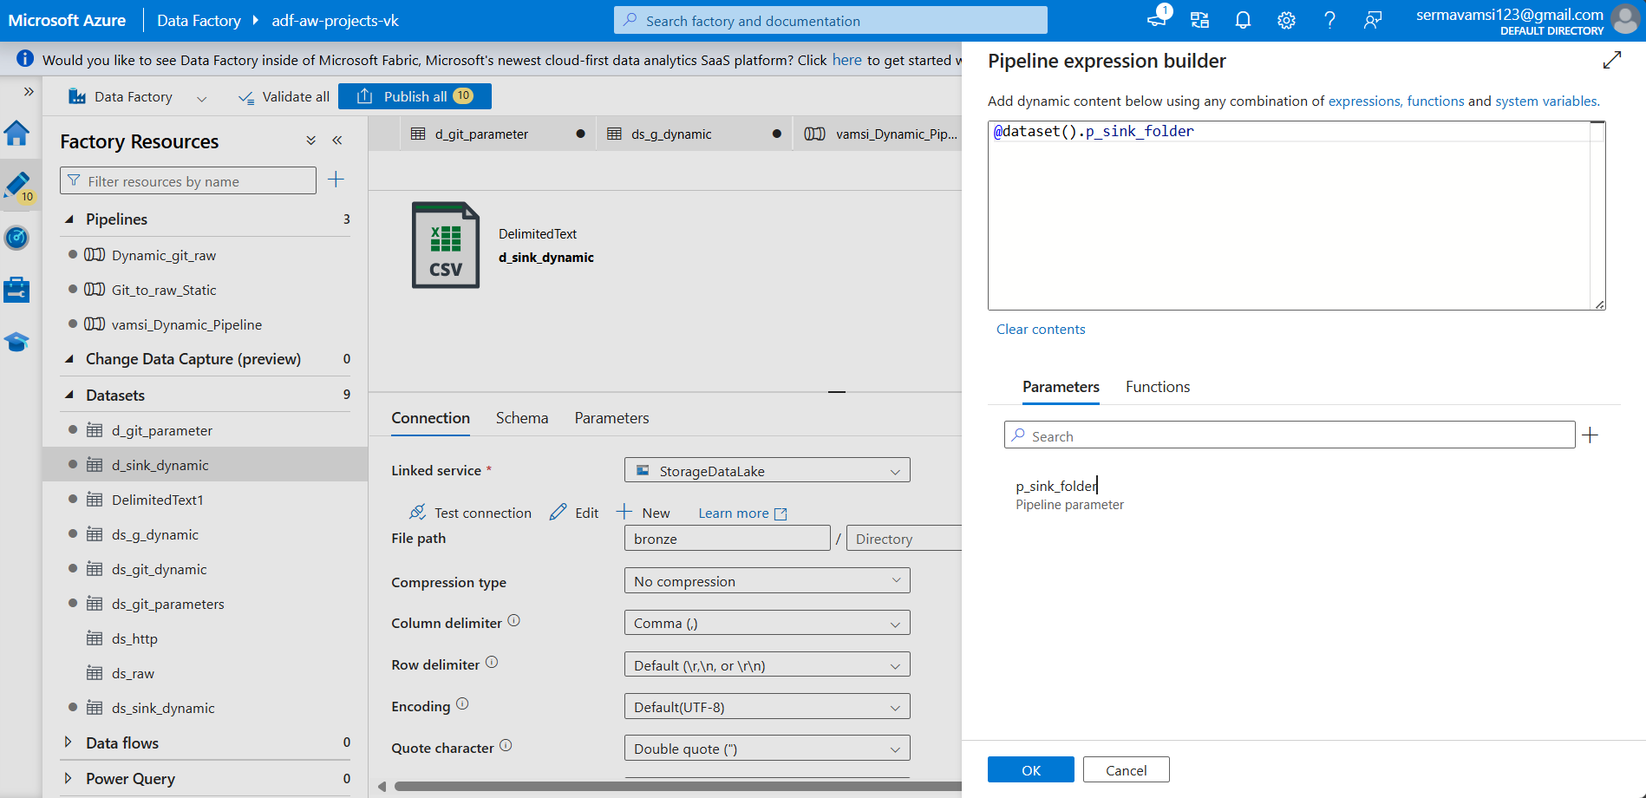

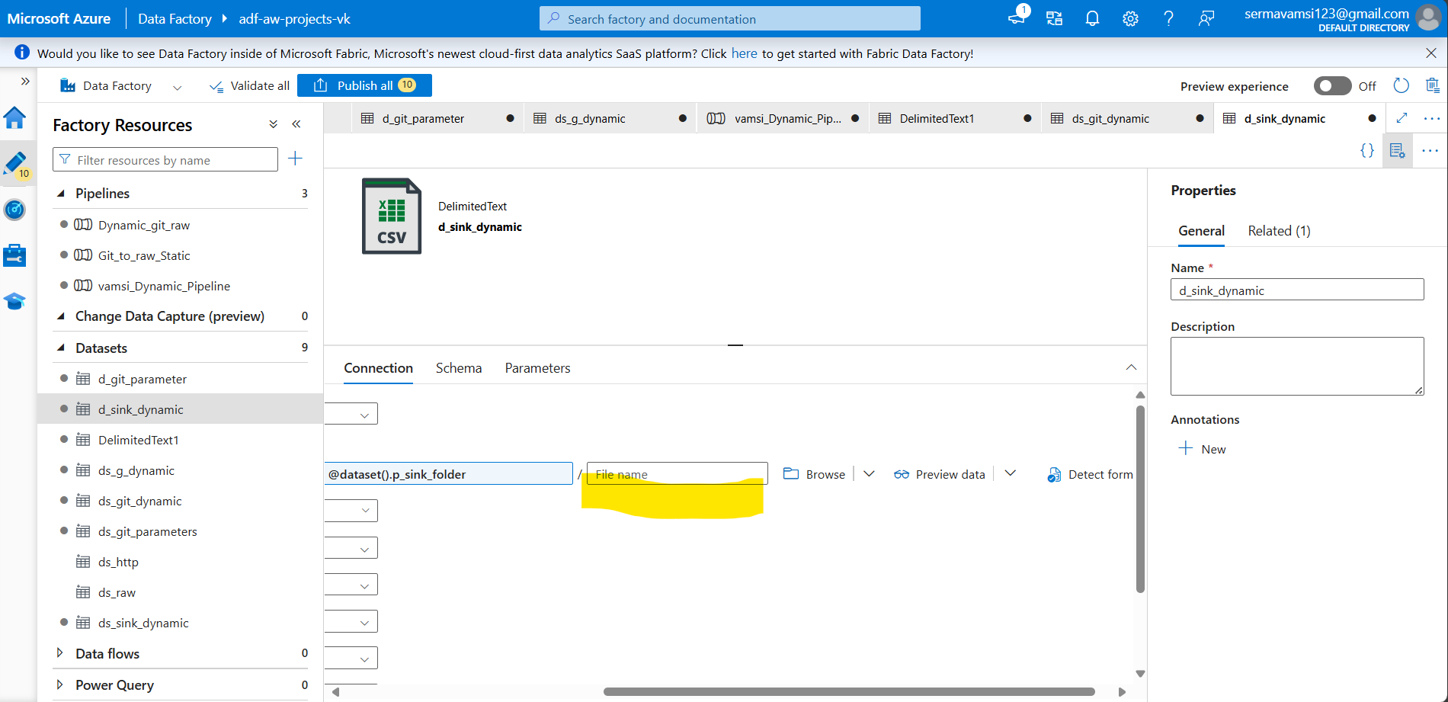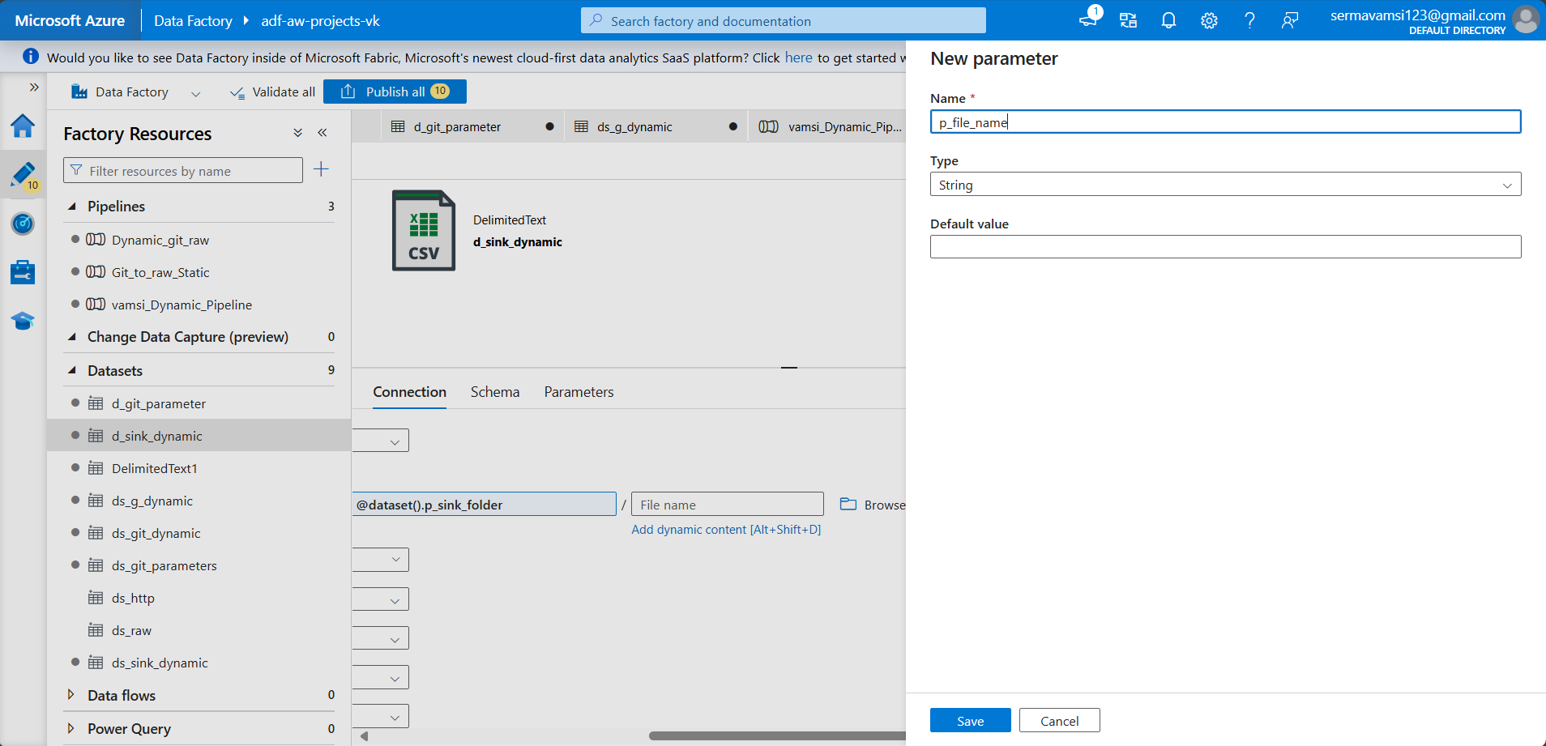

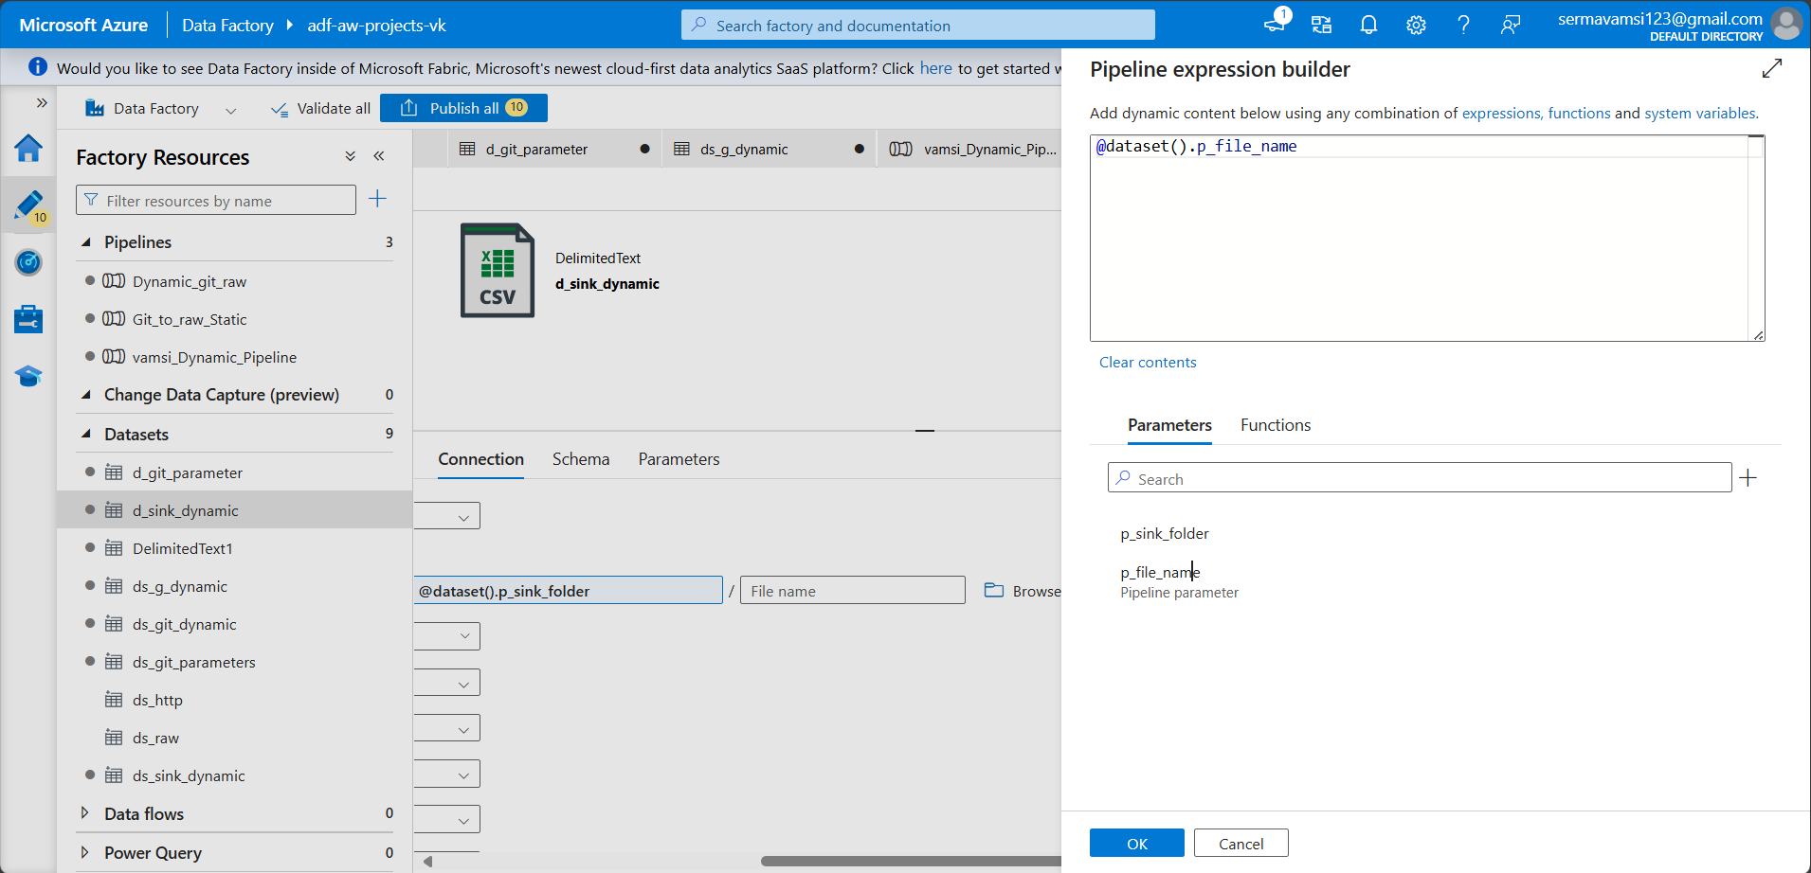  
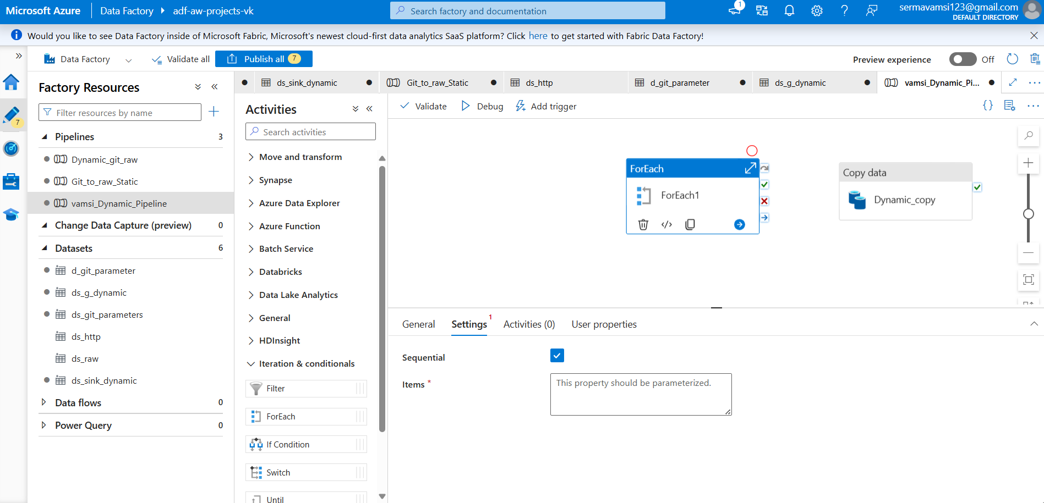Then You can create a JSON file  
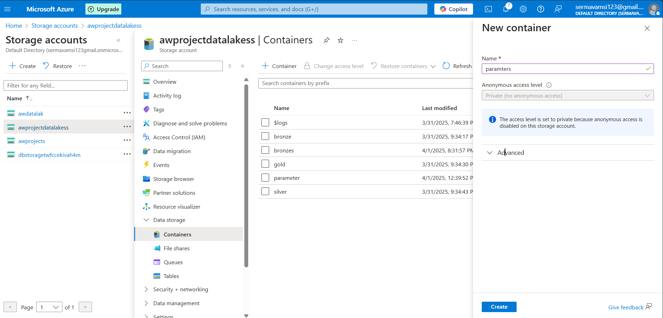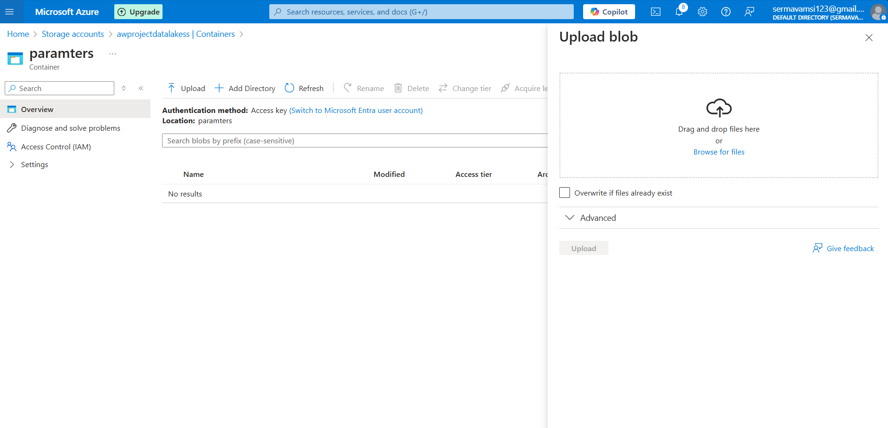

Here you can upload your json file.

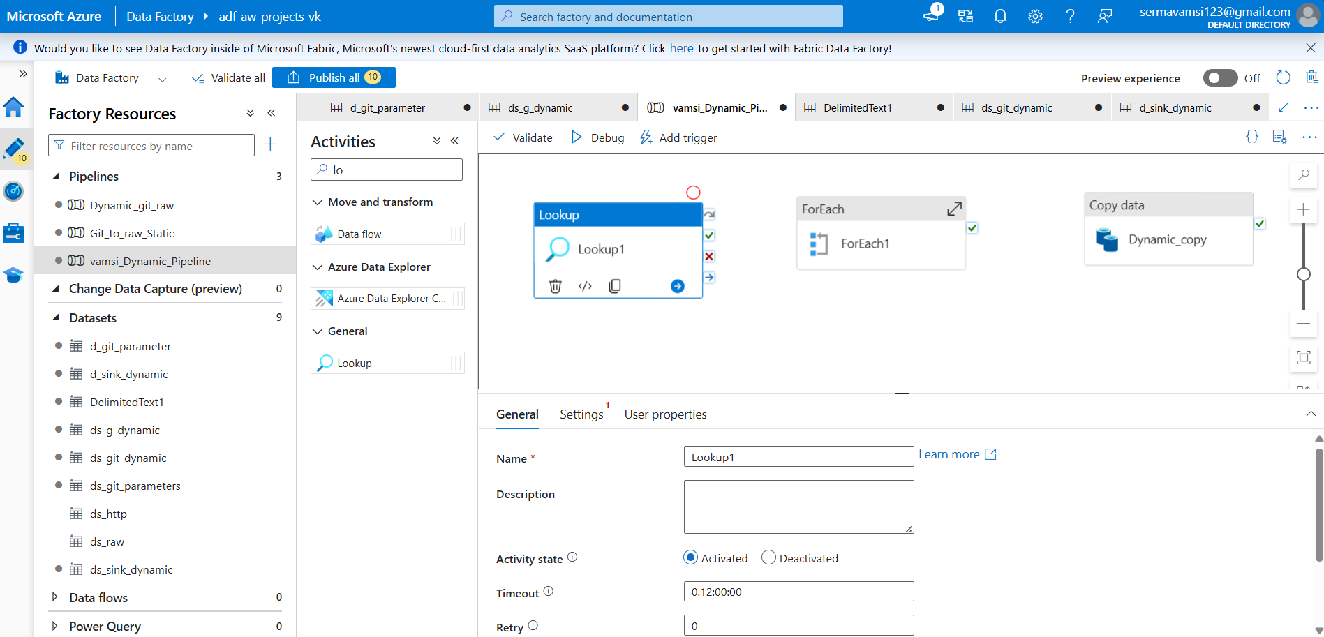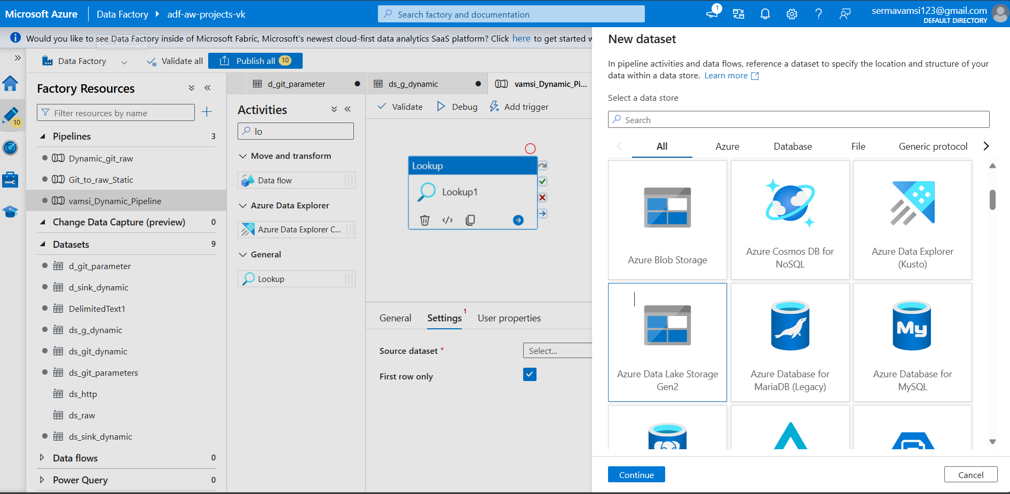

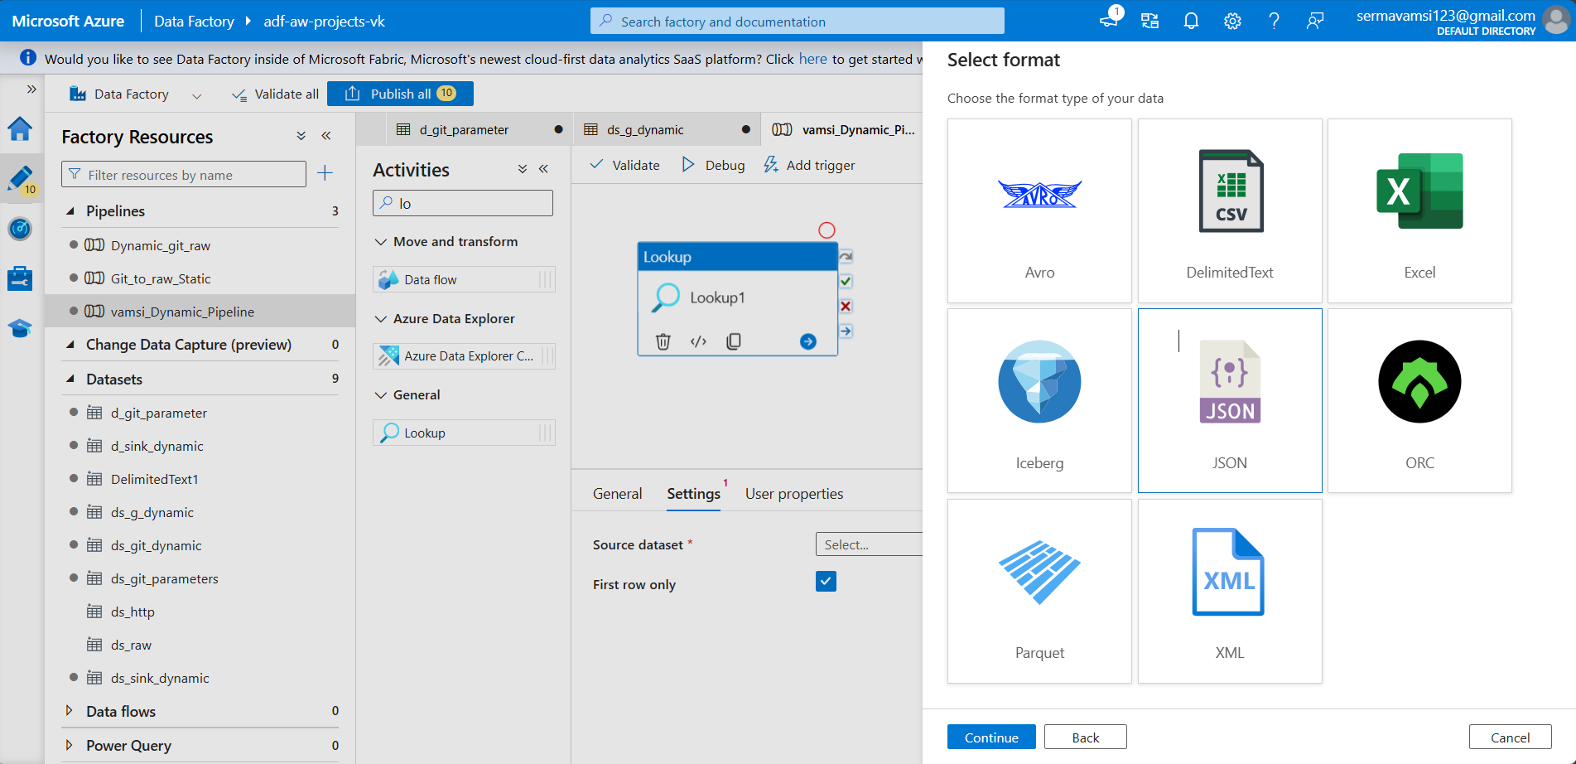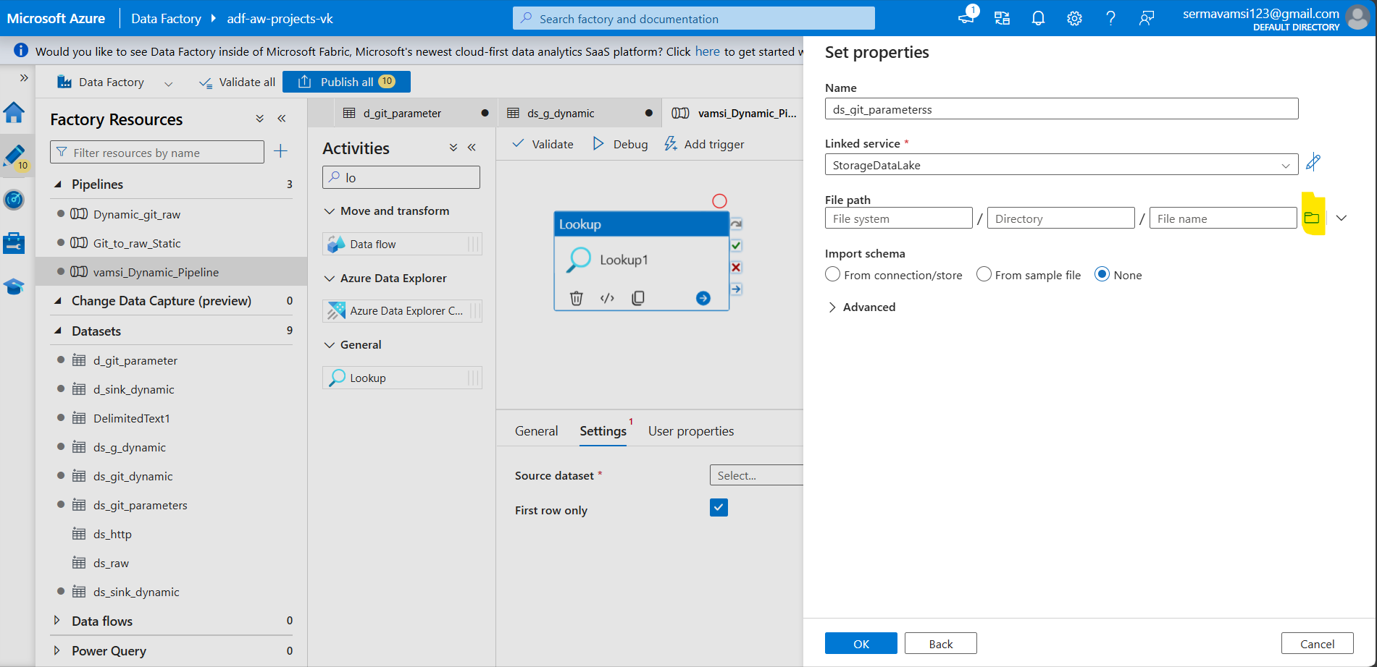

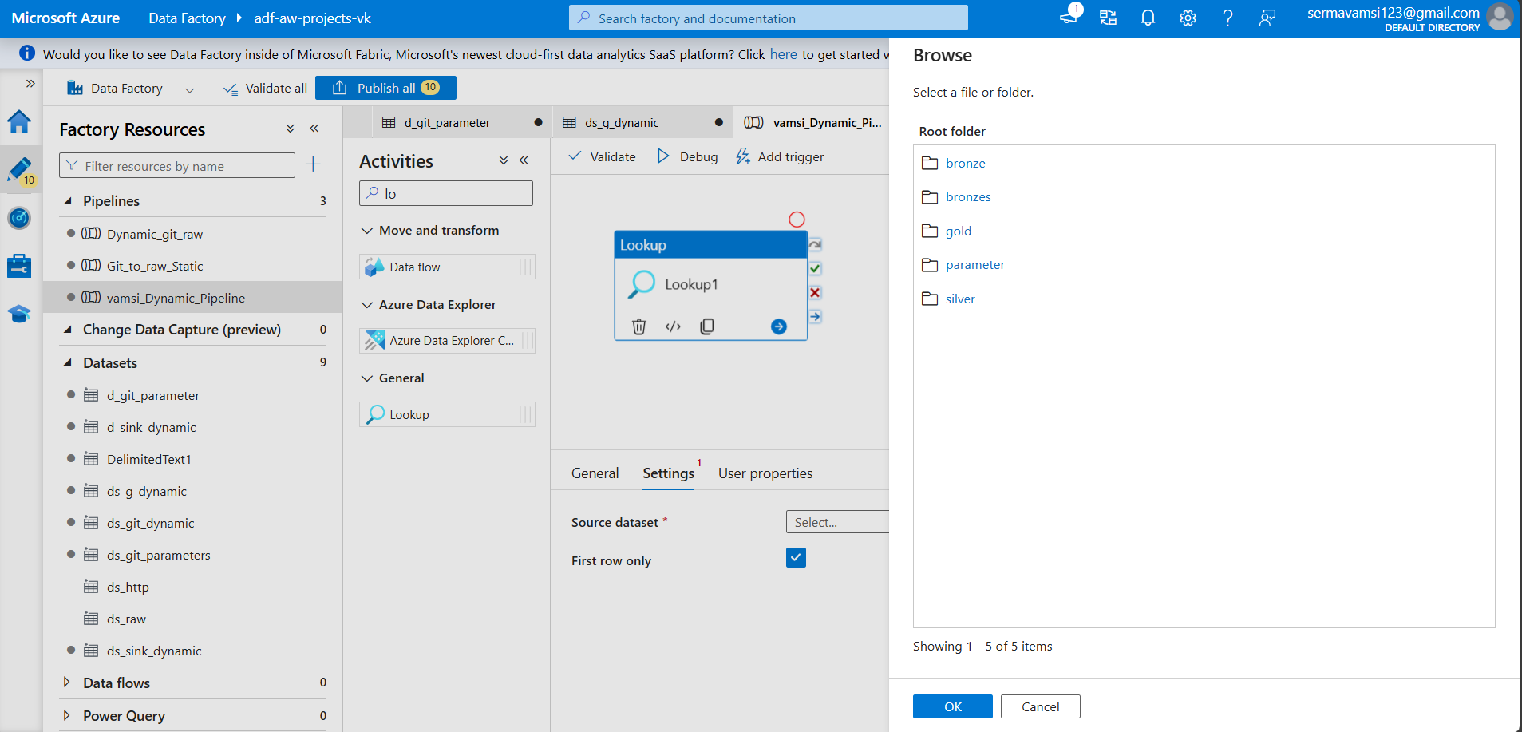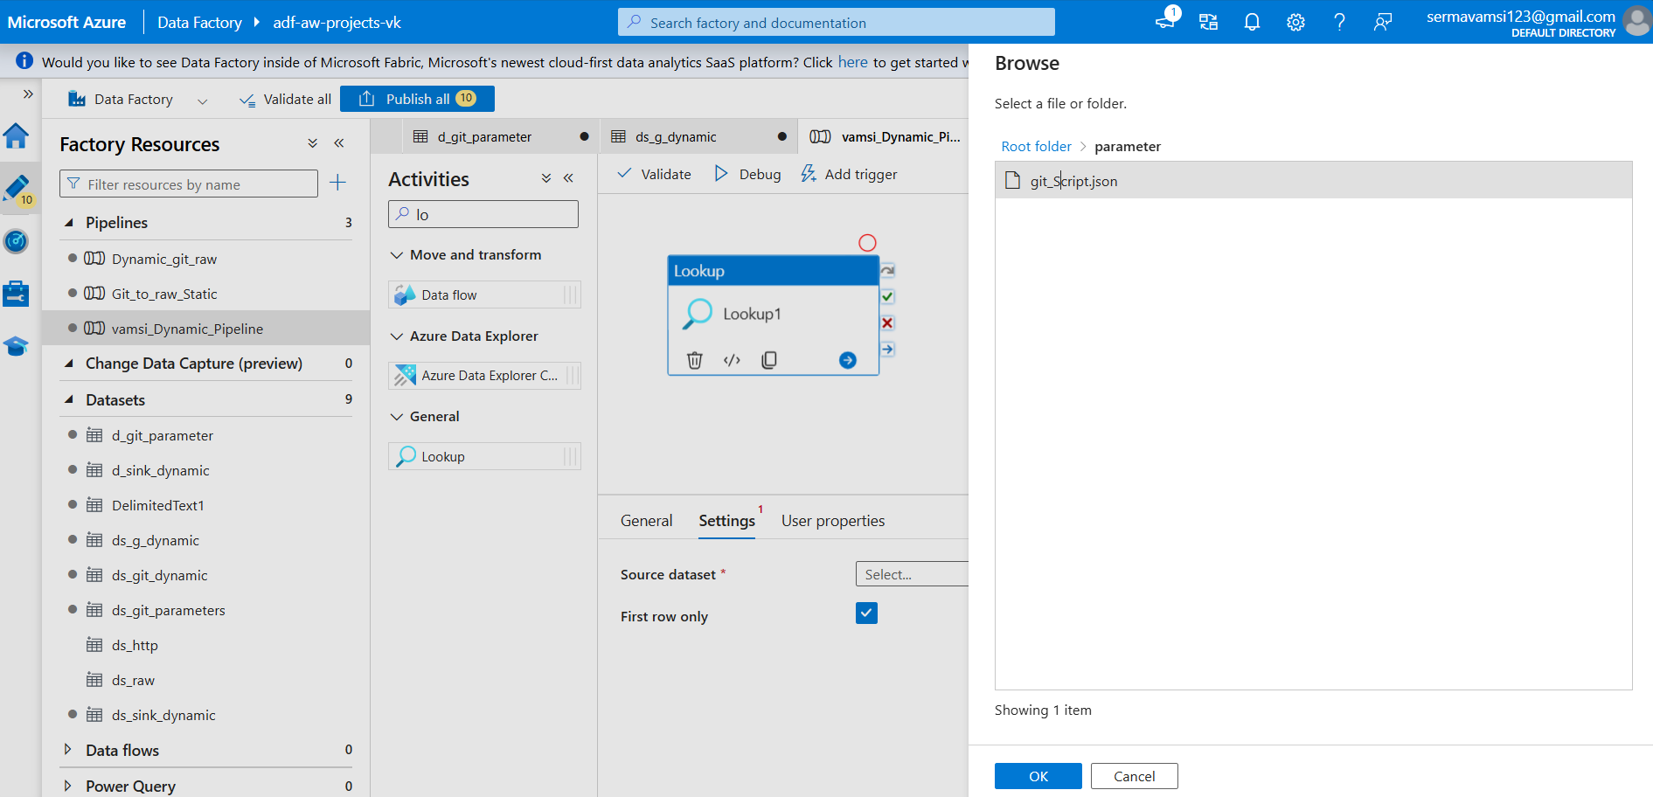

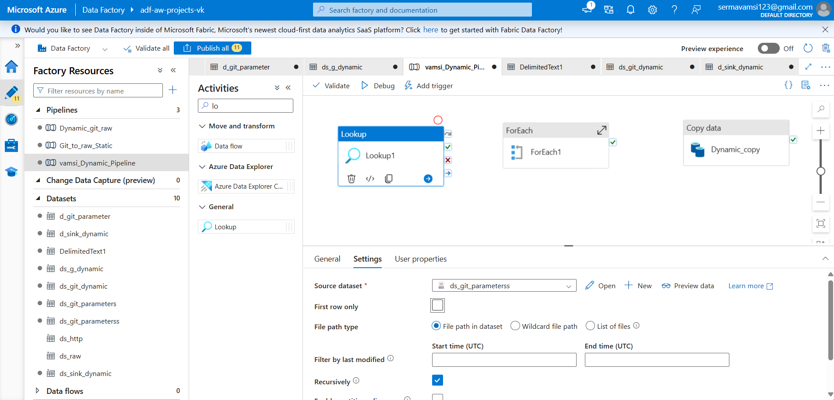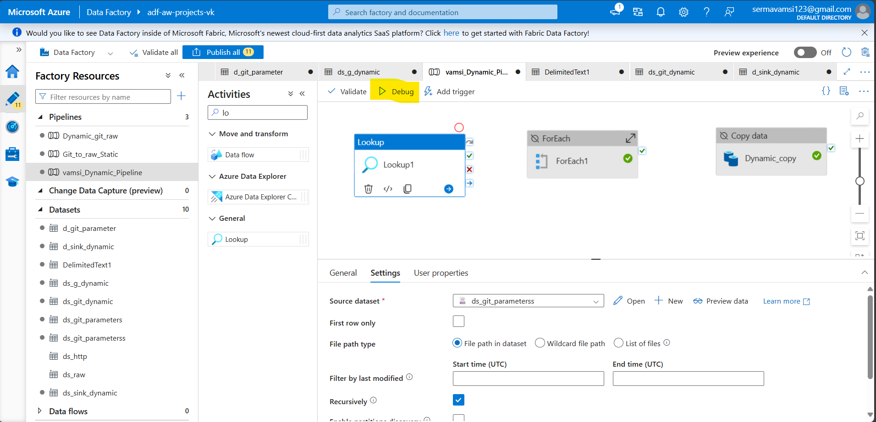

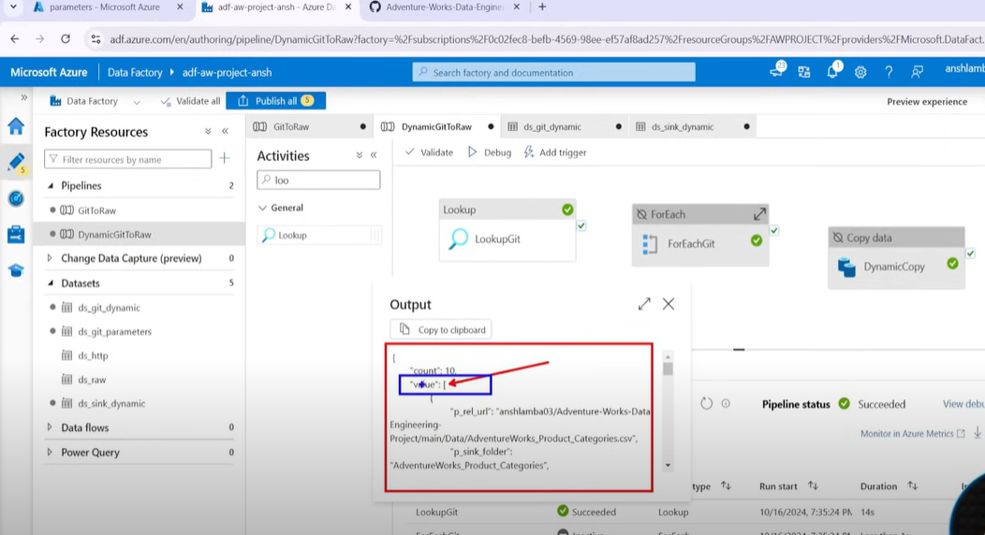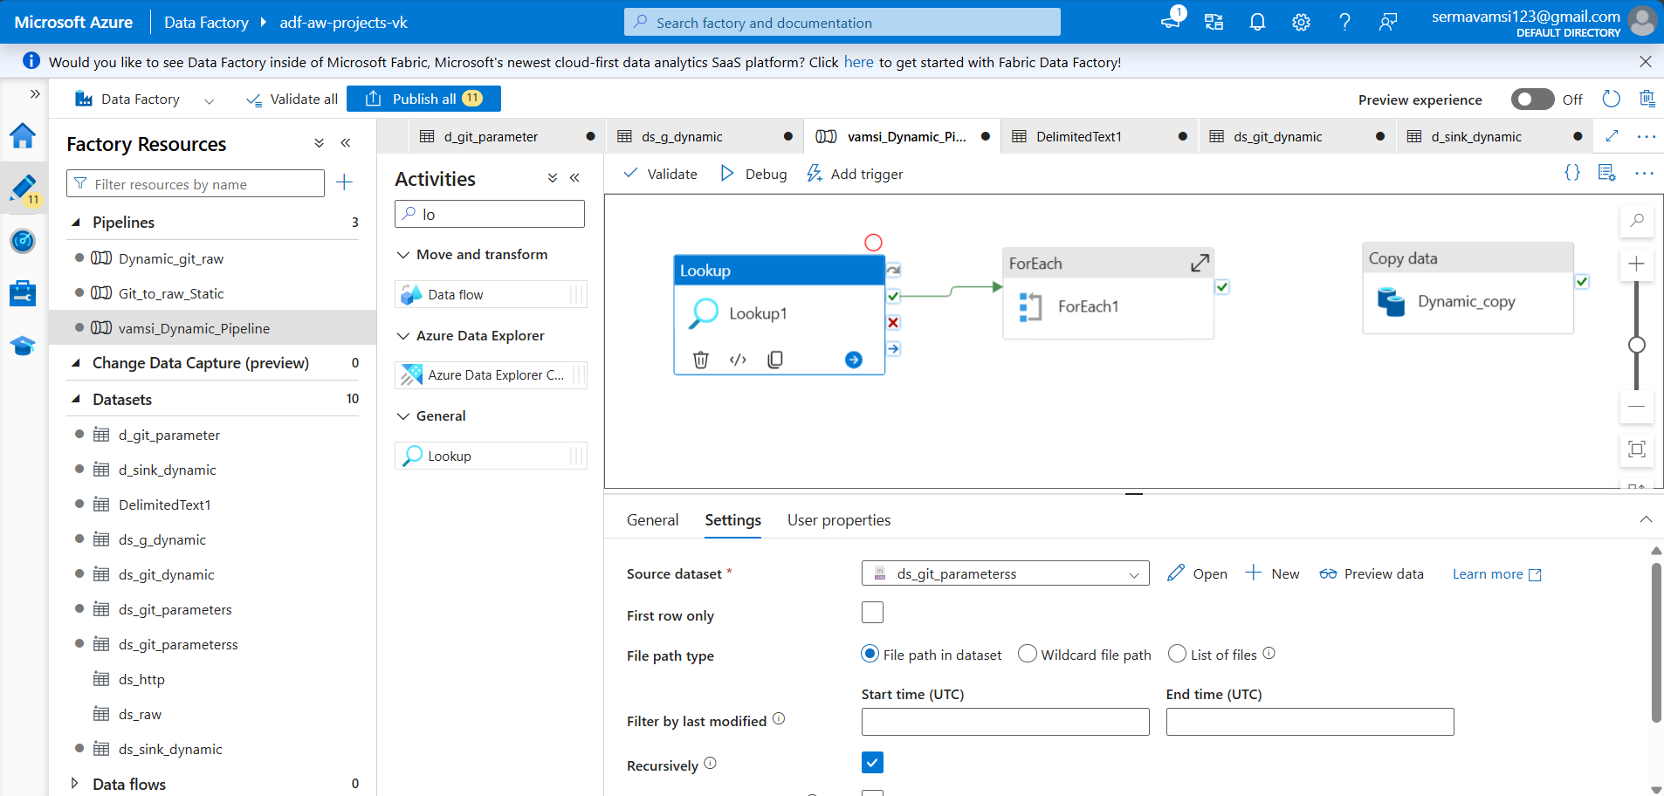

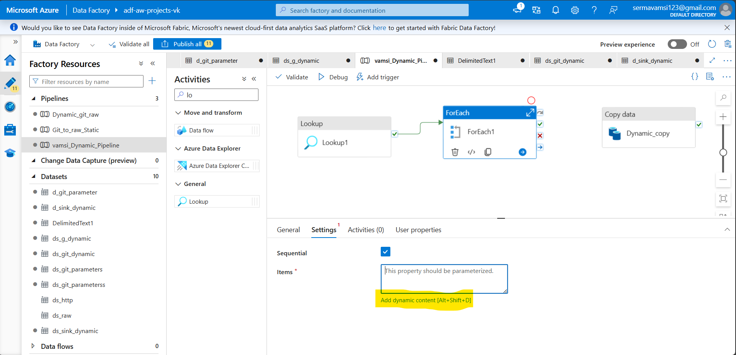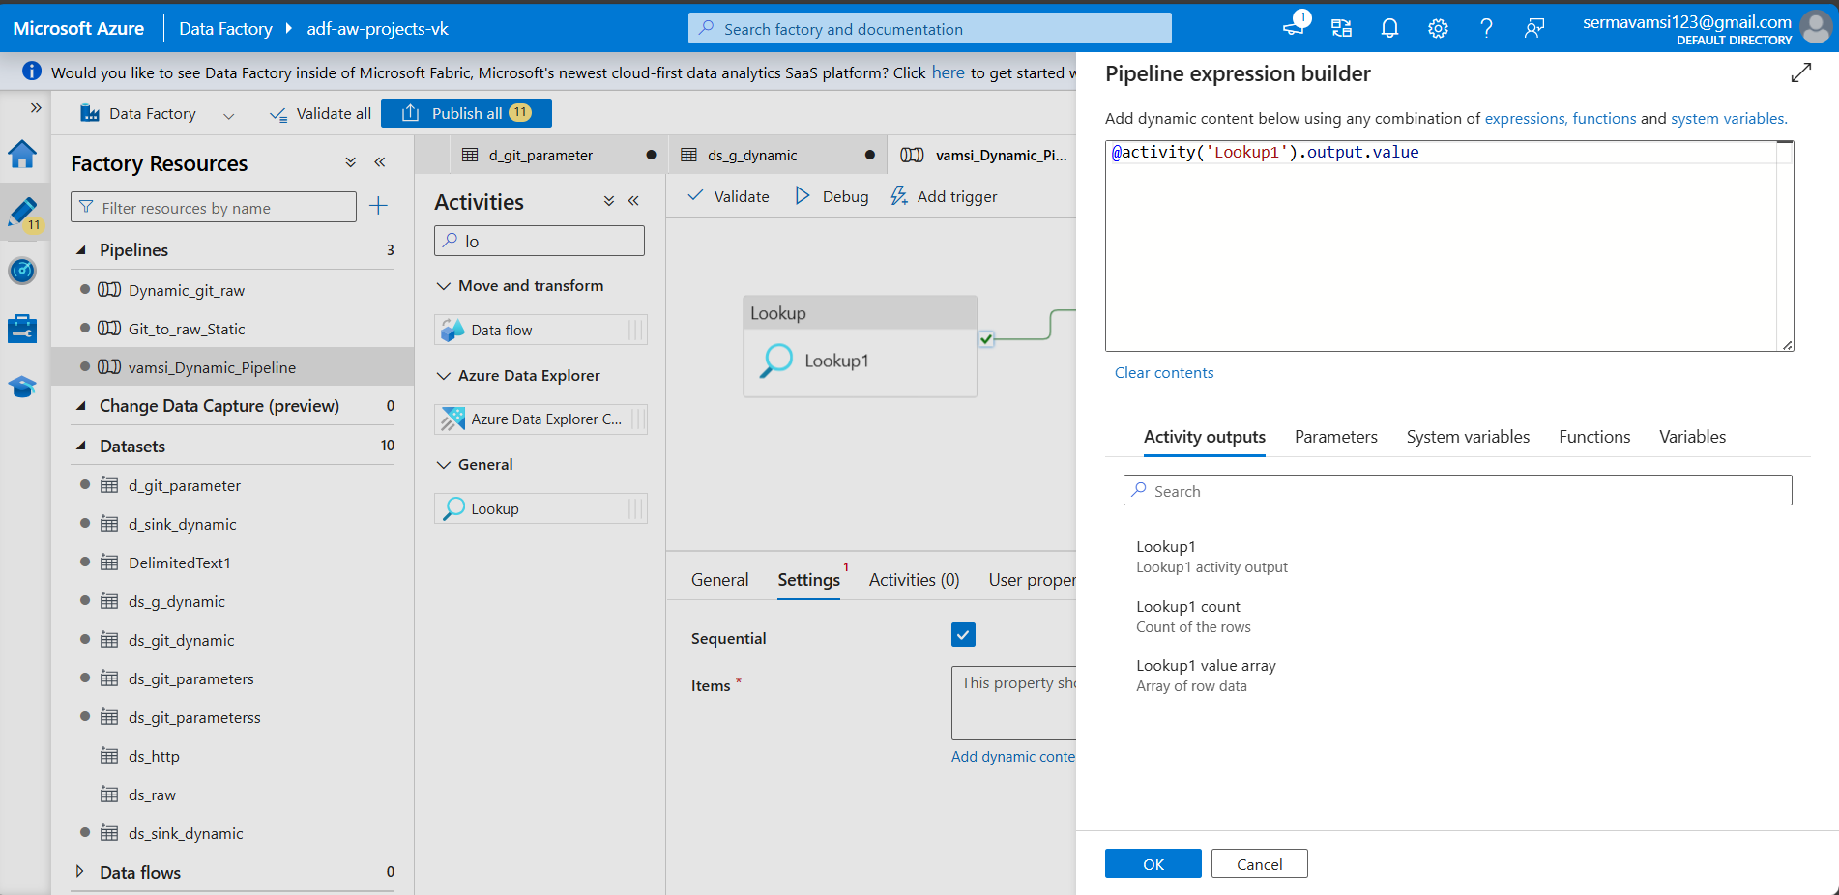

Click on Ctrl+x on the Dynamic _copy

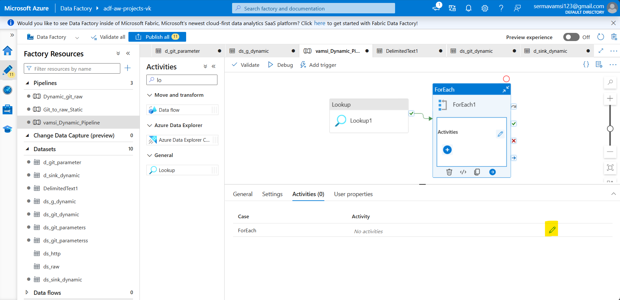 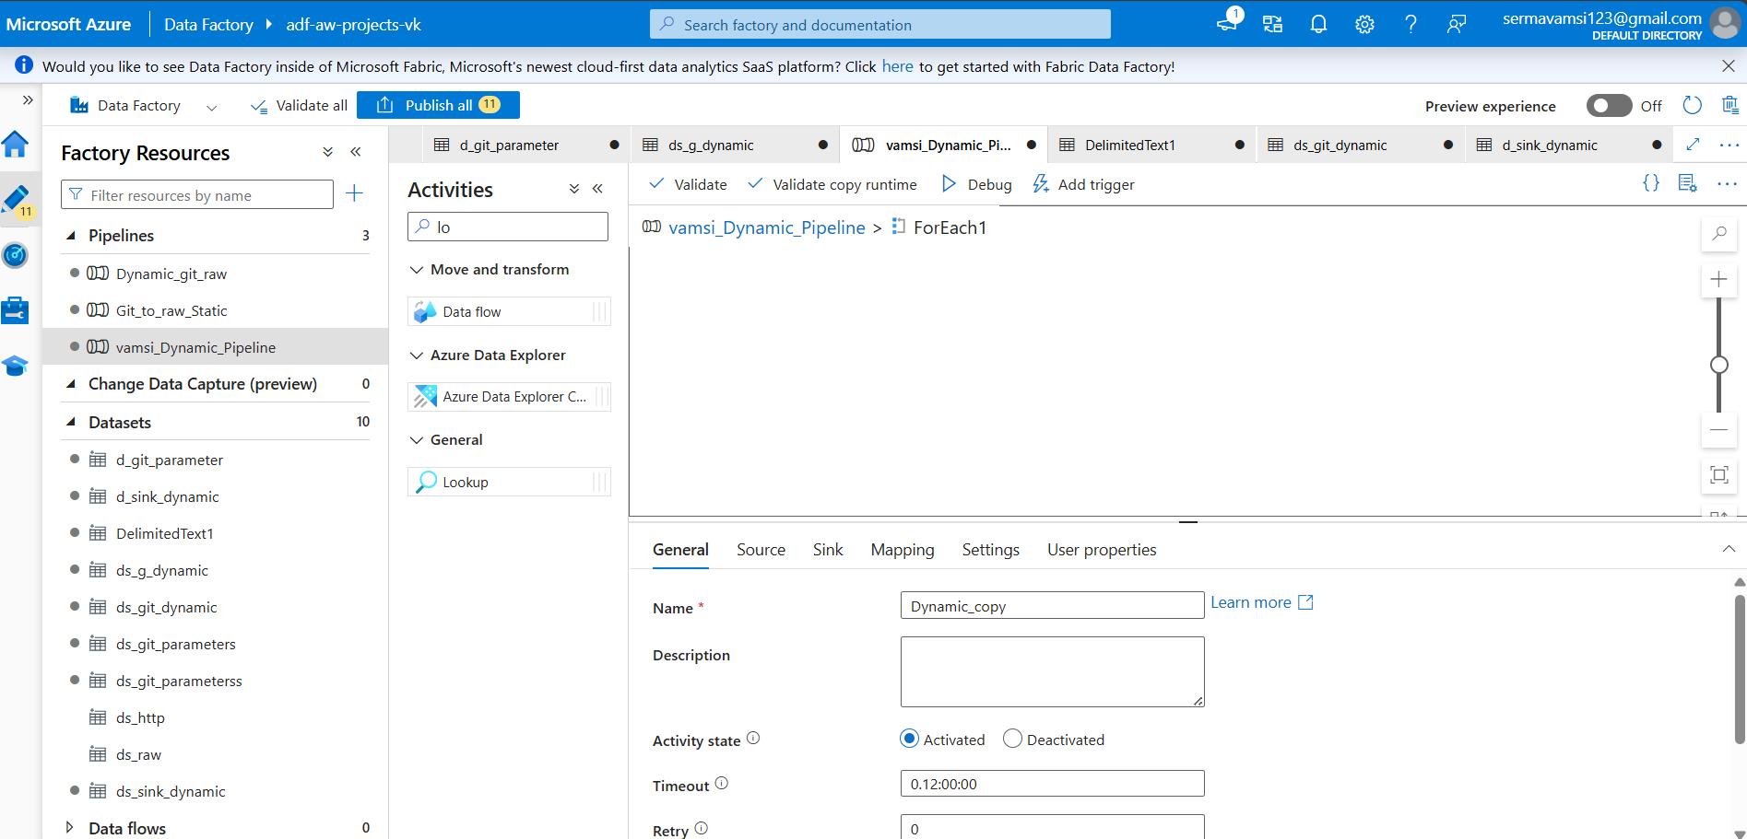

click on Ctrl+v

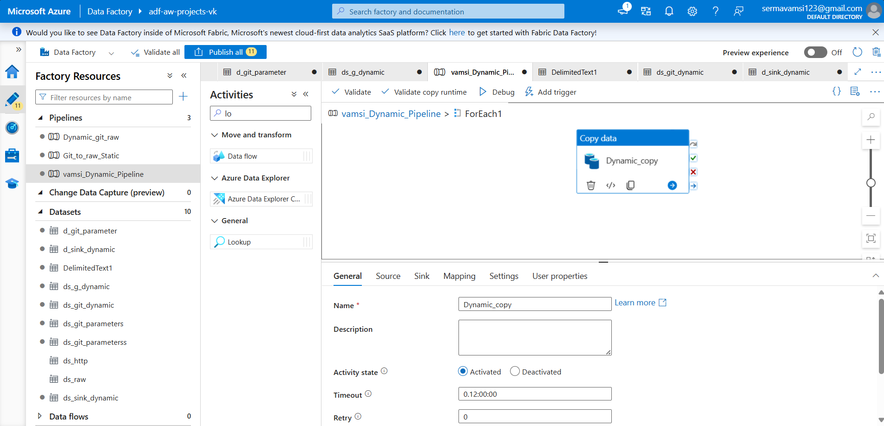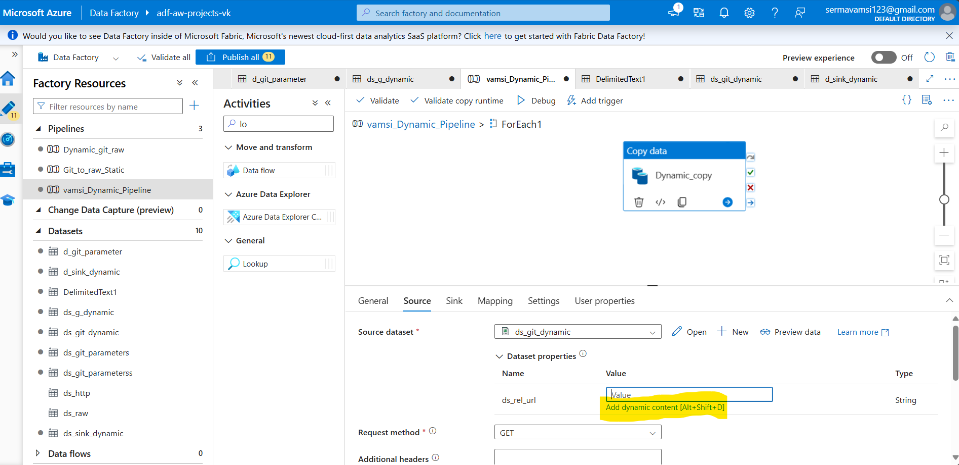

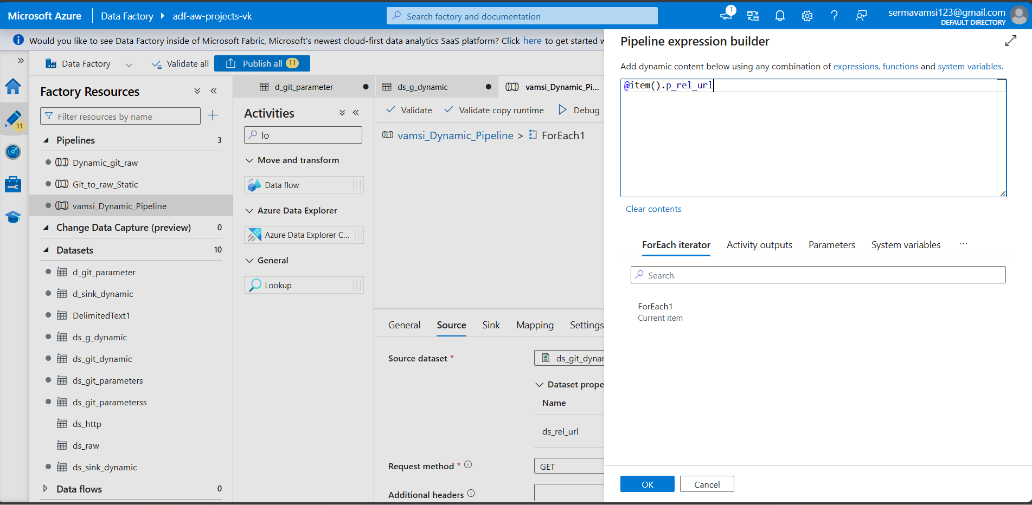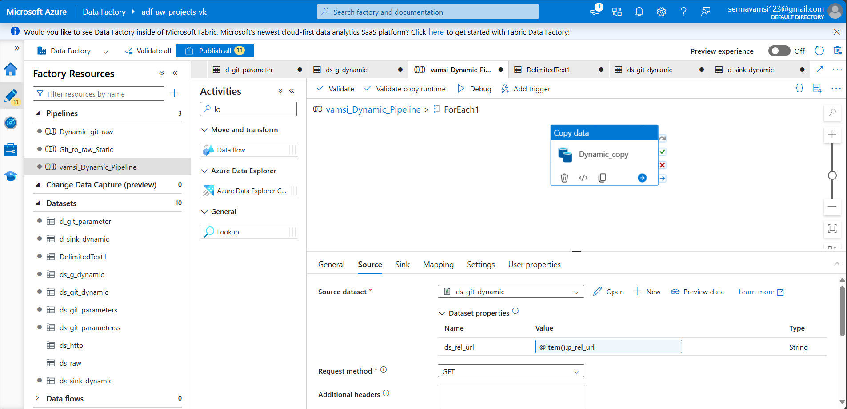

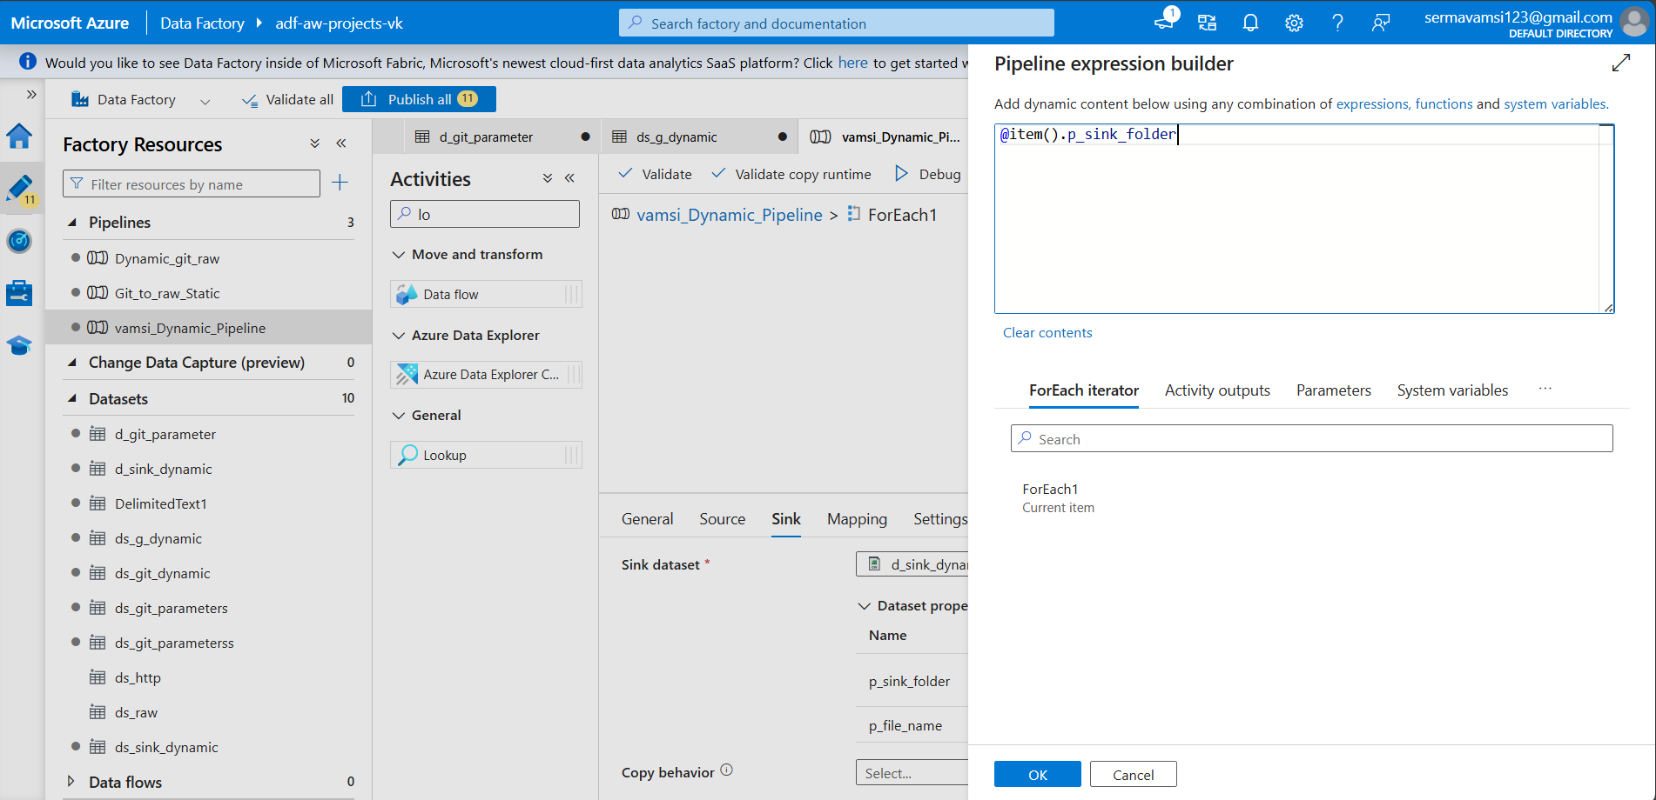

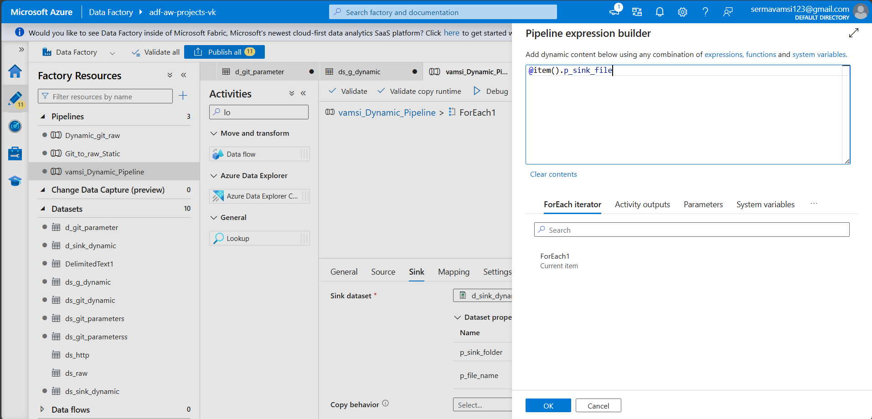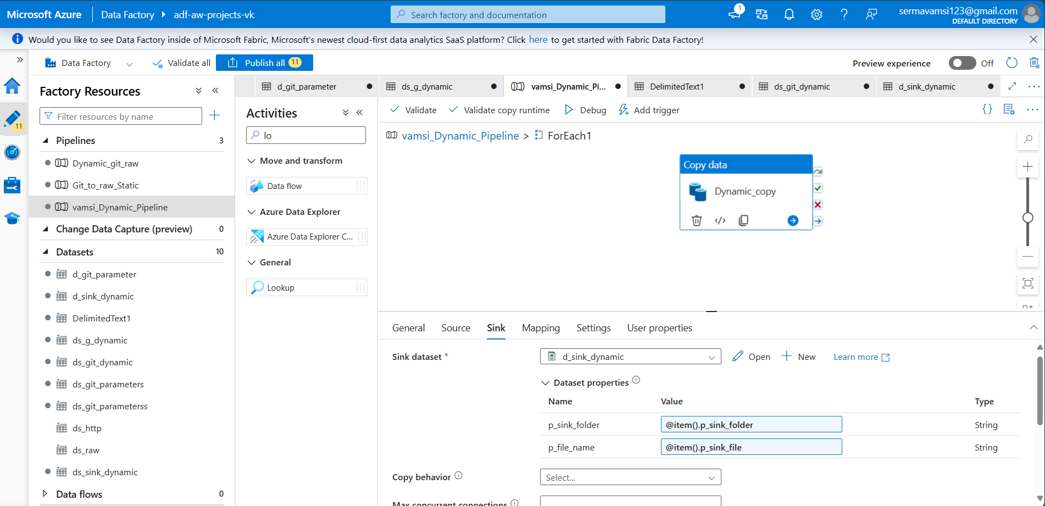

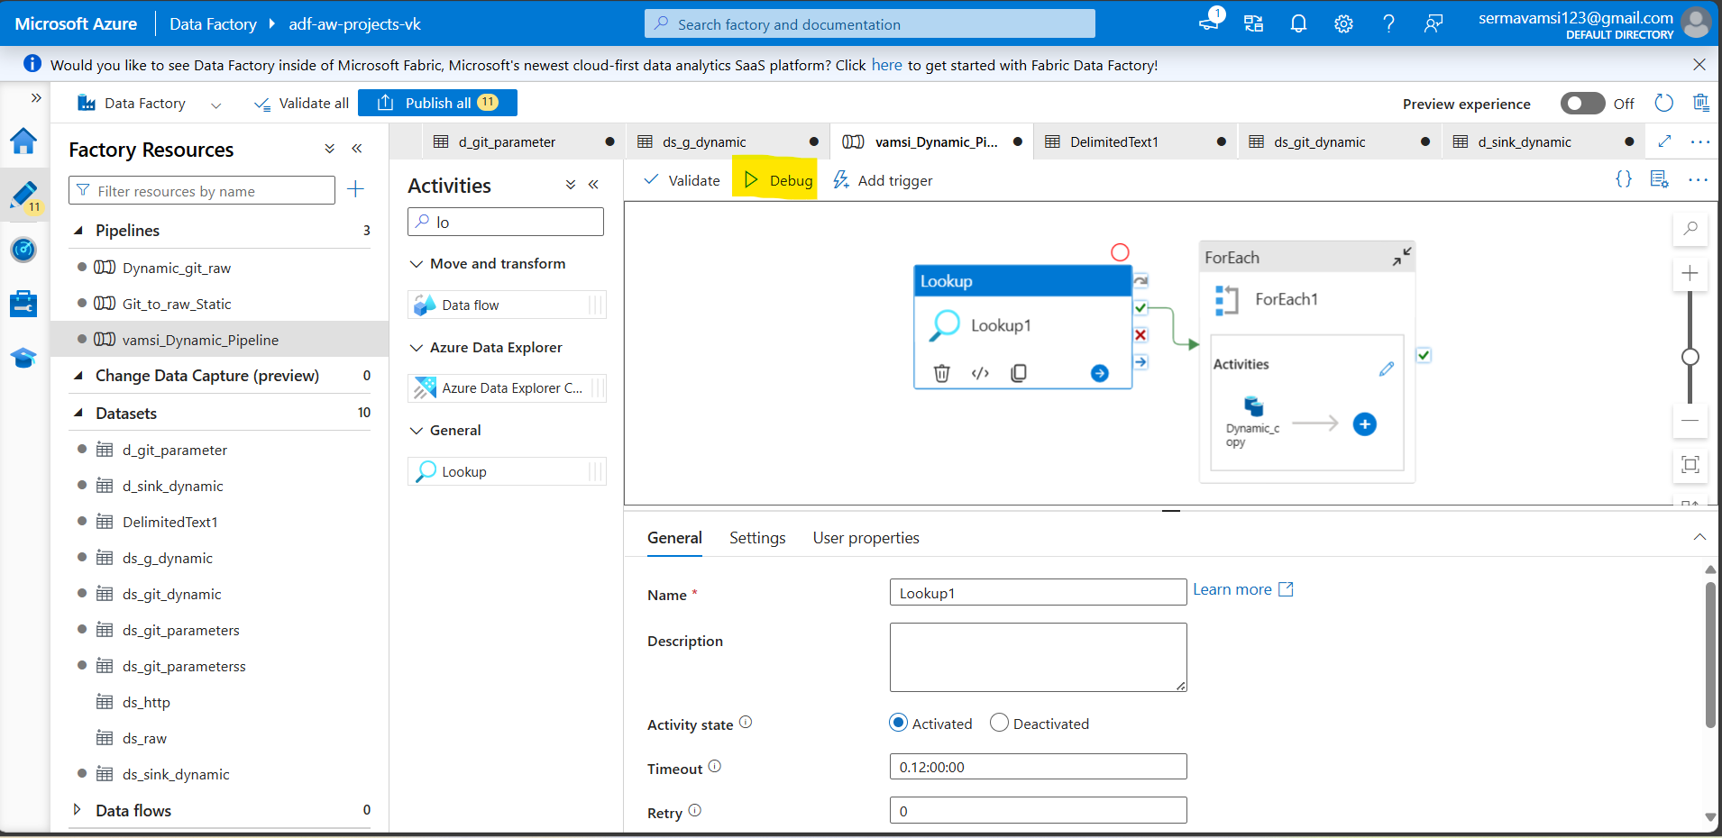

Then you can debug execute and check the silver layer.  
go to >> Storage account >> AWprojectDatalakess >> bronze layer >> Check. Got the file in bronze layer.

Step:3:

Got Azure>> Click the create a resource >> search for the data bricks>> create button>>

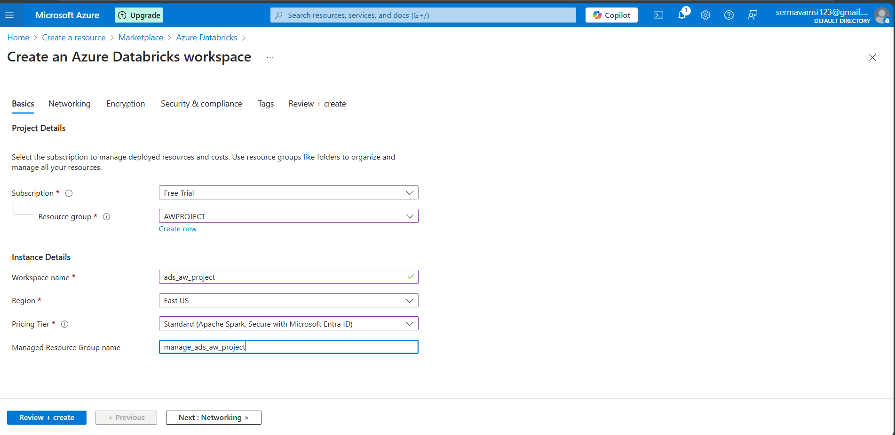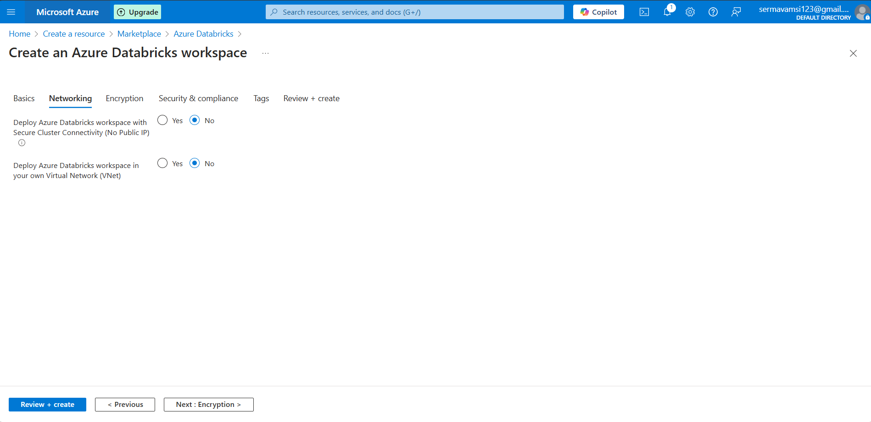

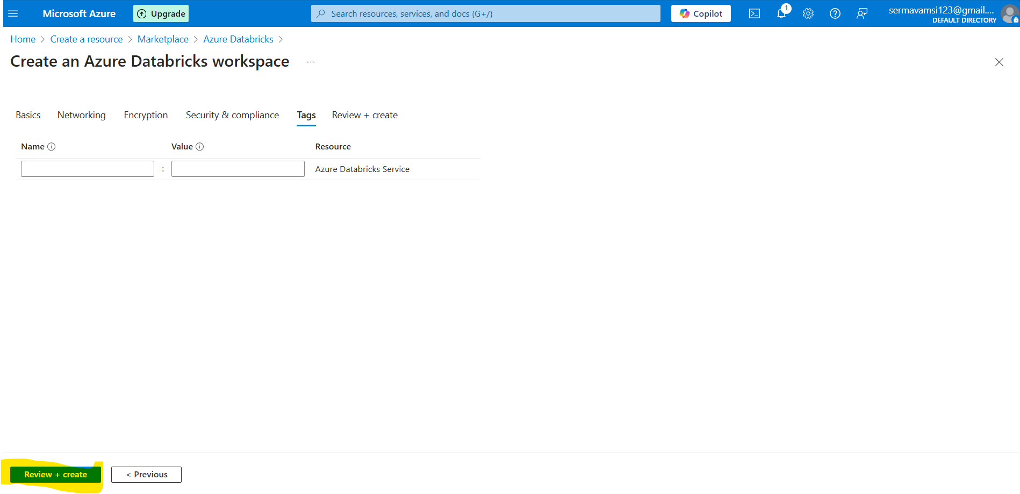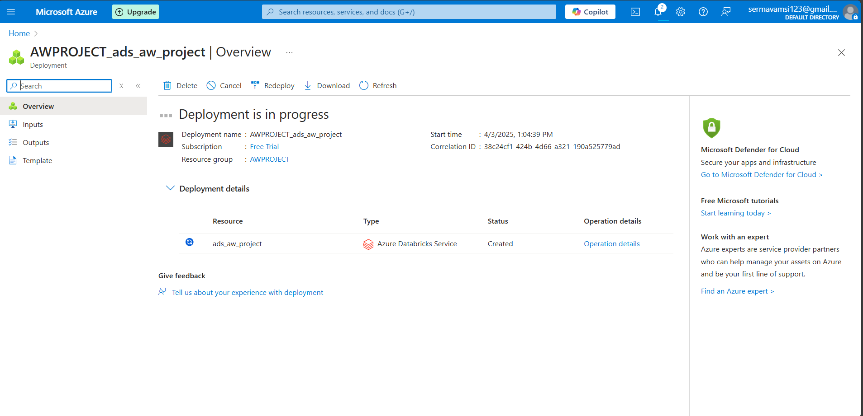

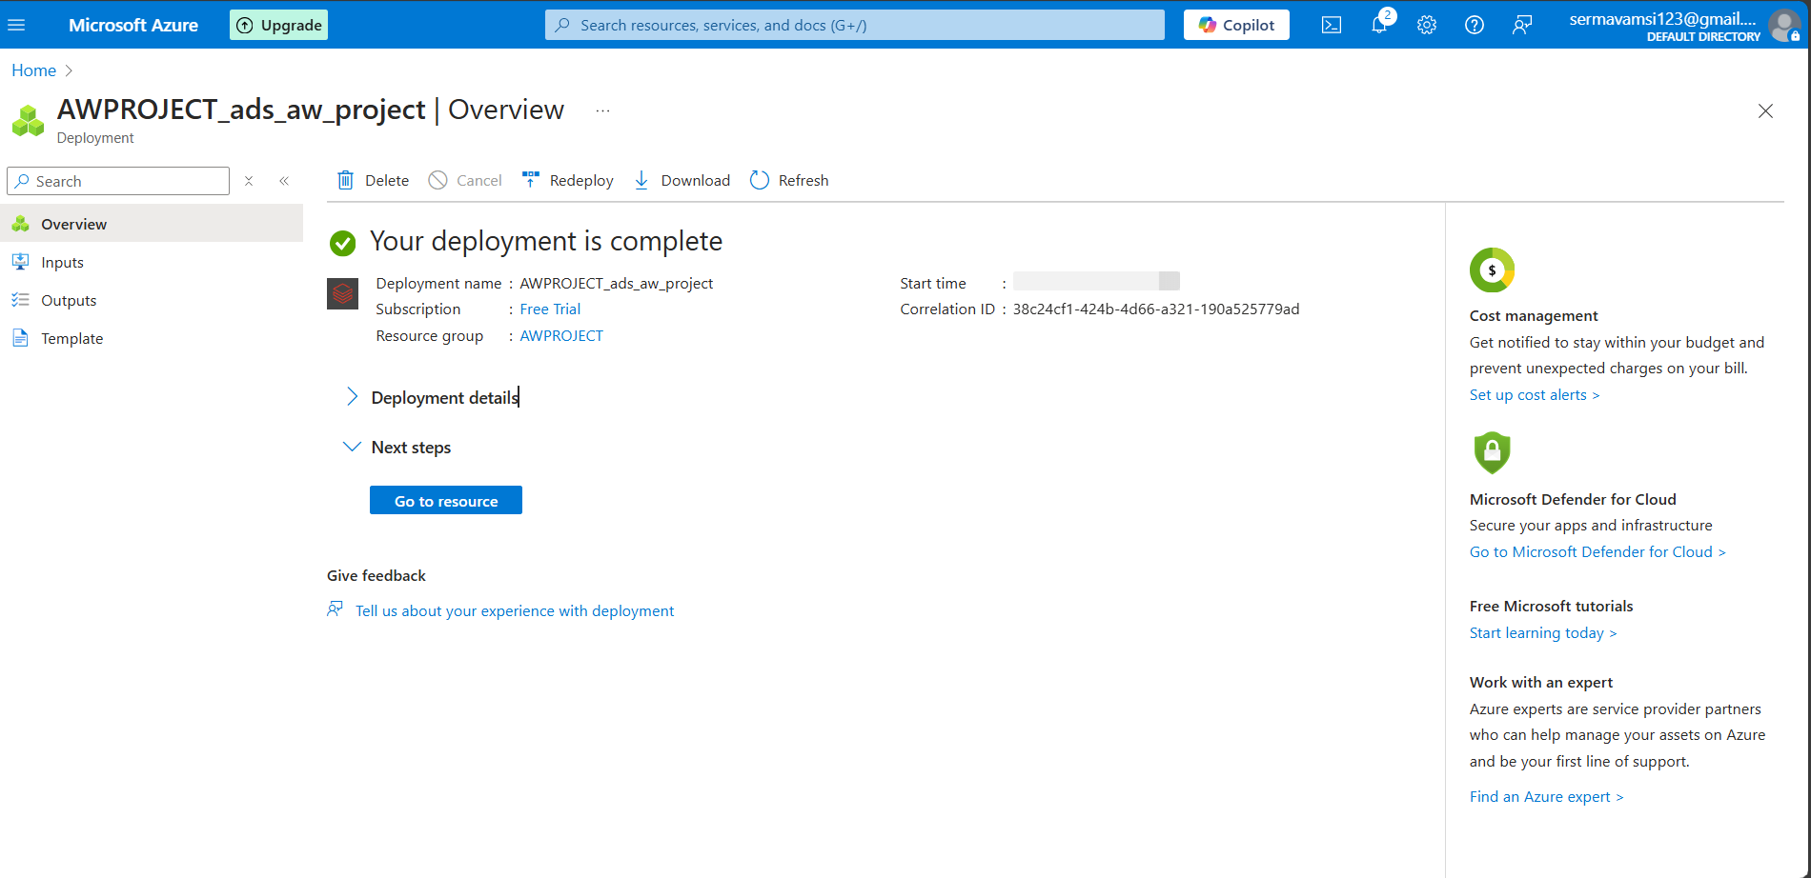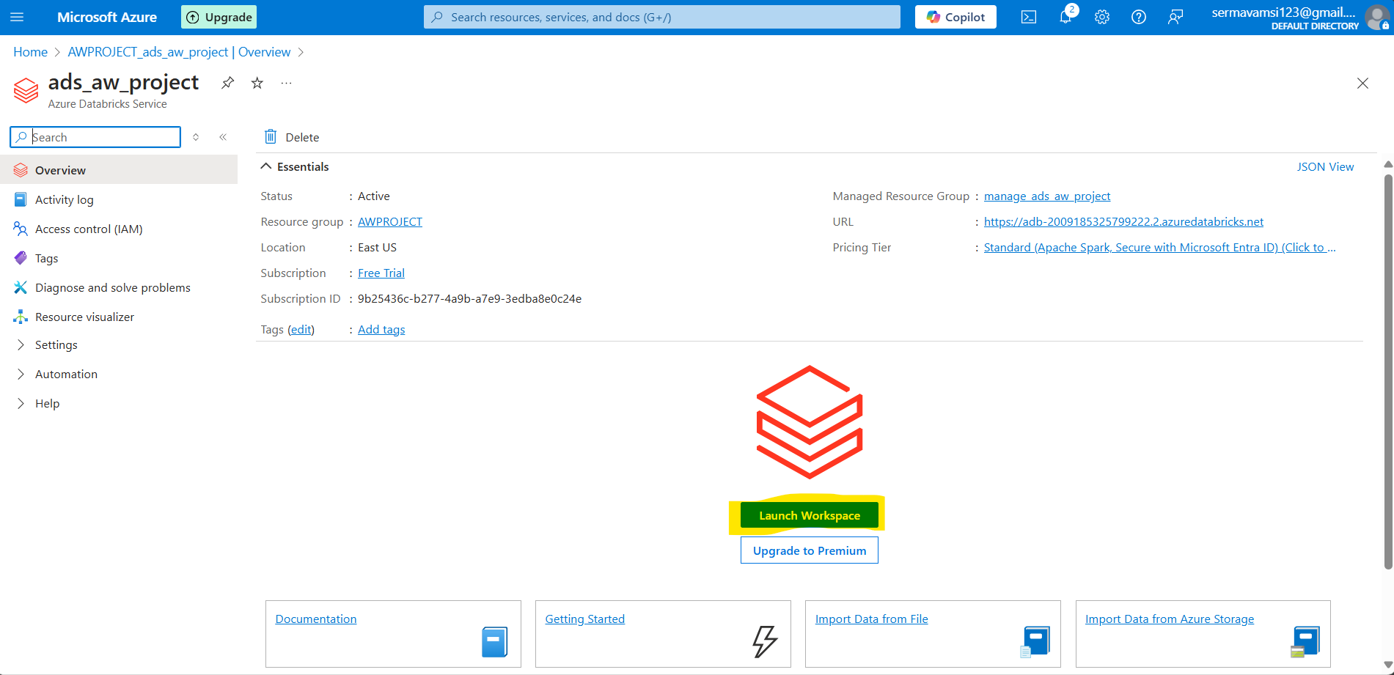

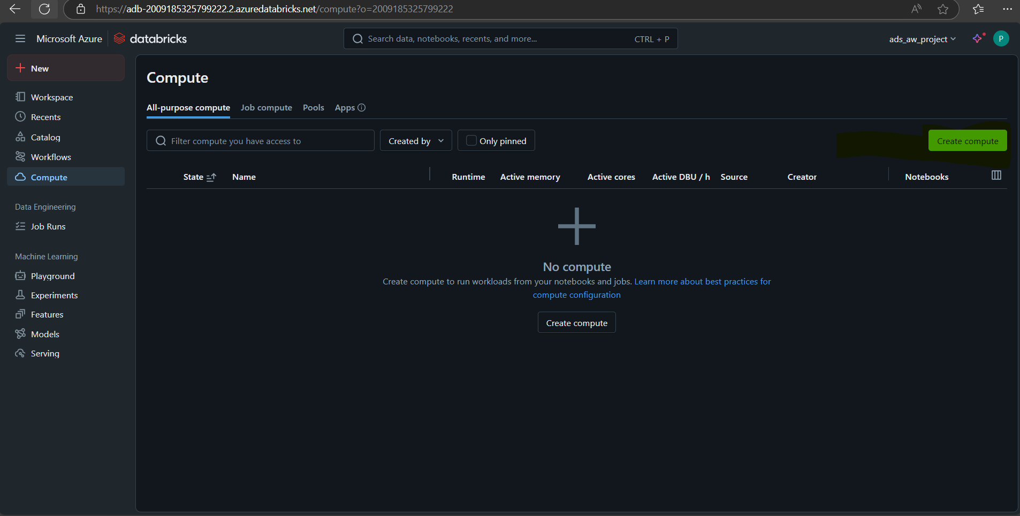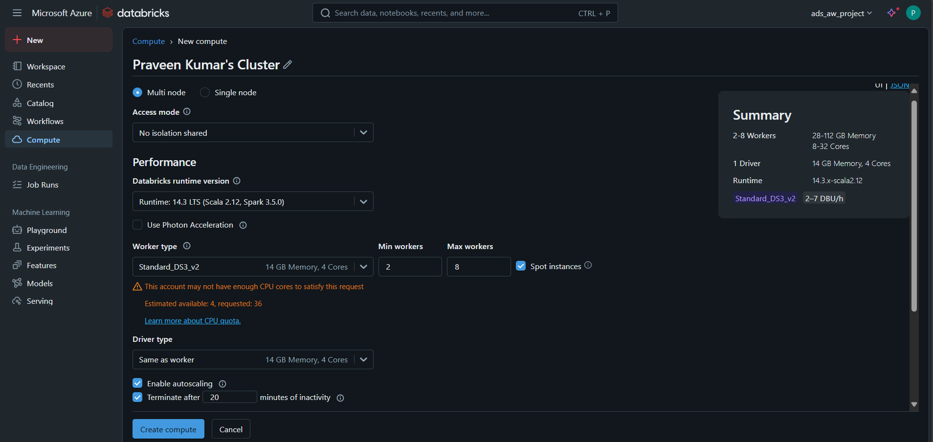

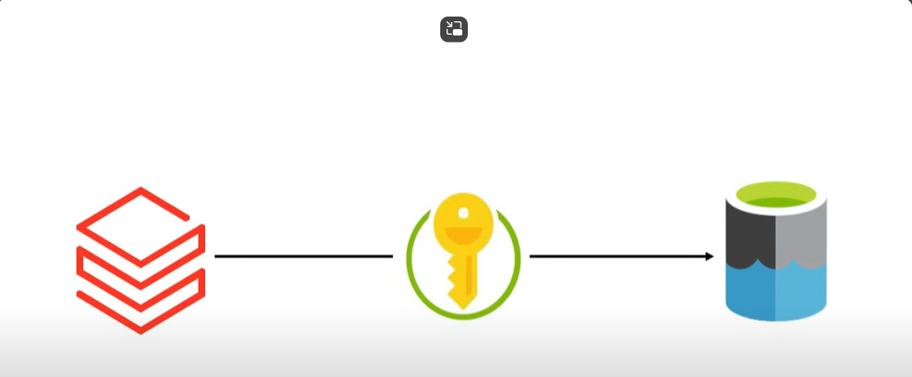

Then you need to create >> Microsoft Entra ID >>App Registration >>

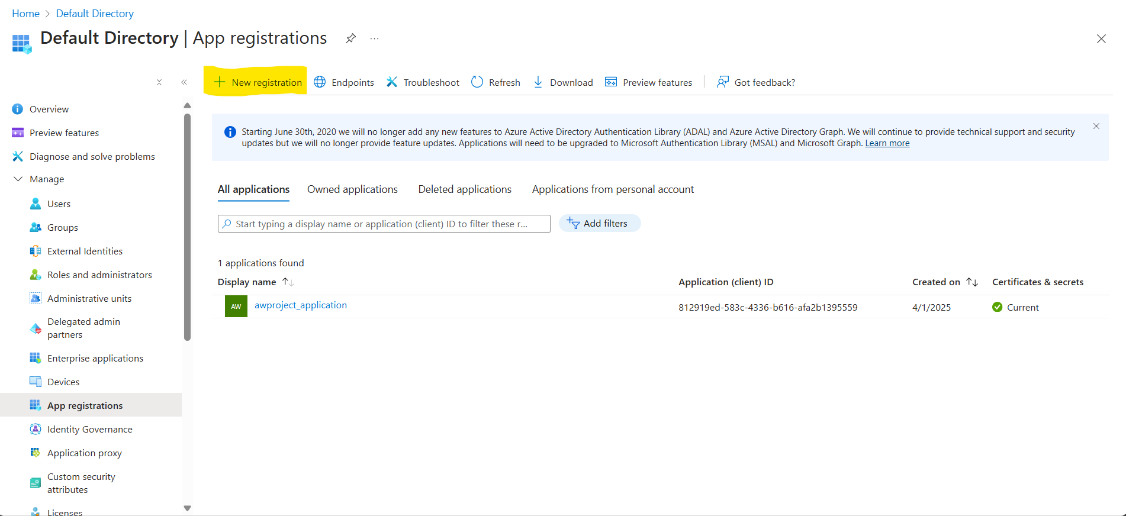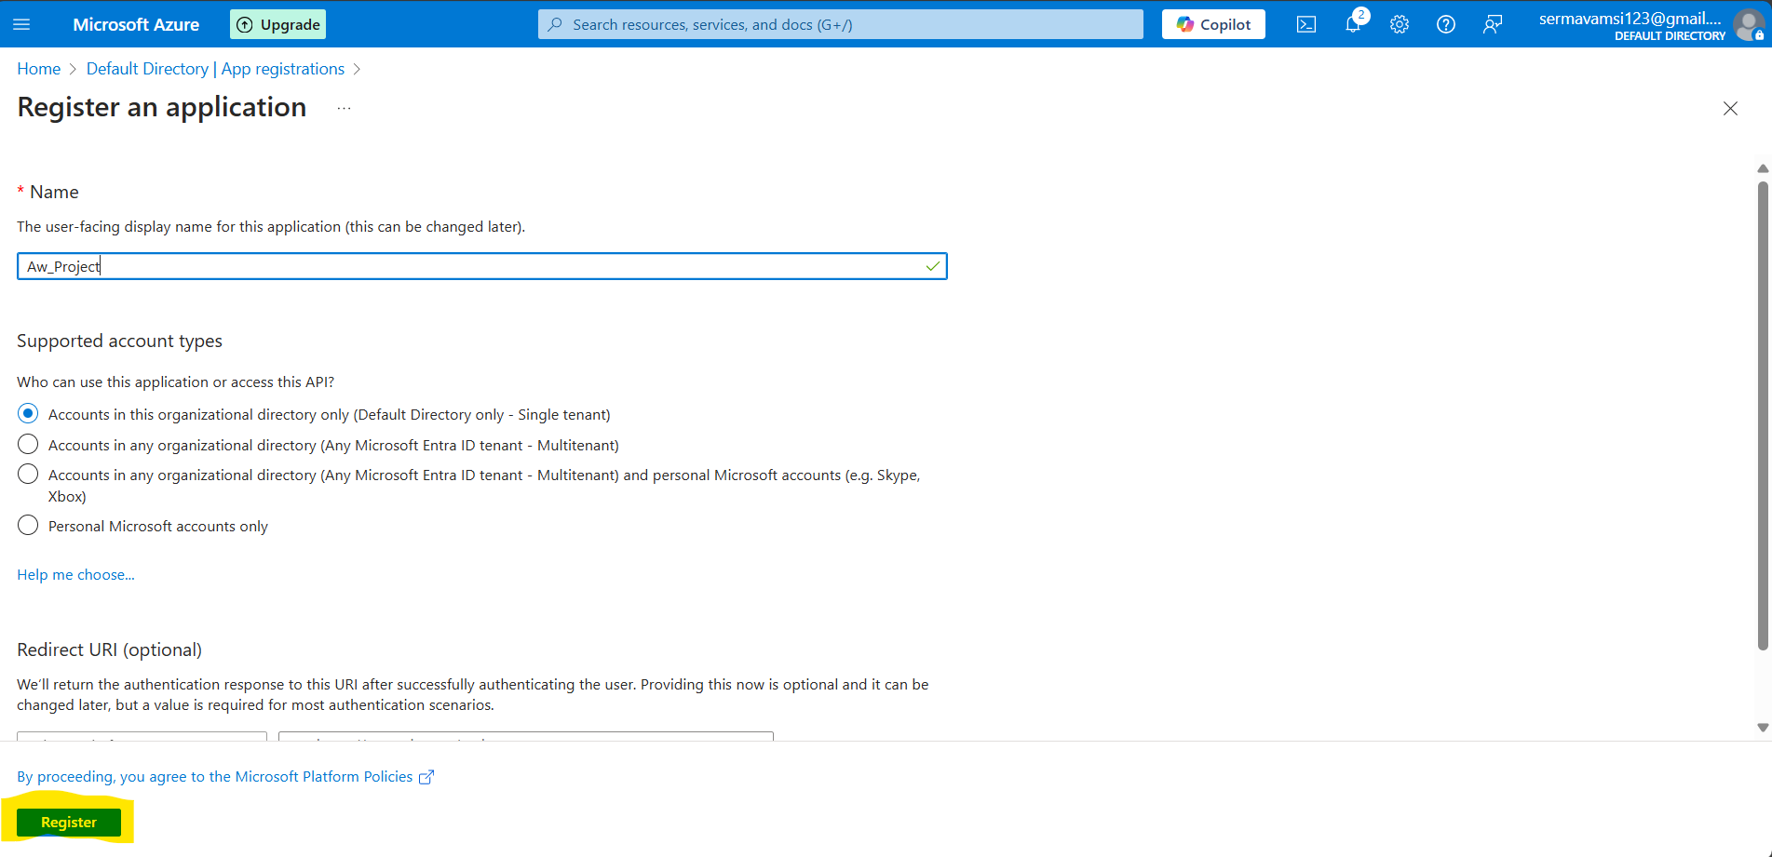

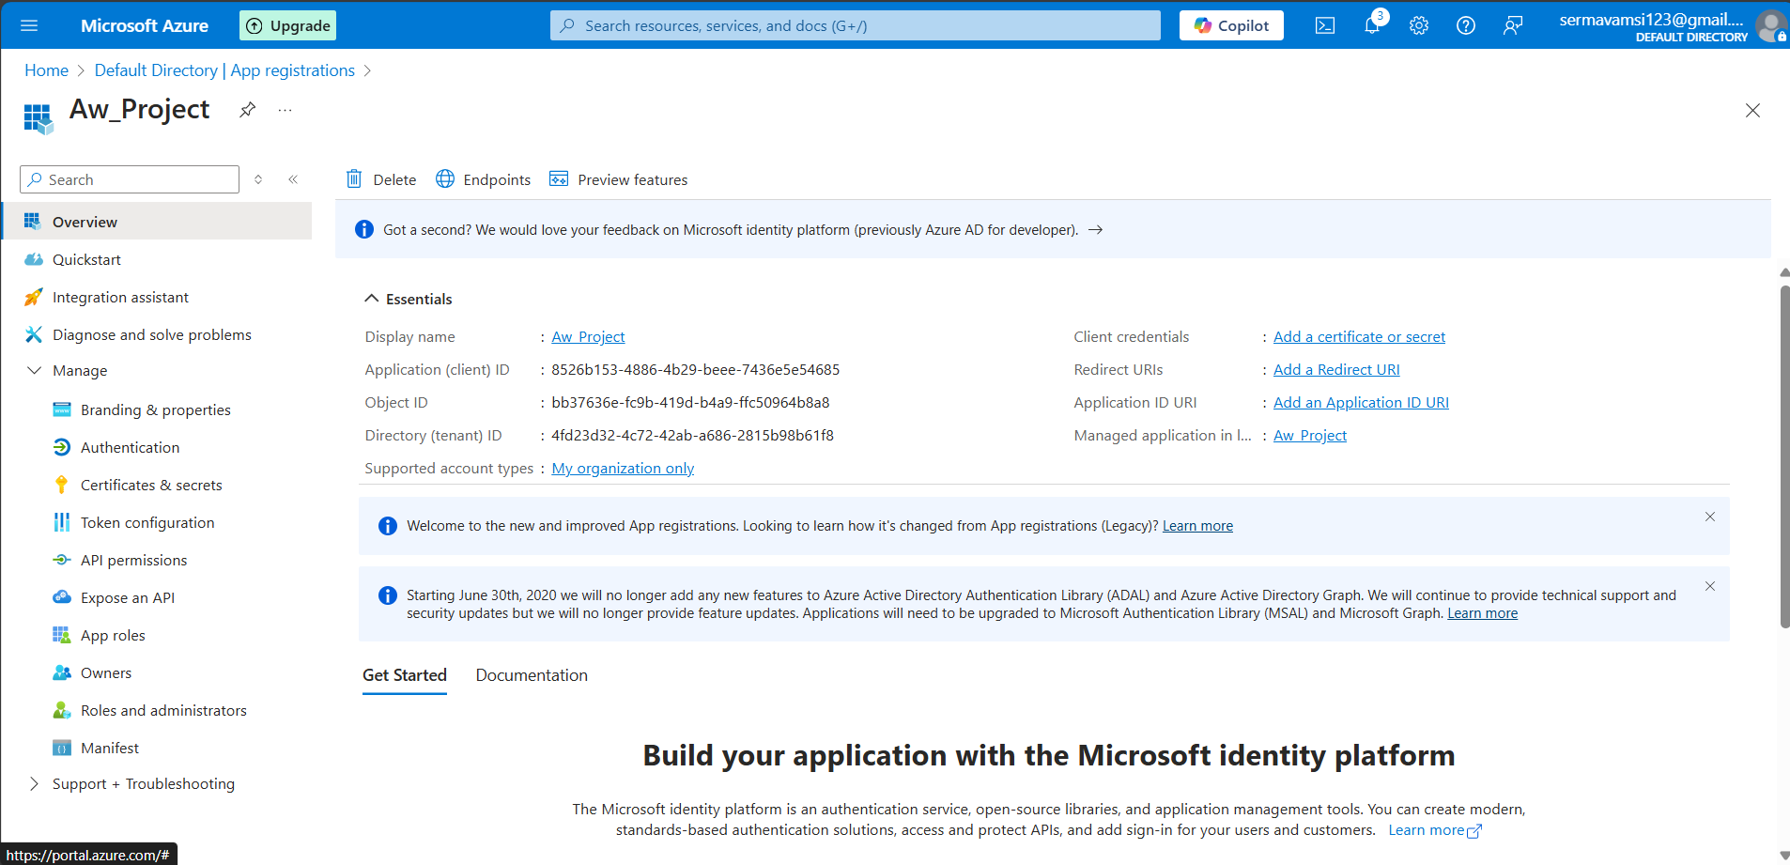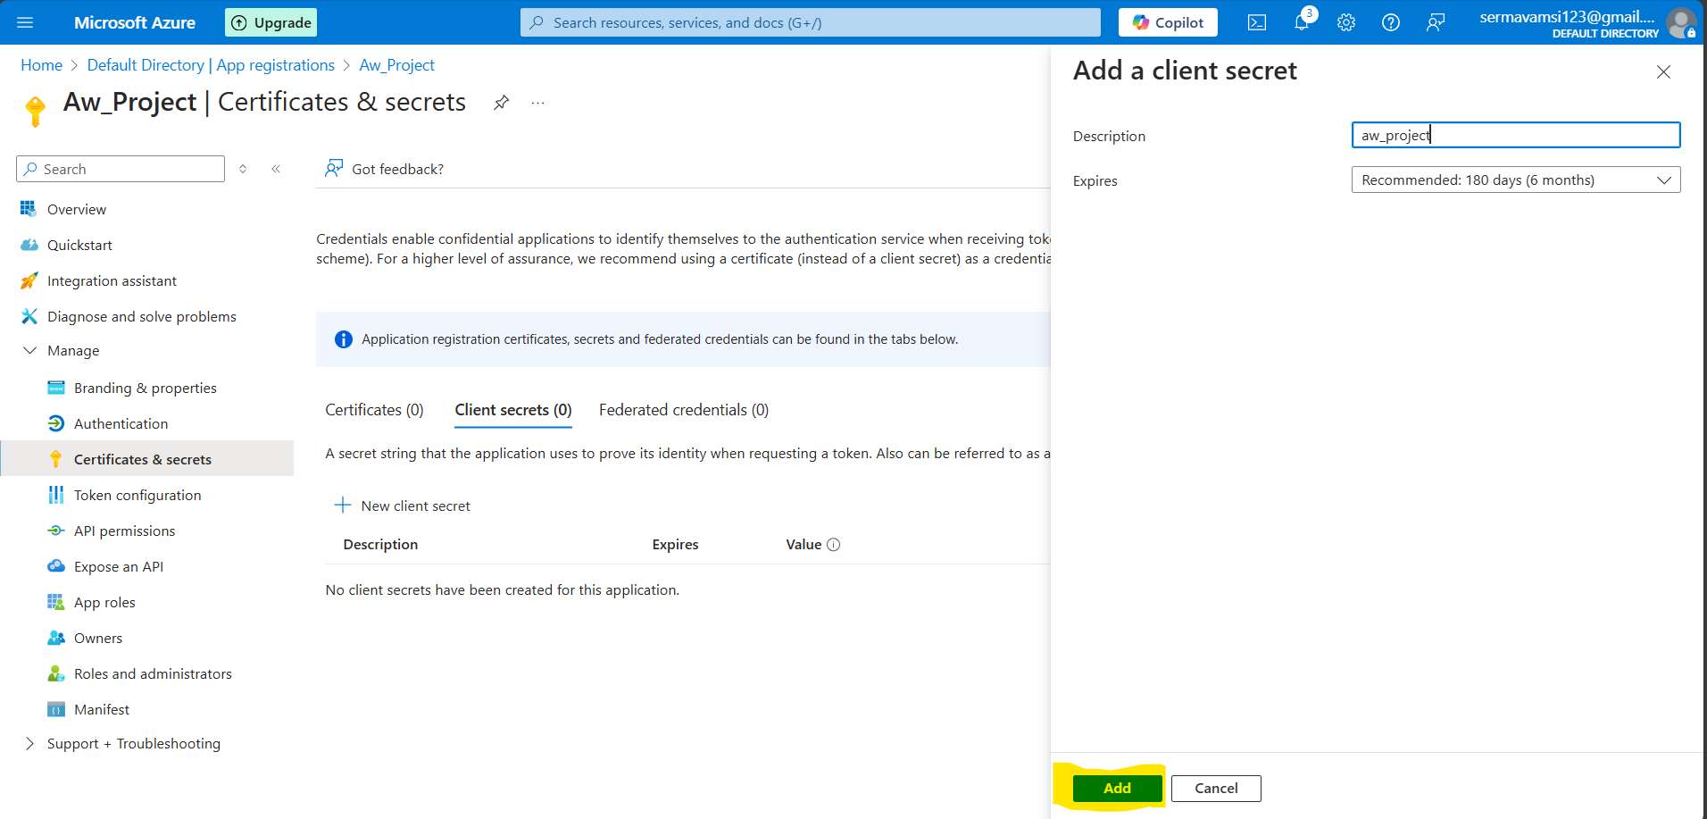

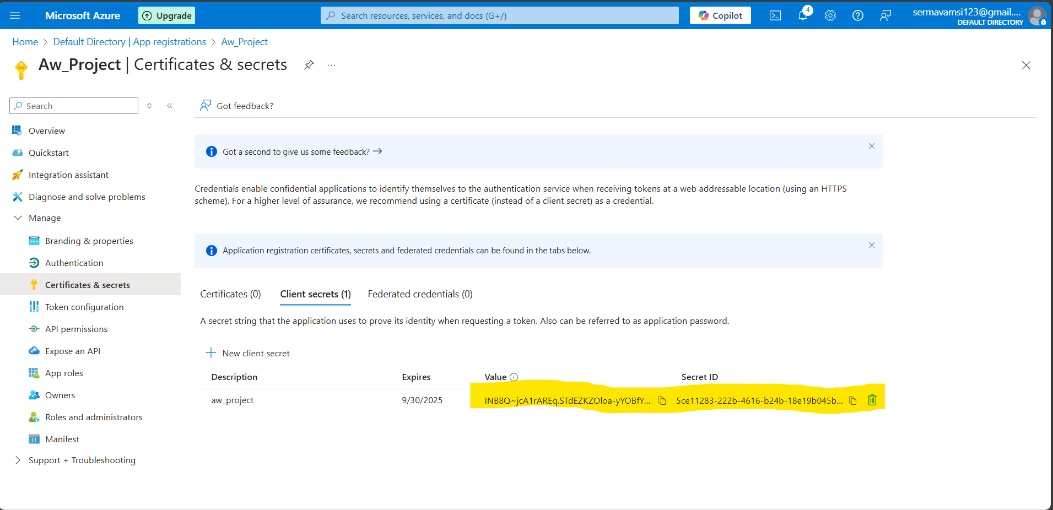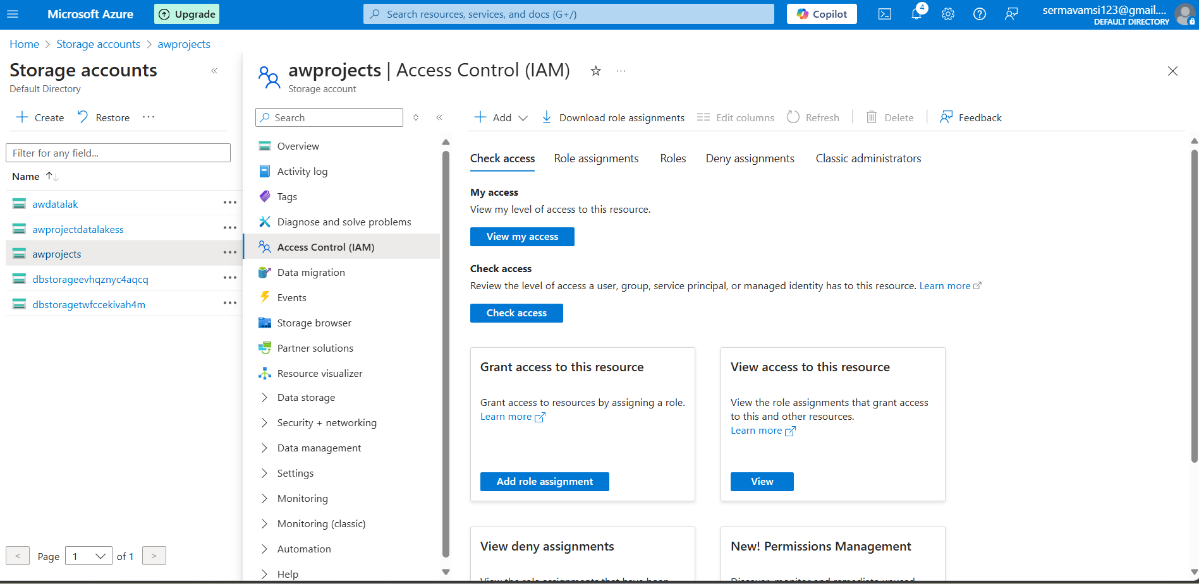

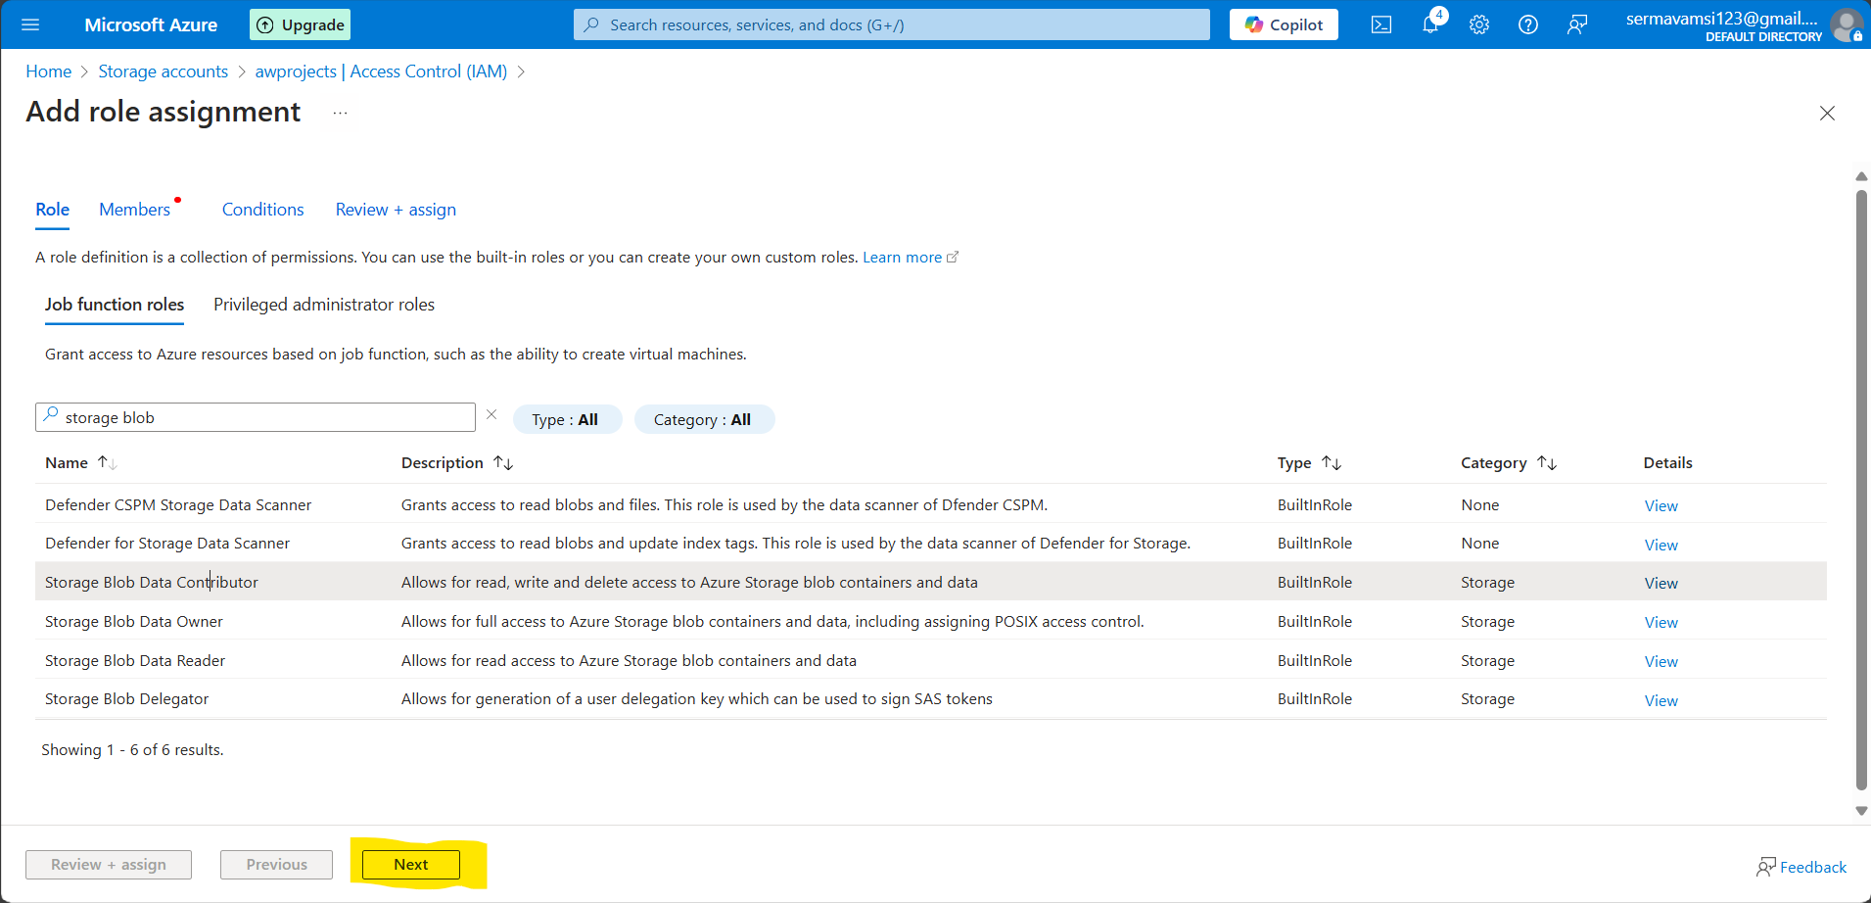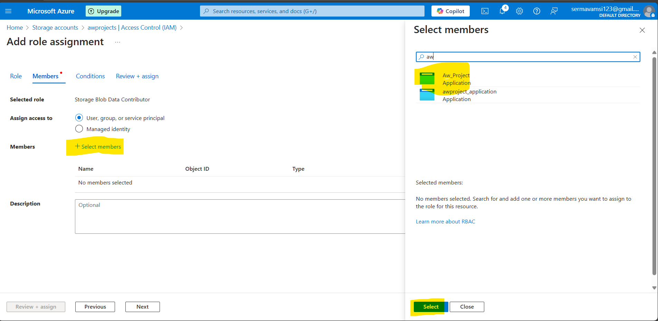

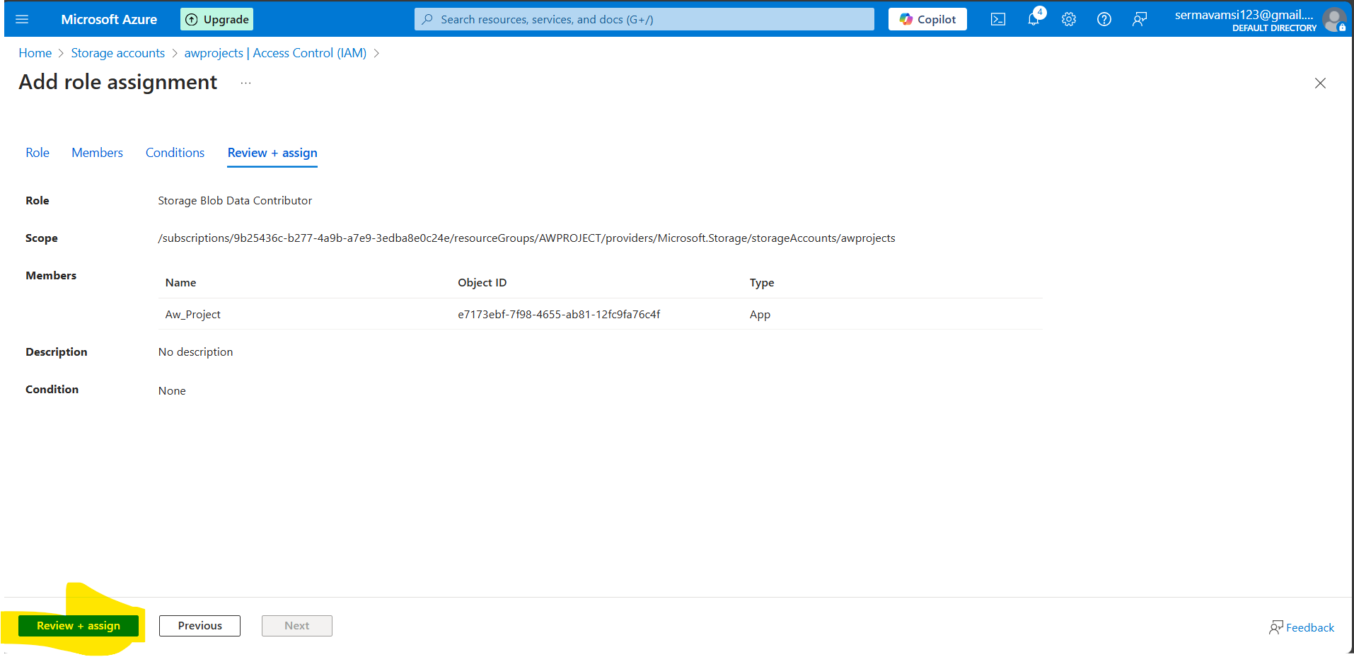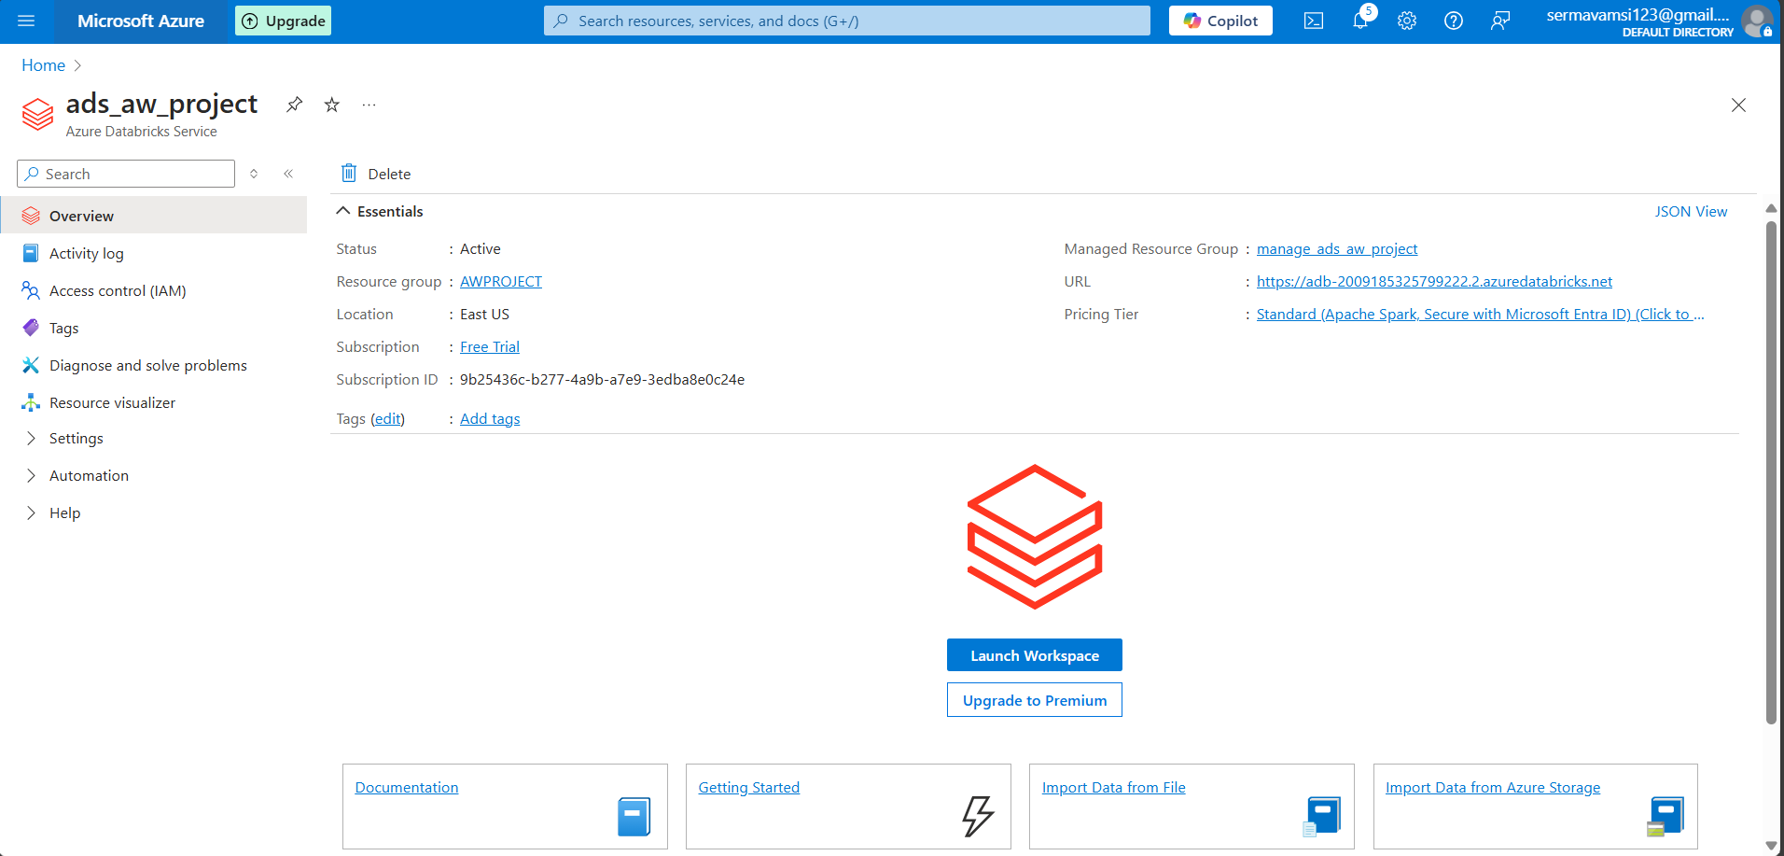

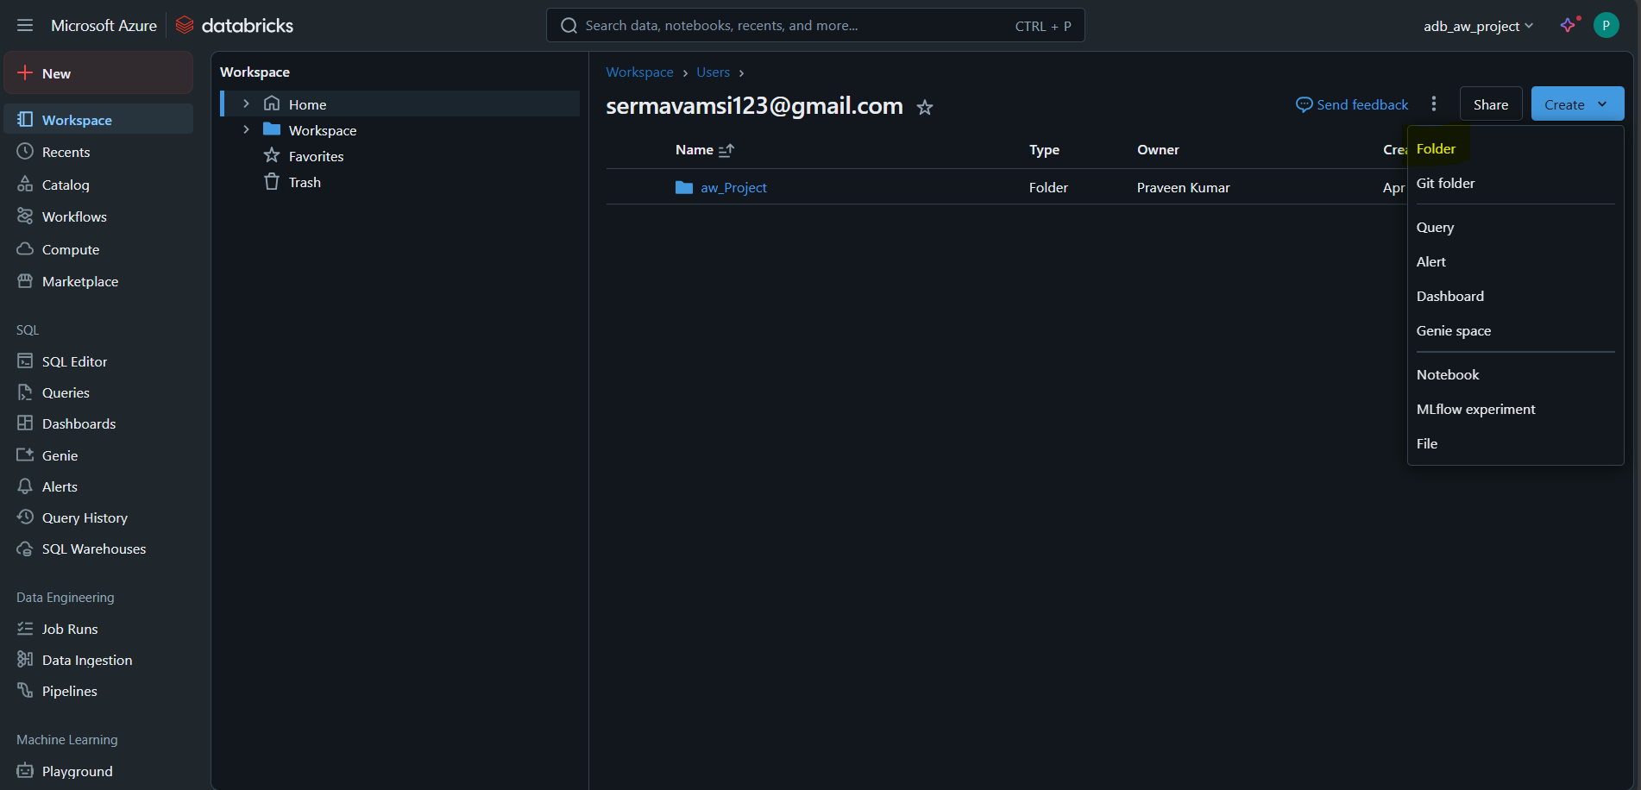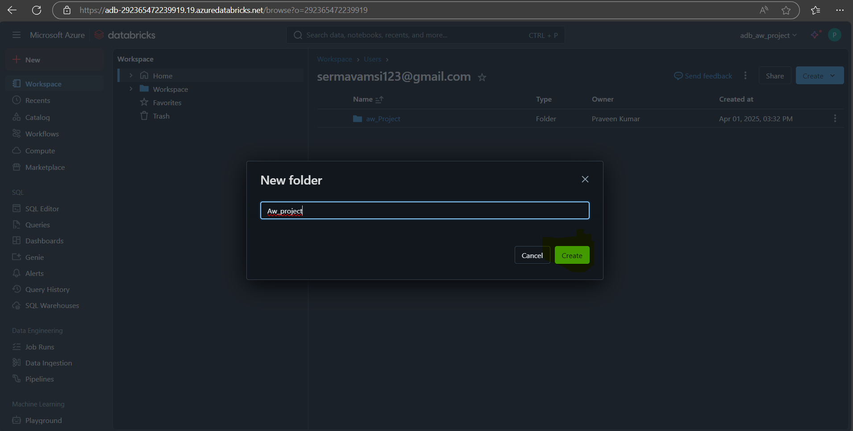

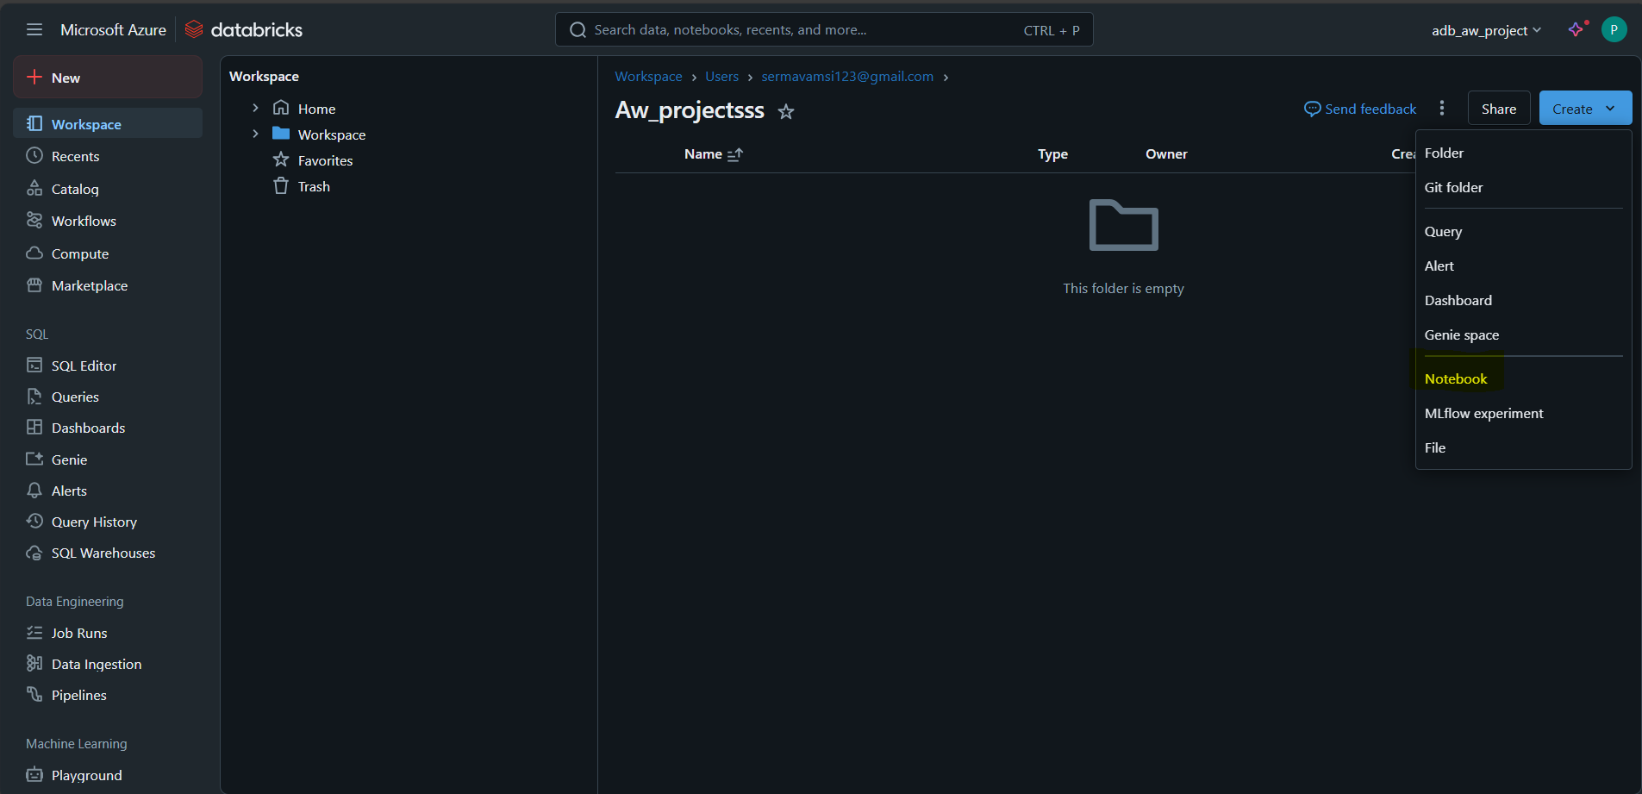

Create a note book and create a script and and exexute then do that transformations and that transformation files extecute shifted to the silver layer.

Ref link: [https://learn.microsoft.com/en-us/azure/databricks/connect/storage/azure-storage#azureserviceprincipal](https://learn.microsoft.com/en-us/azure/databricks/connect/storage/azure-storage%23azureserviceprincipal)

Once can see the this files are loaded in silver layer.once check.

Step: 4:

Go to Azure portal >> Create A resource >> Search Synapse analytics>> once you got click on that one create button>>

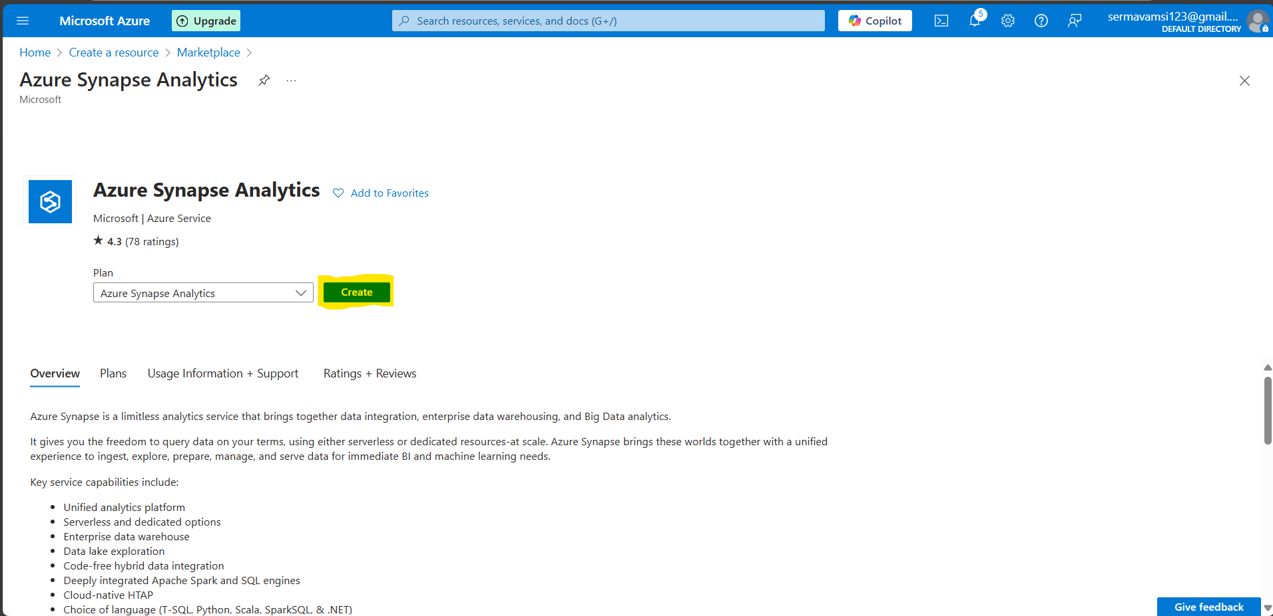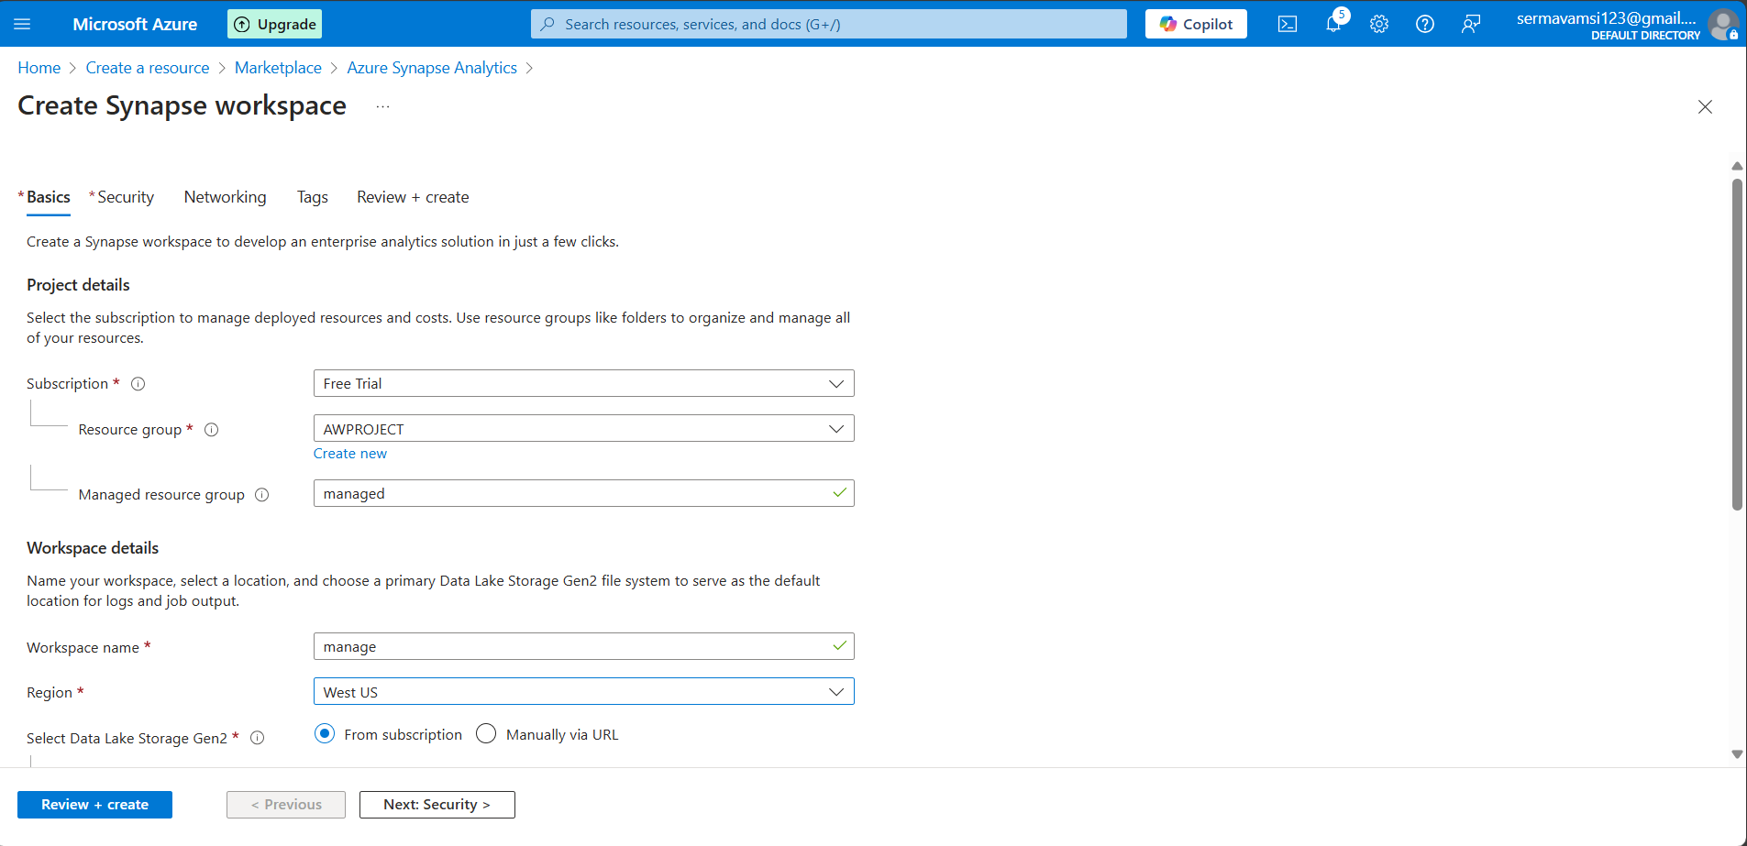

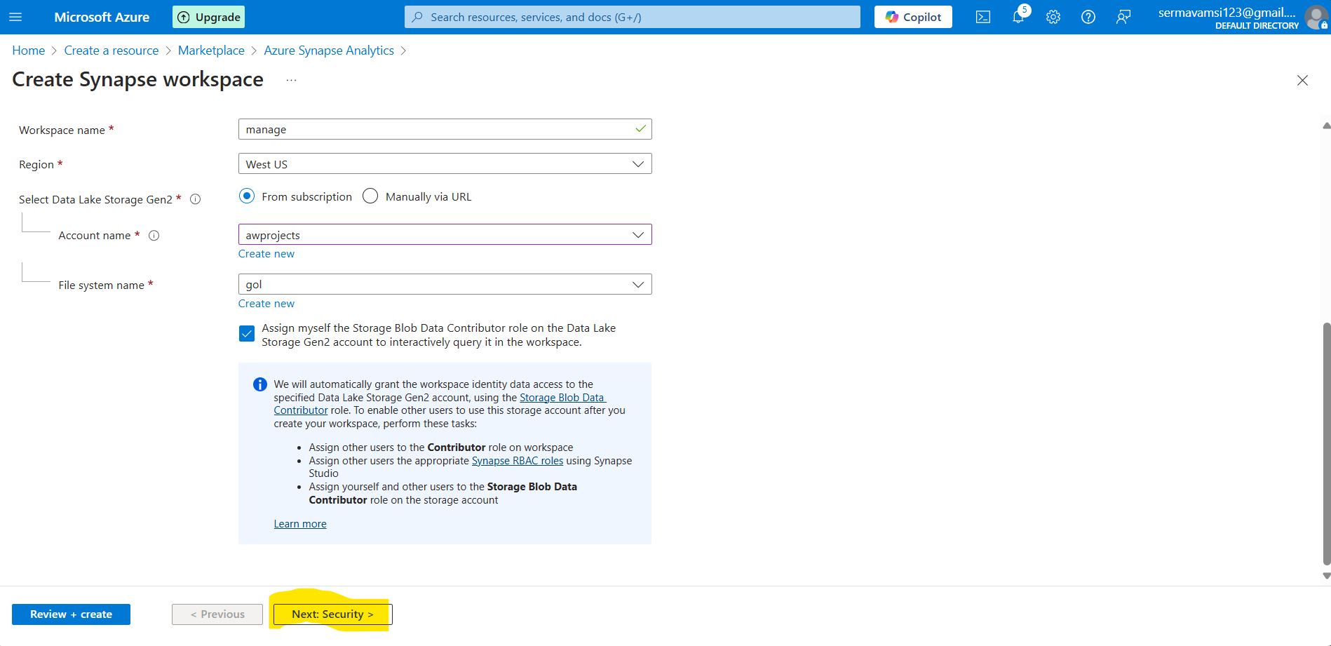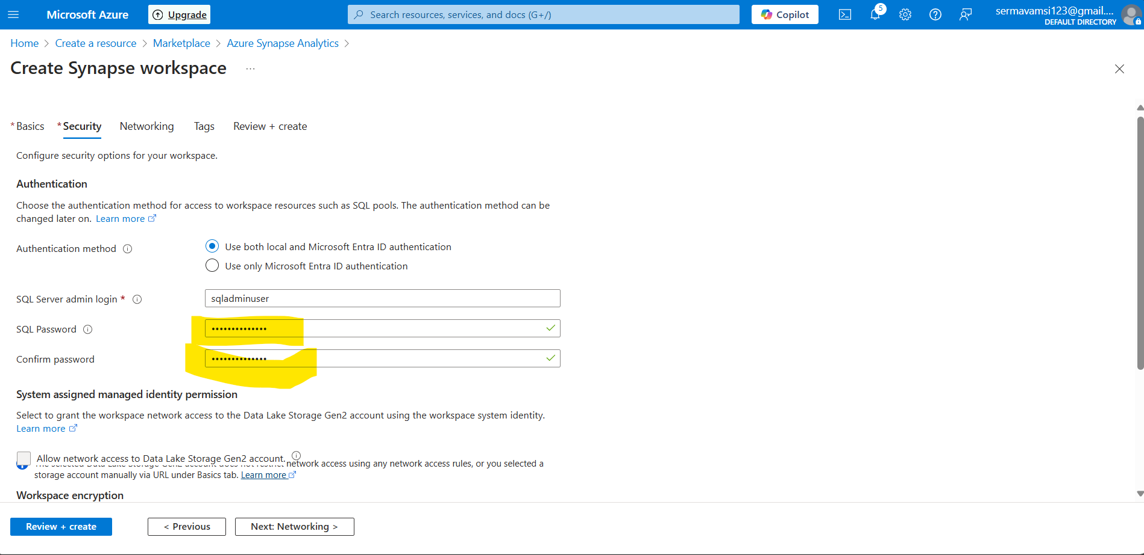

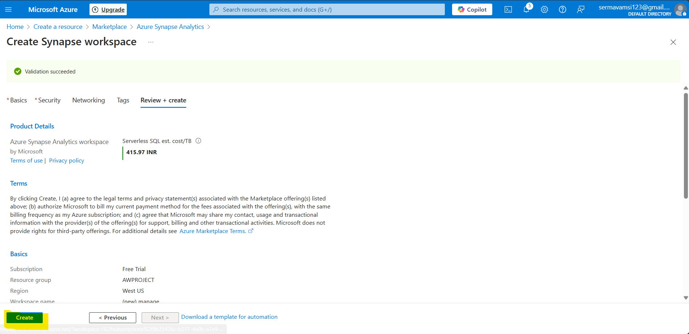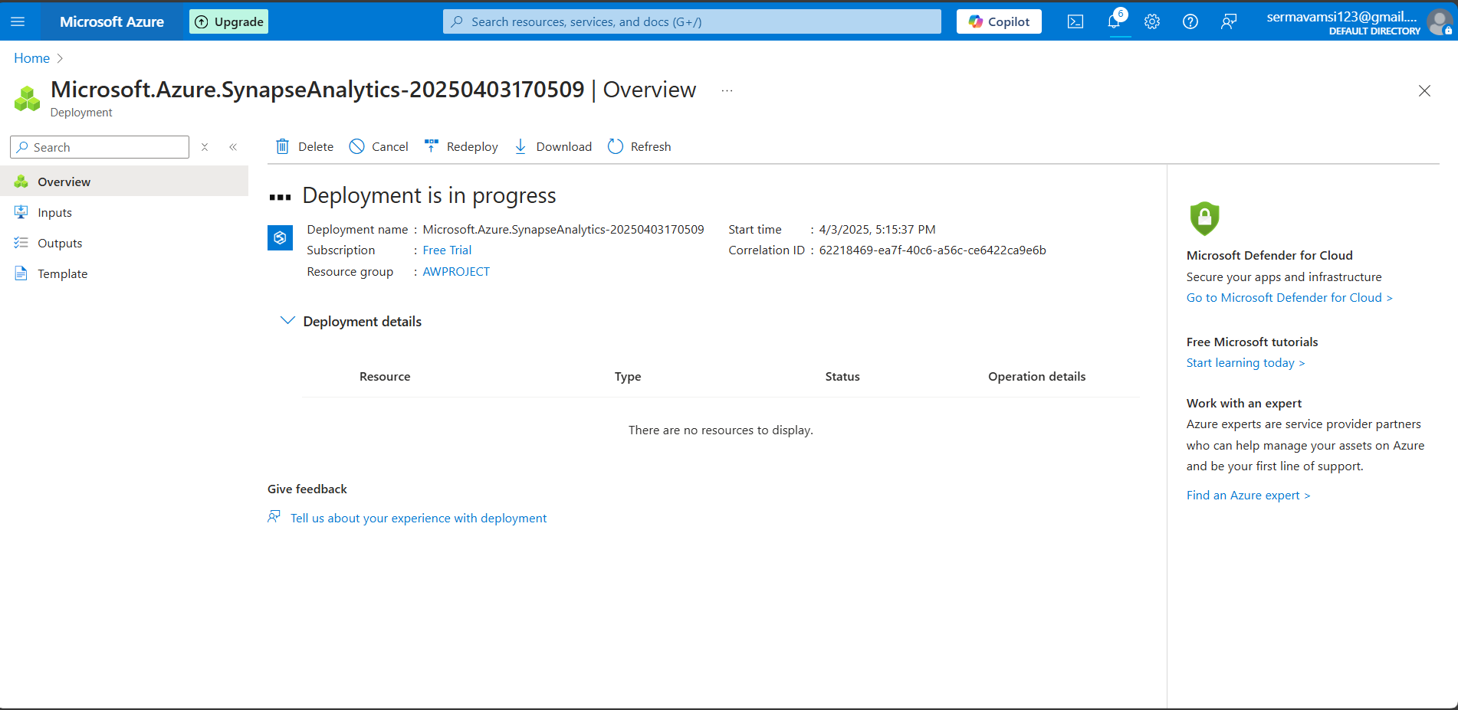

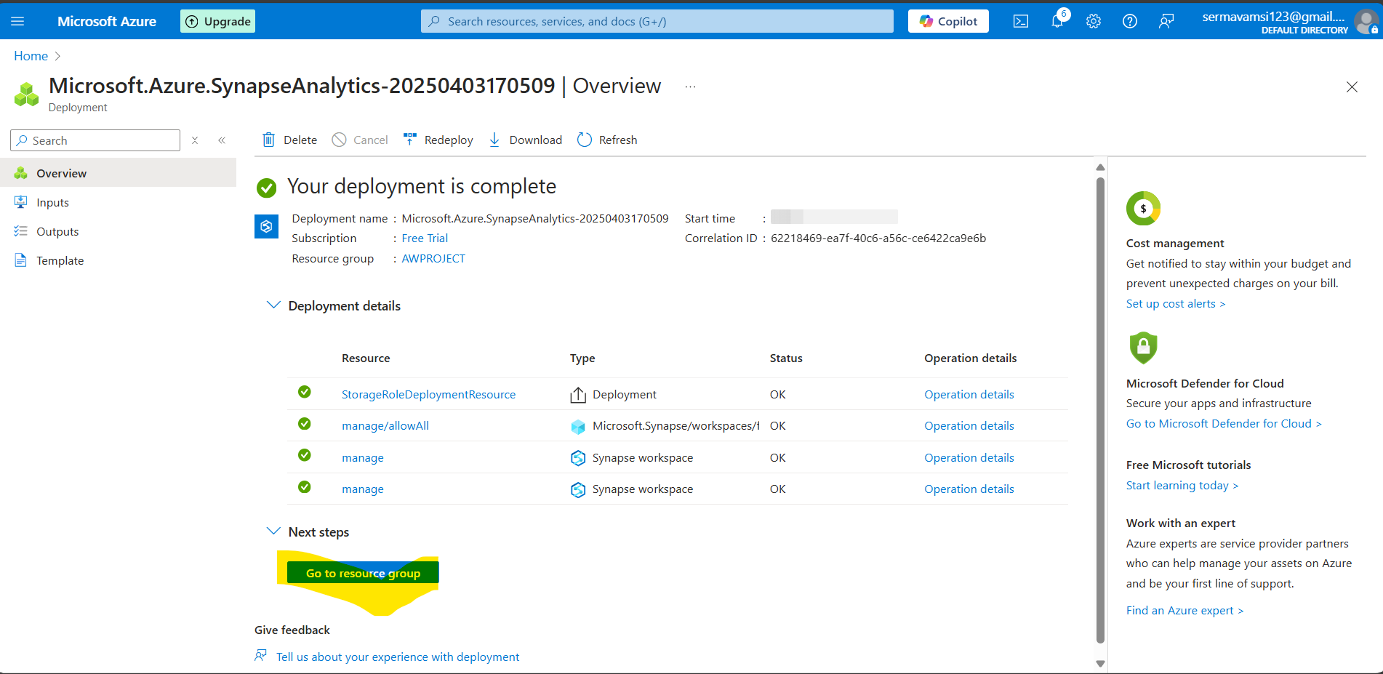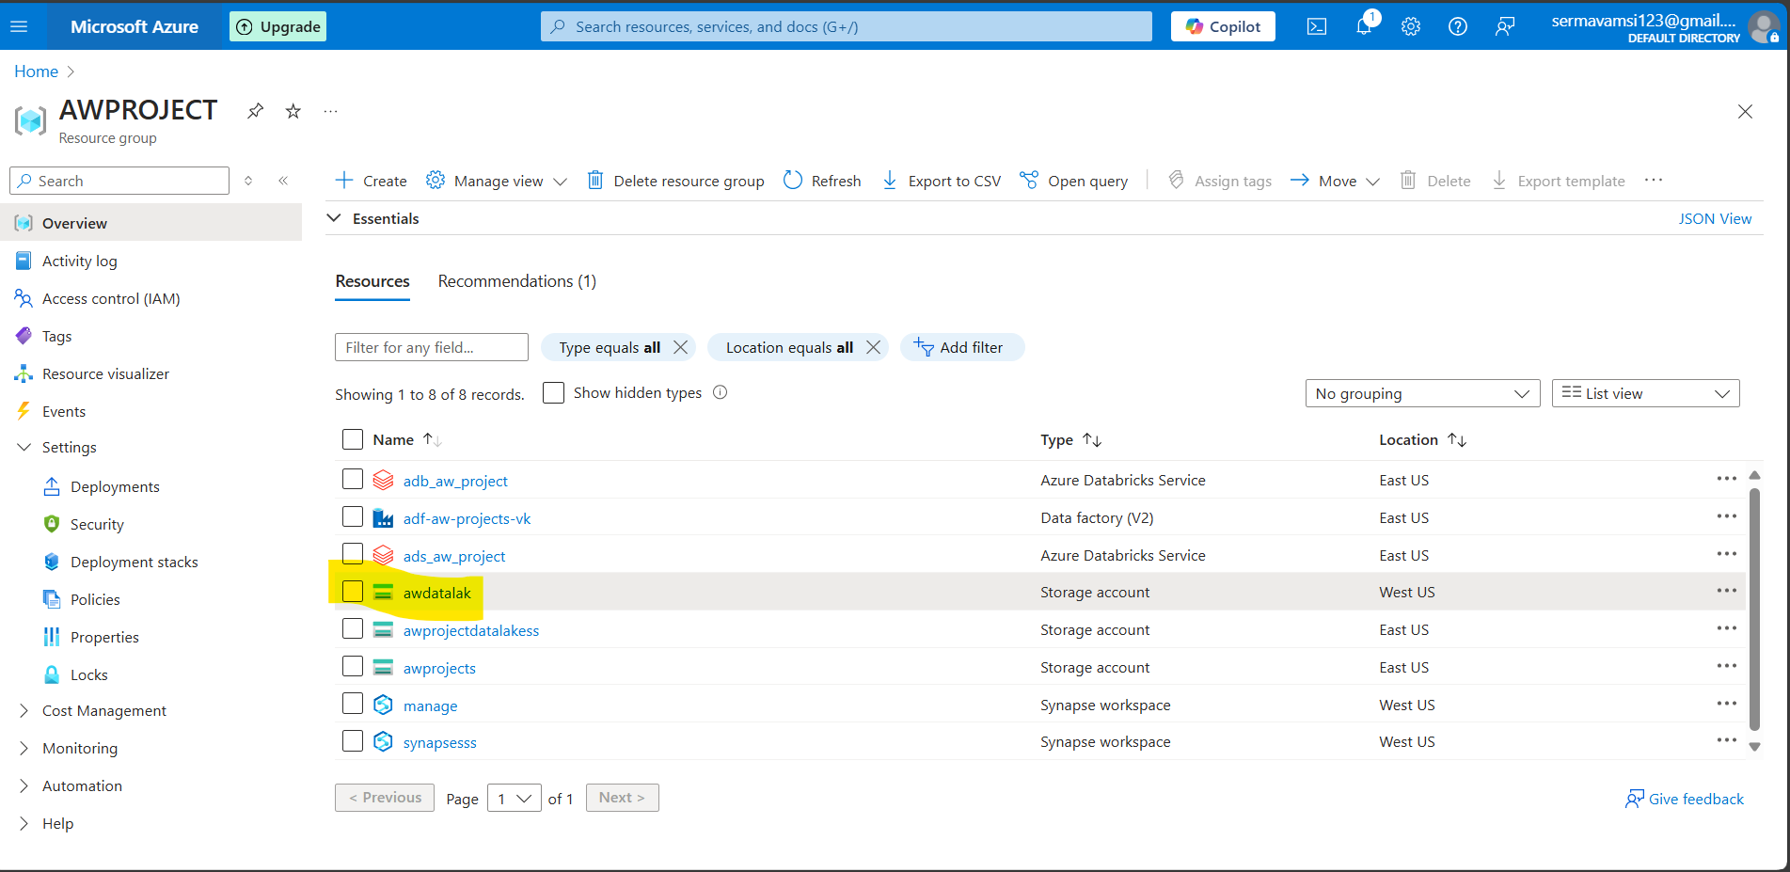

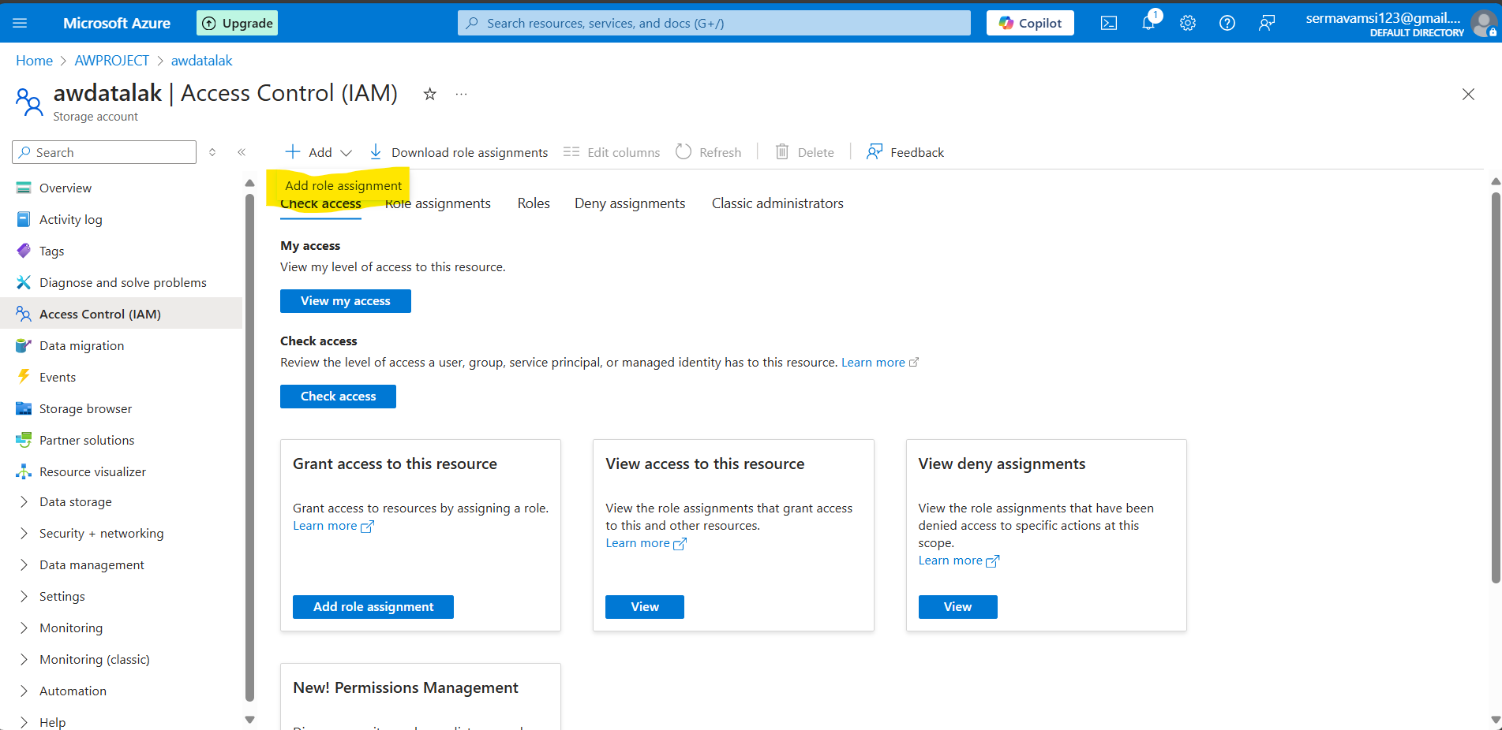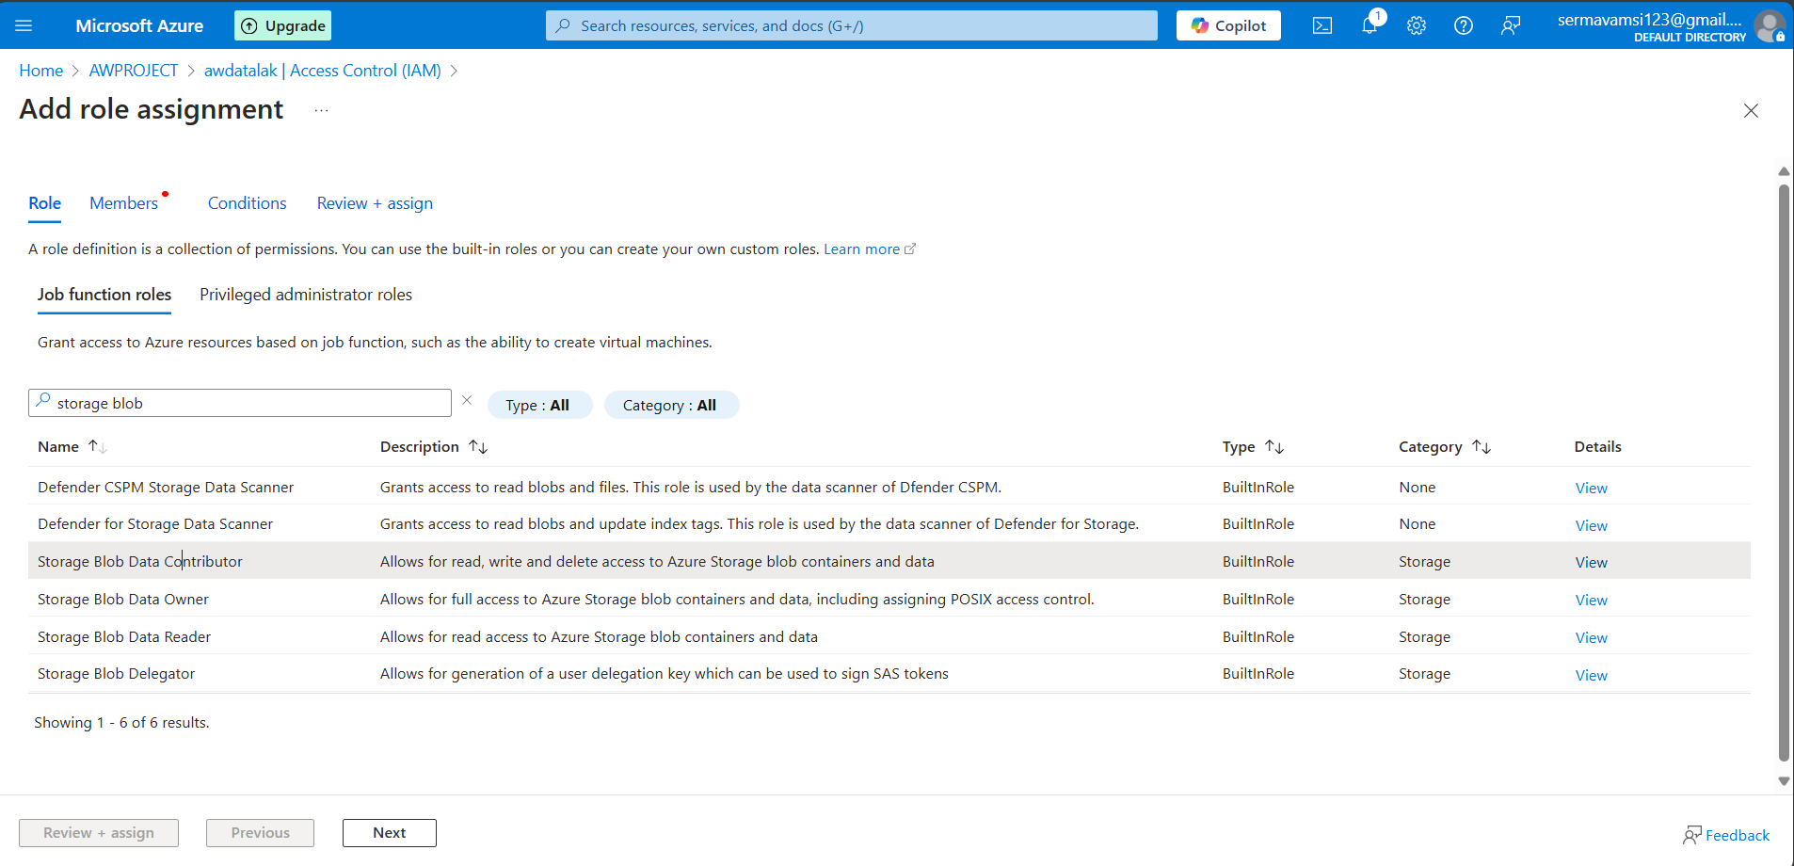

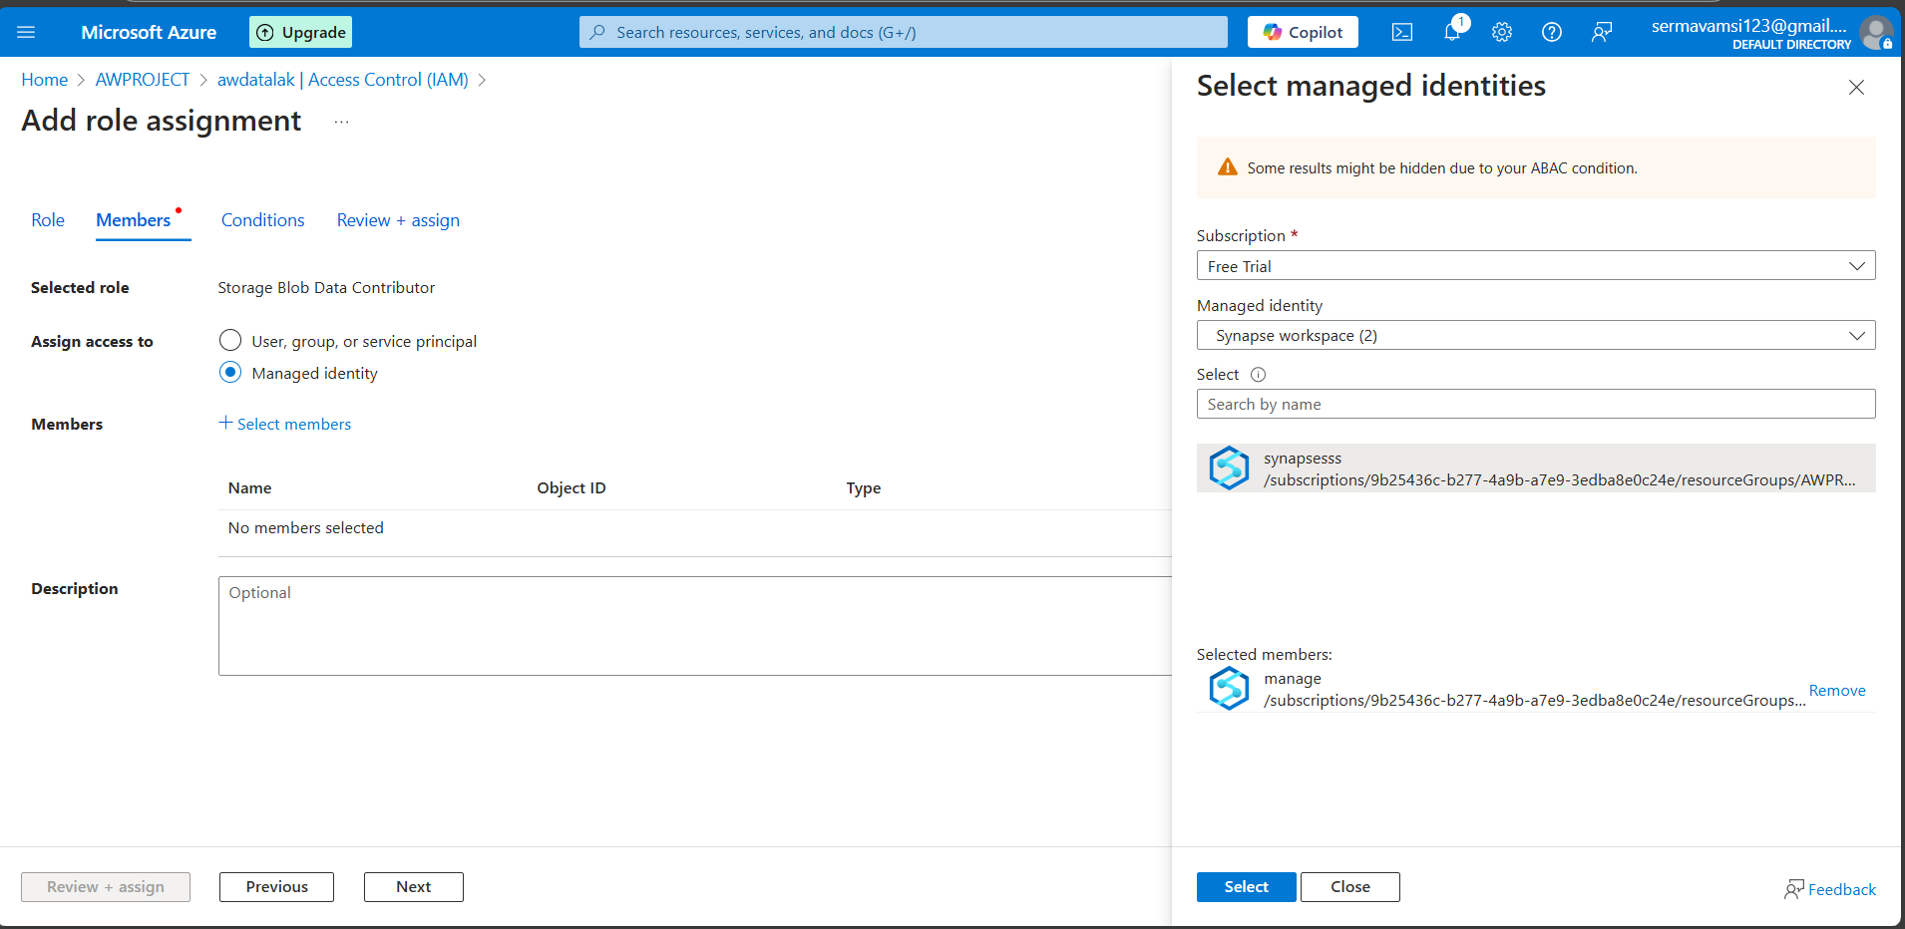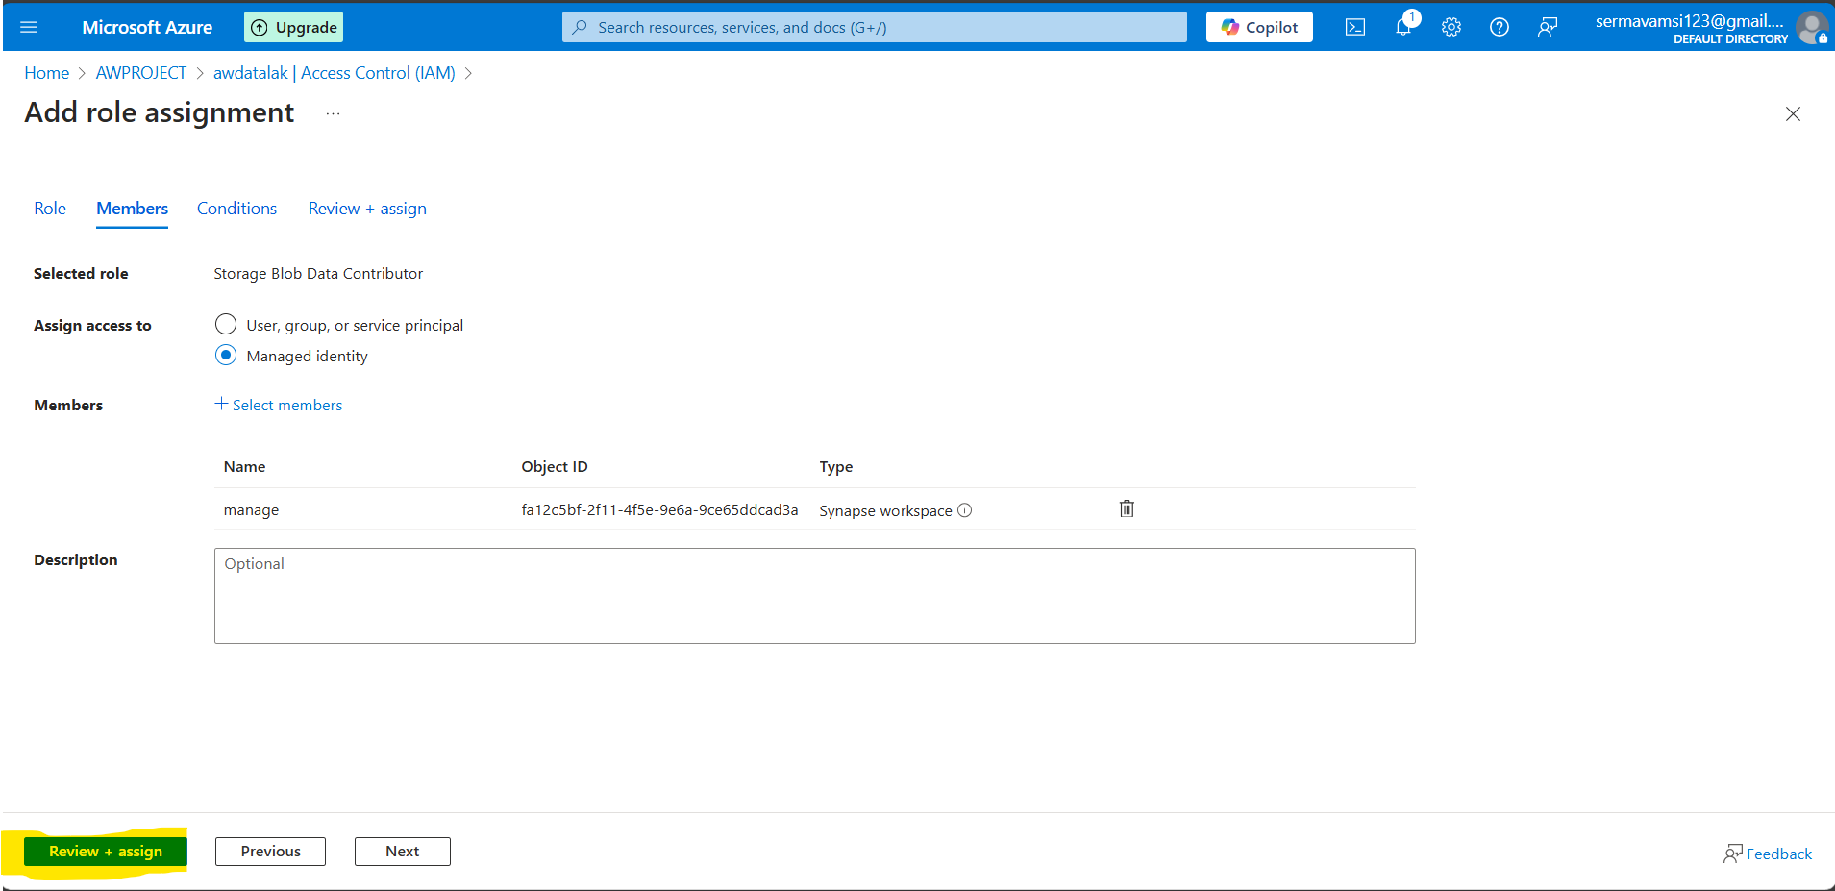

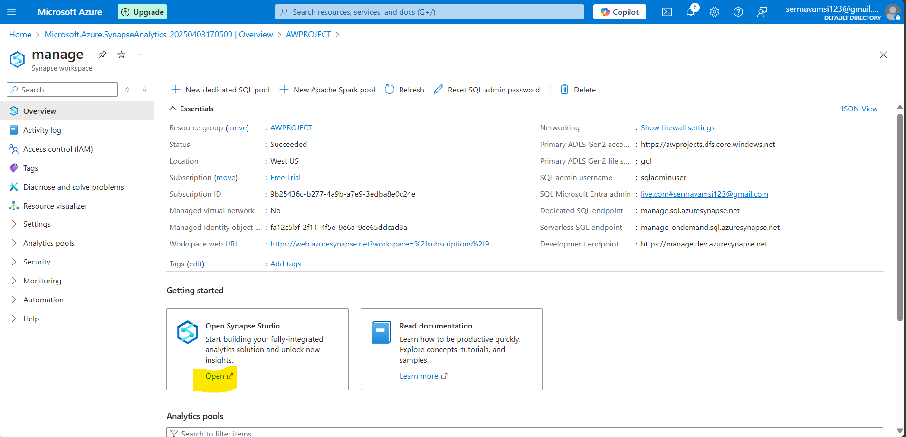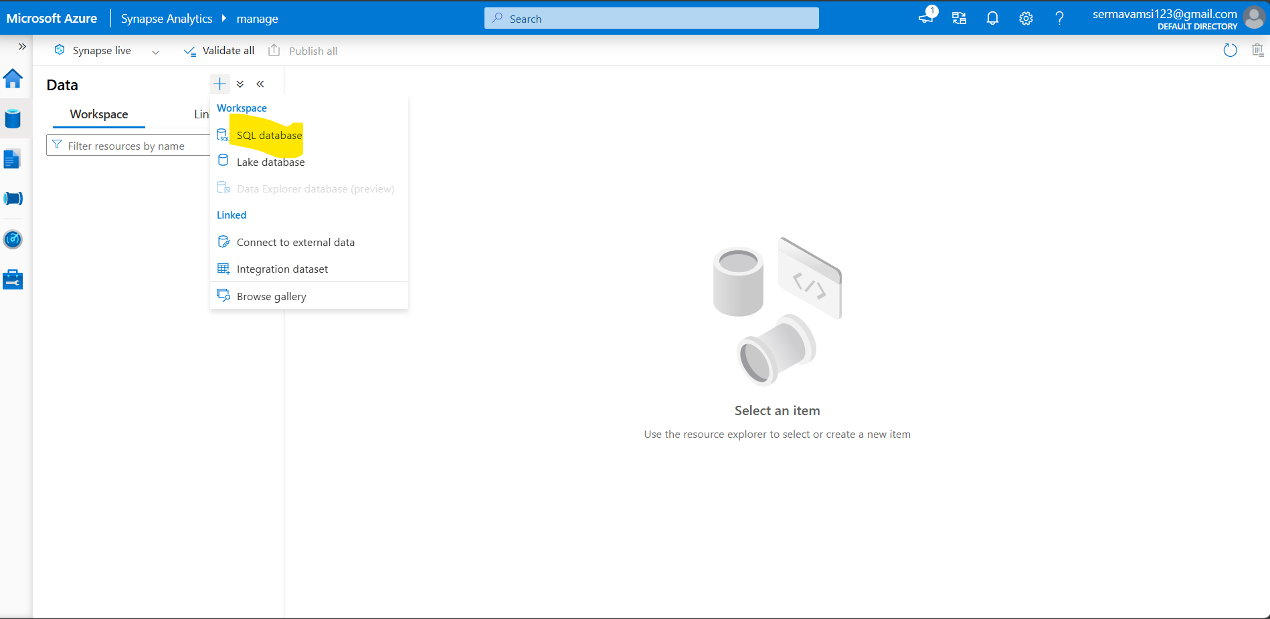

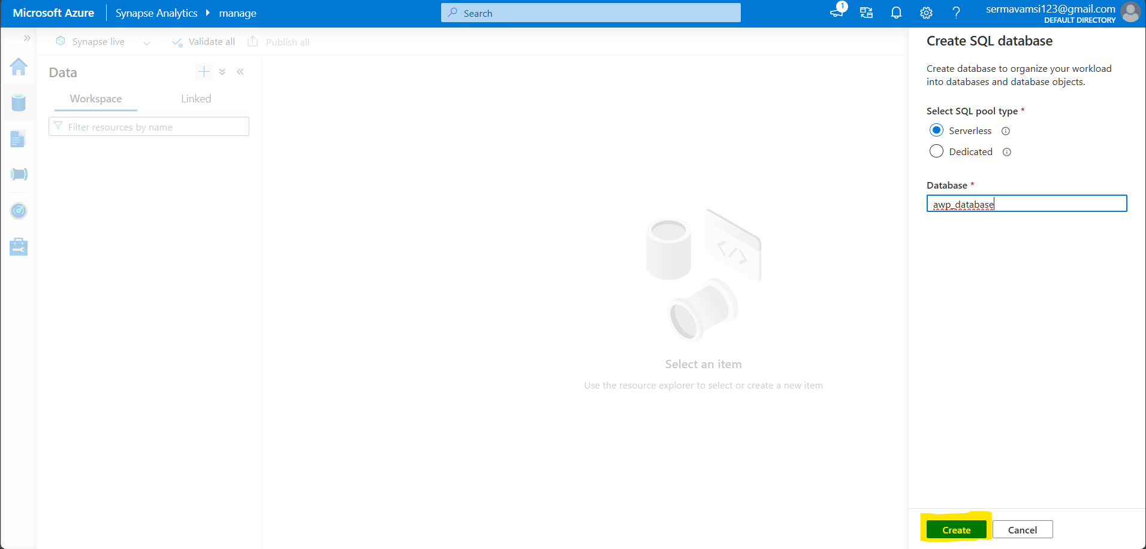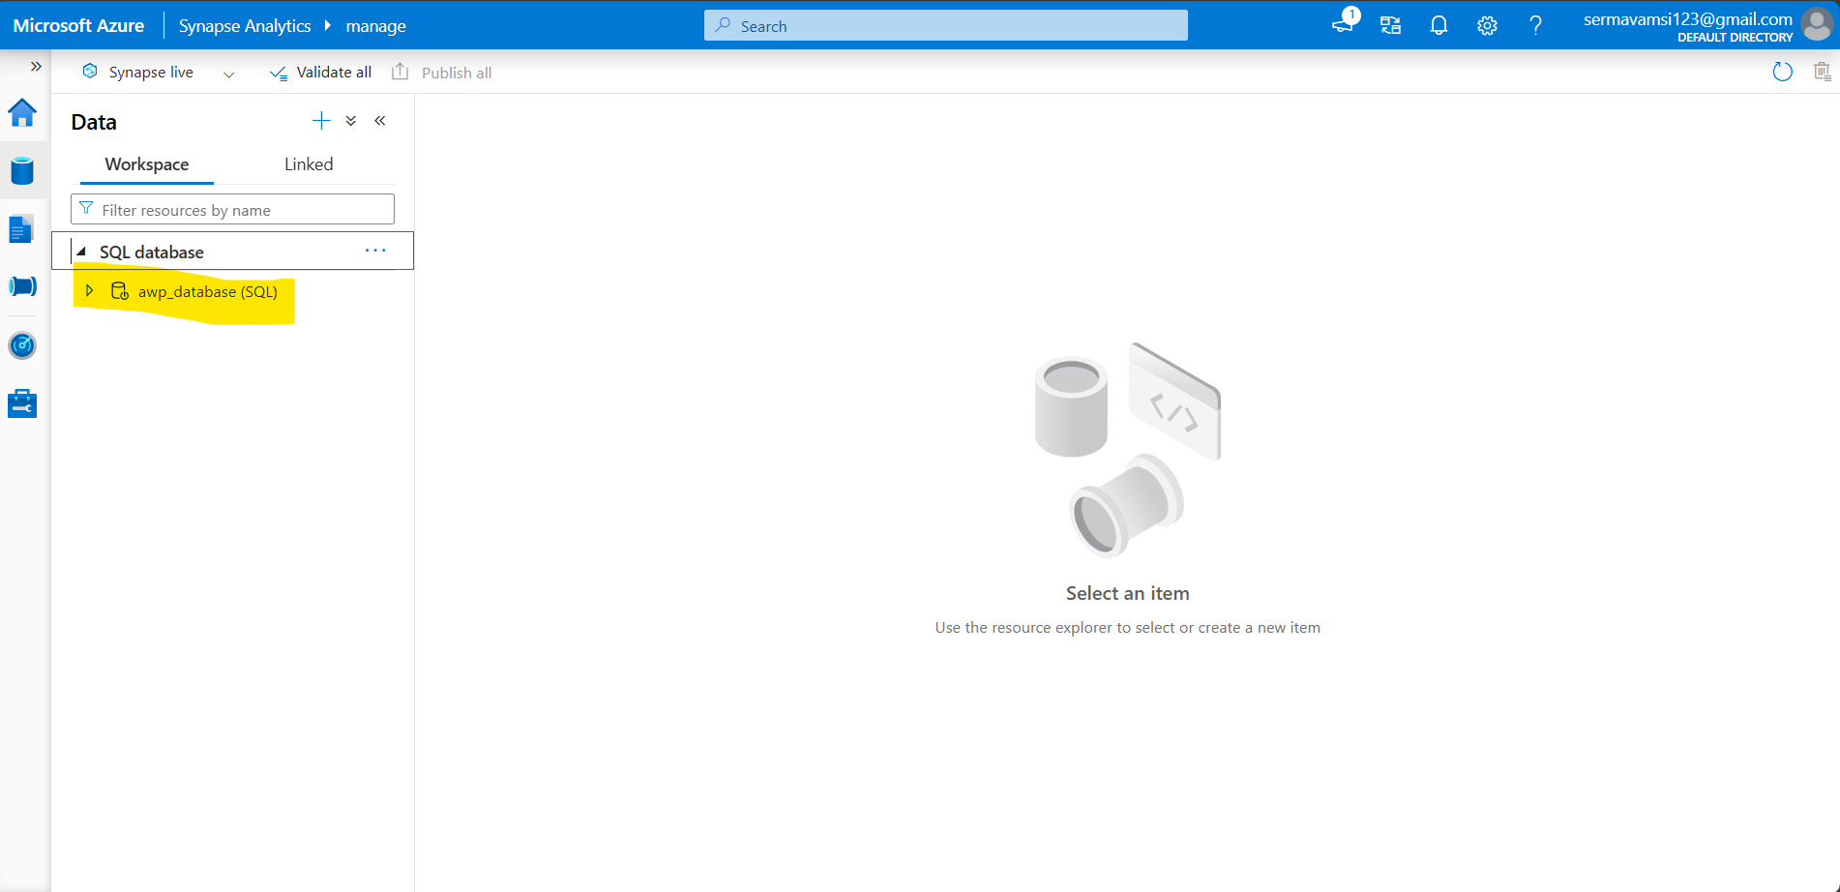

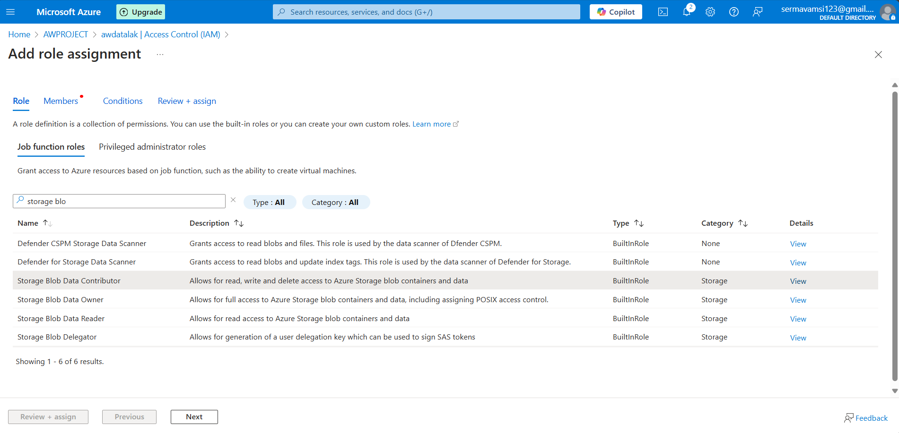

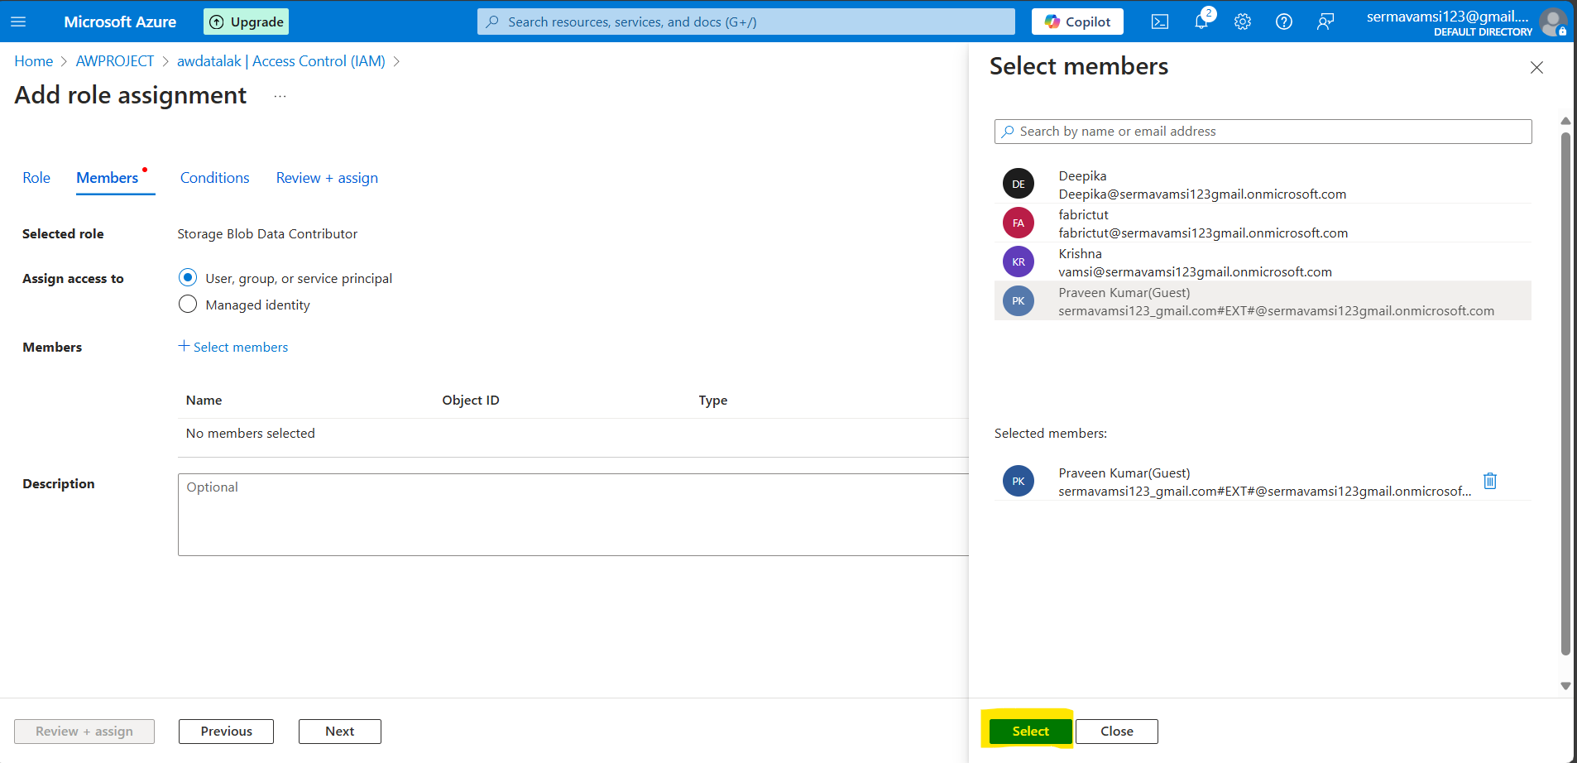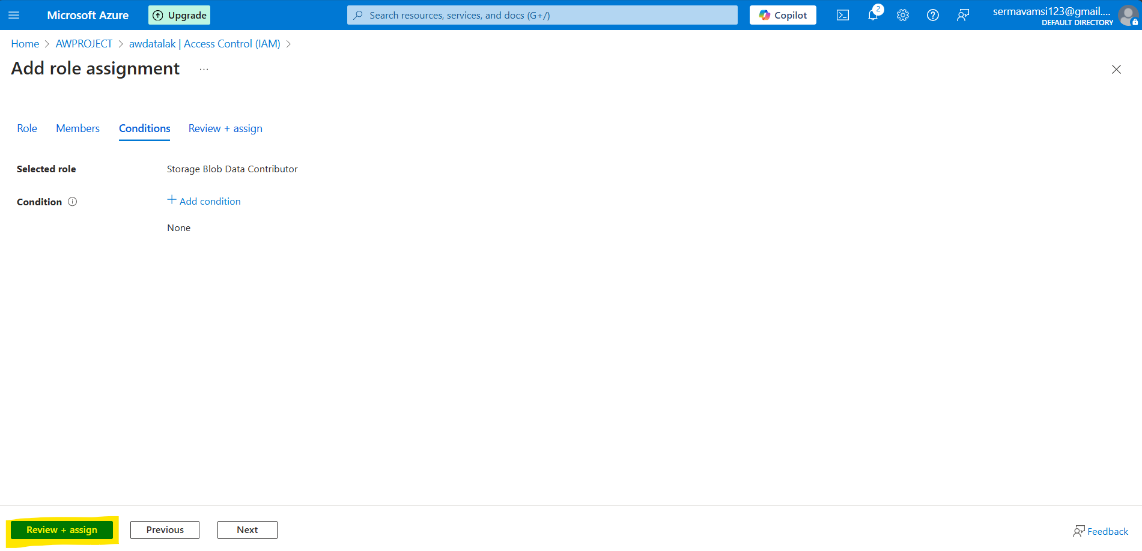

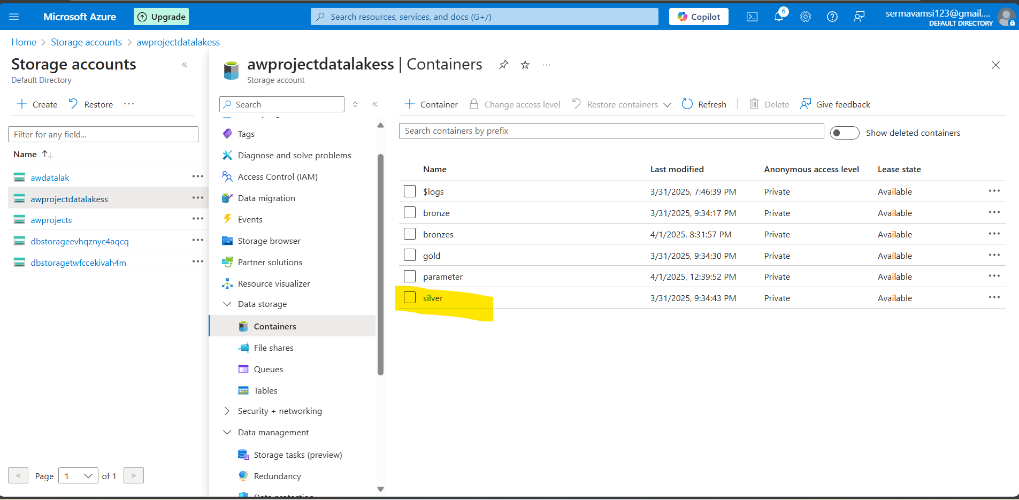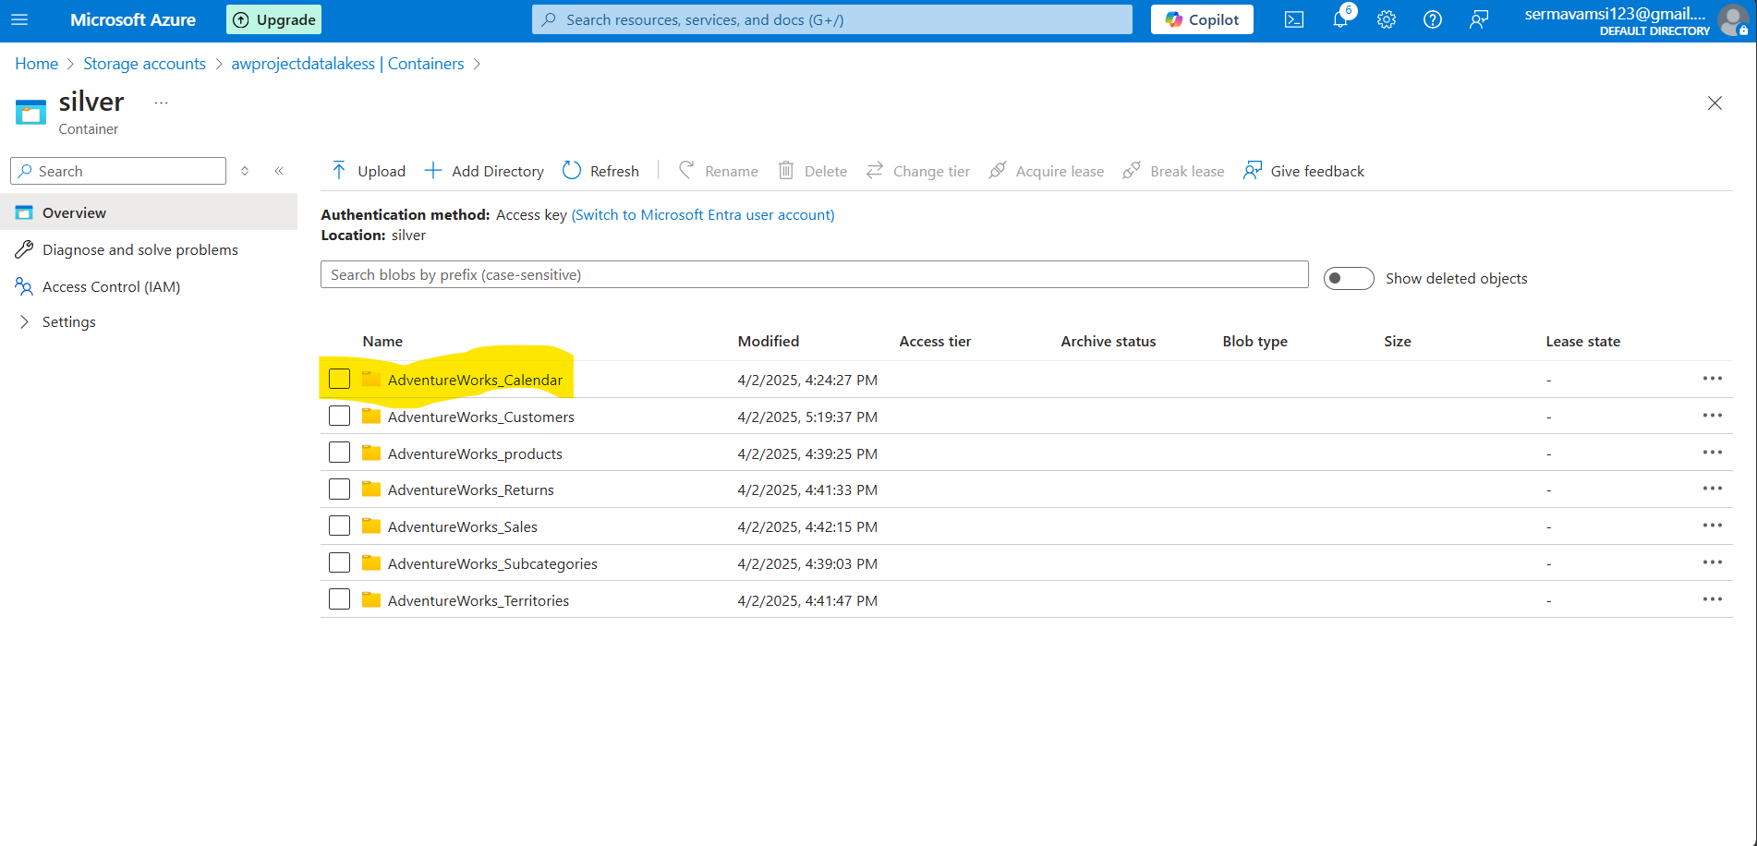

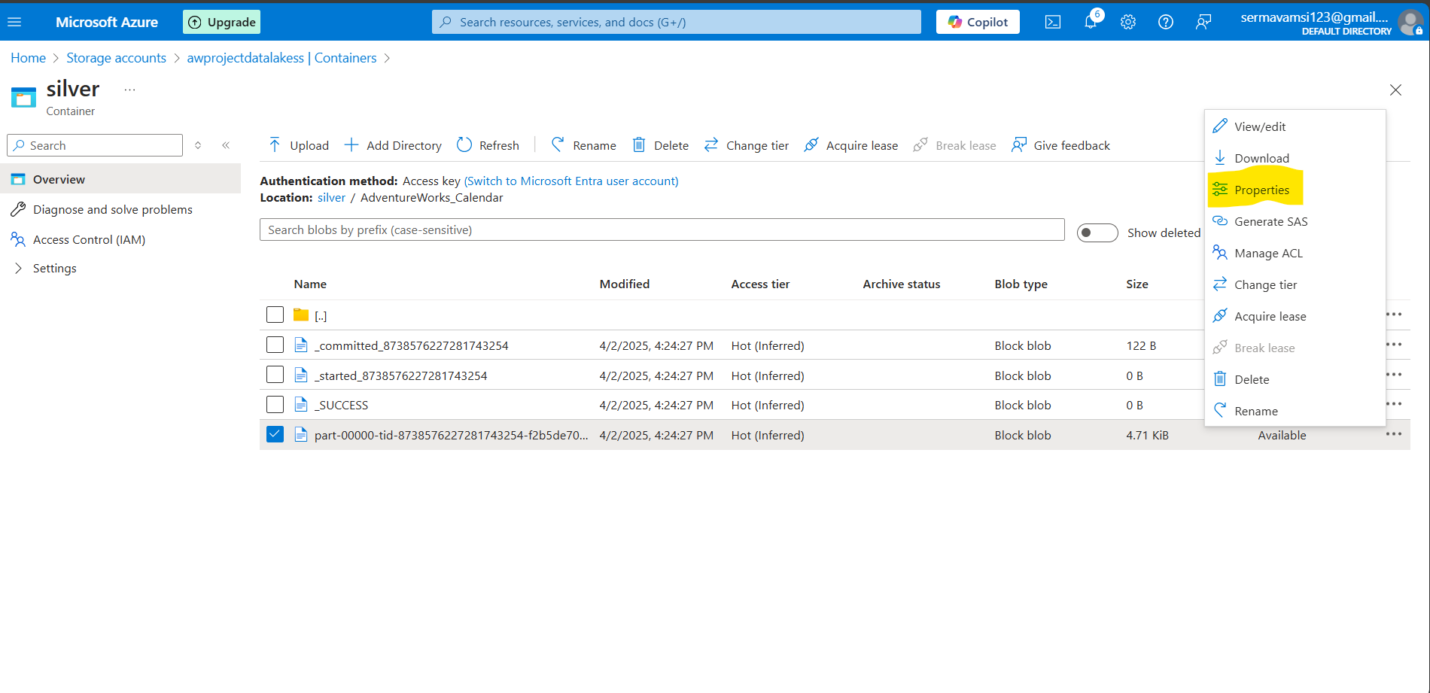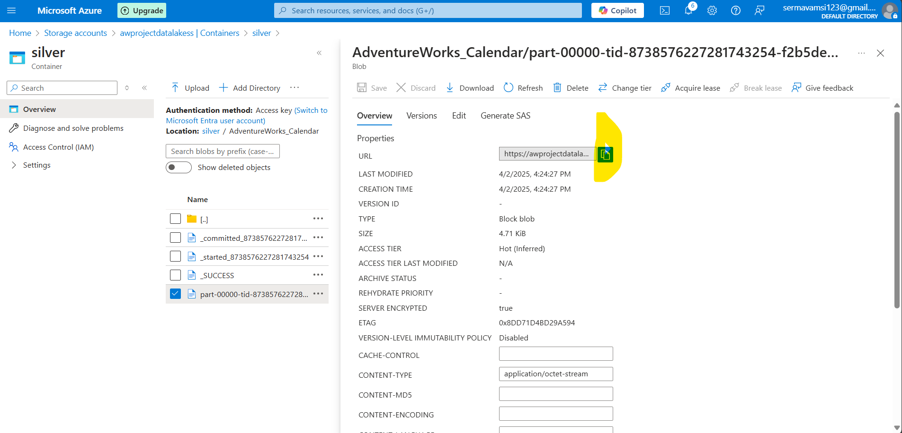

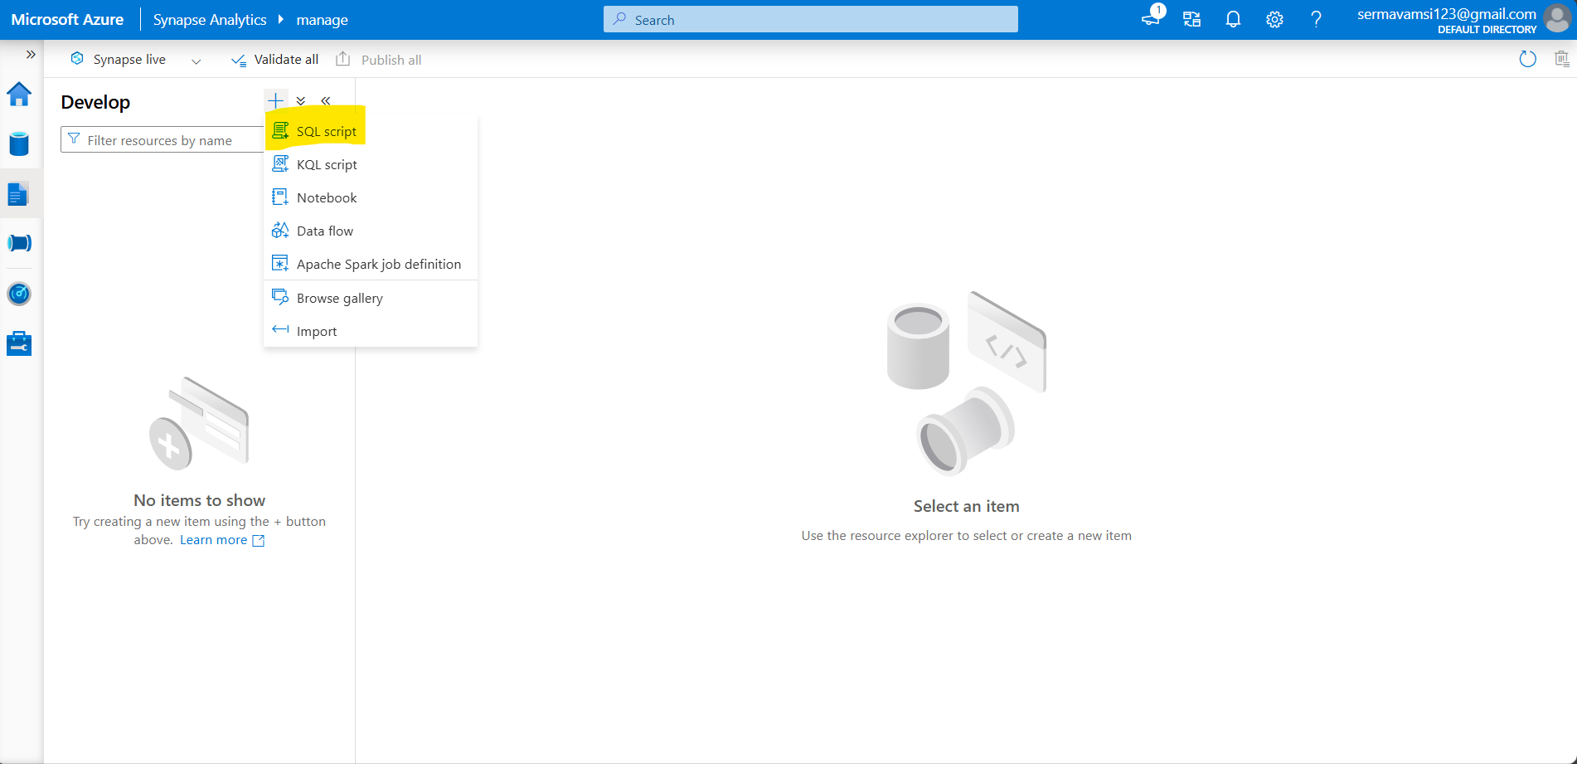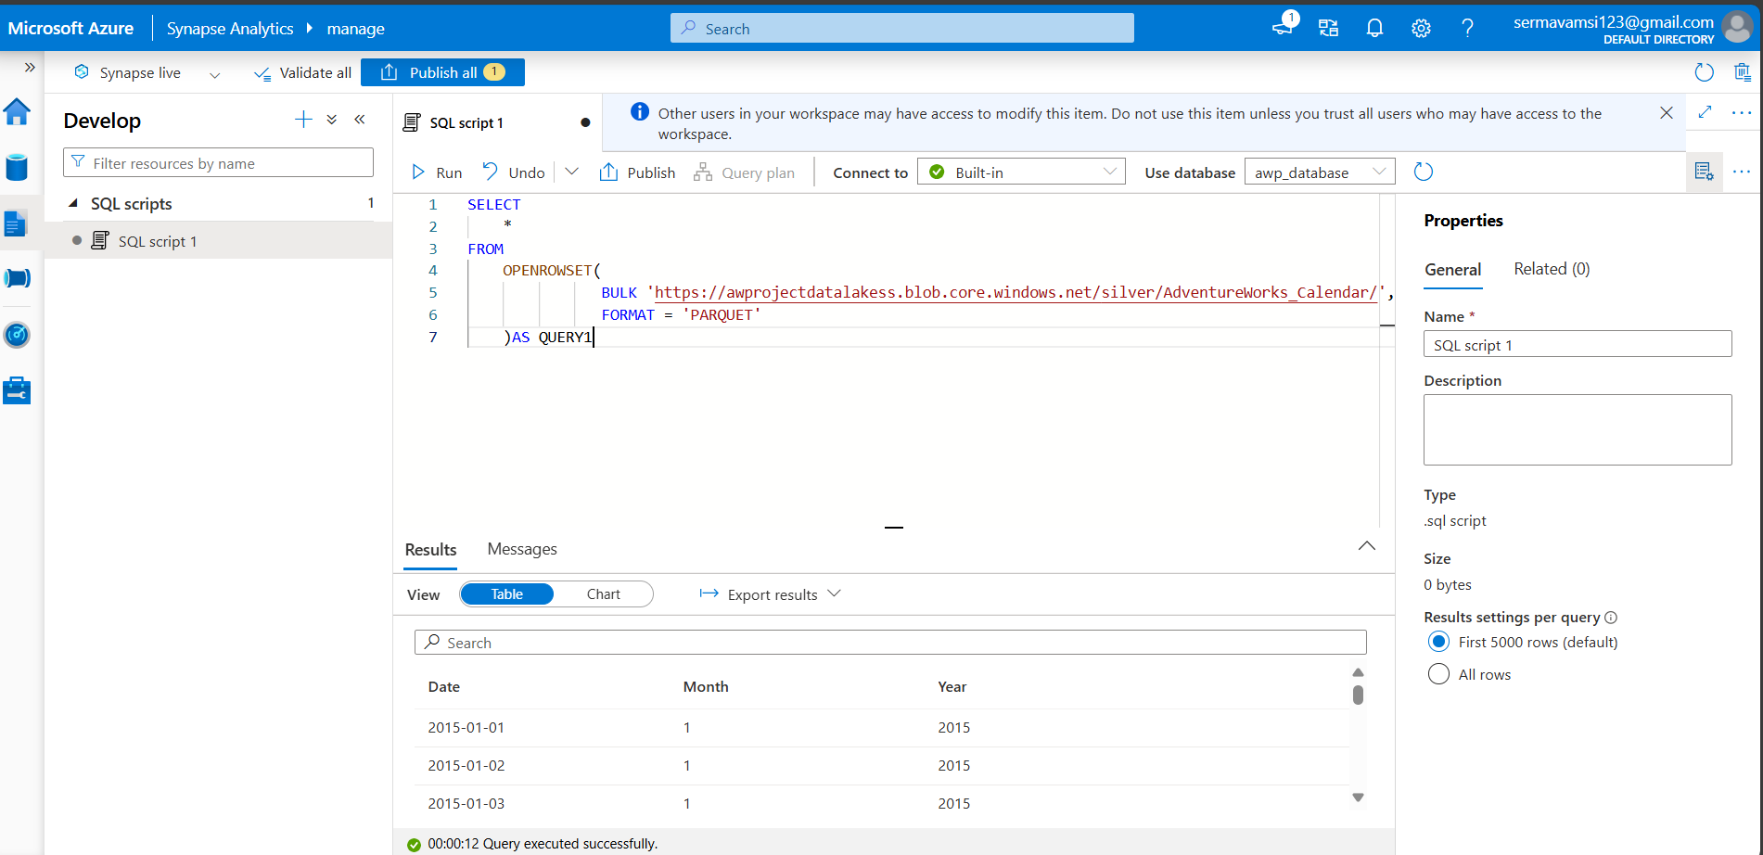

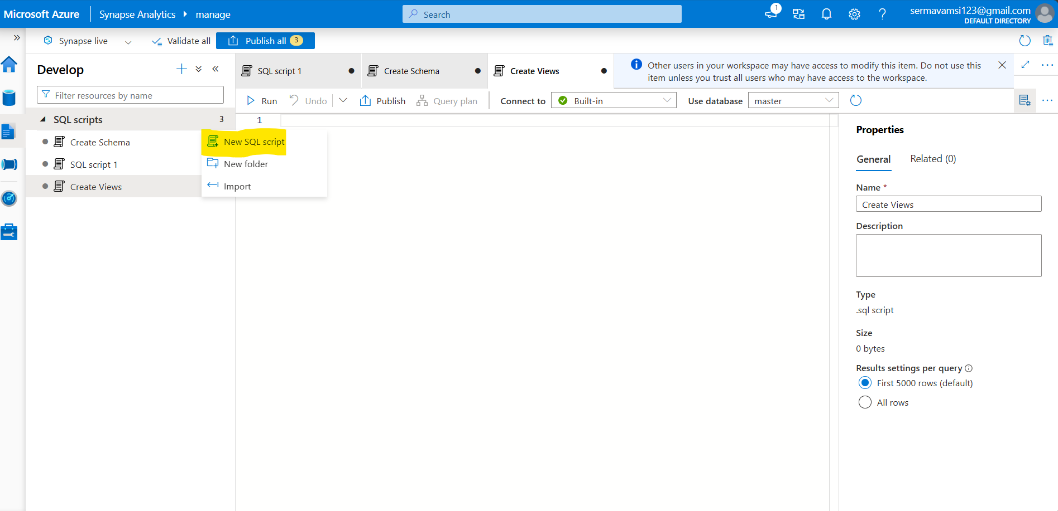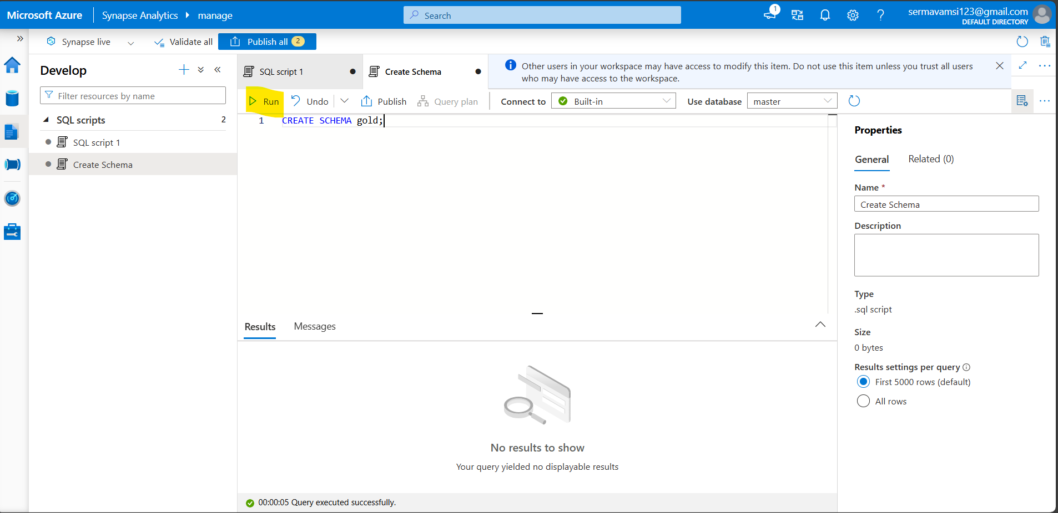

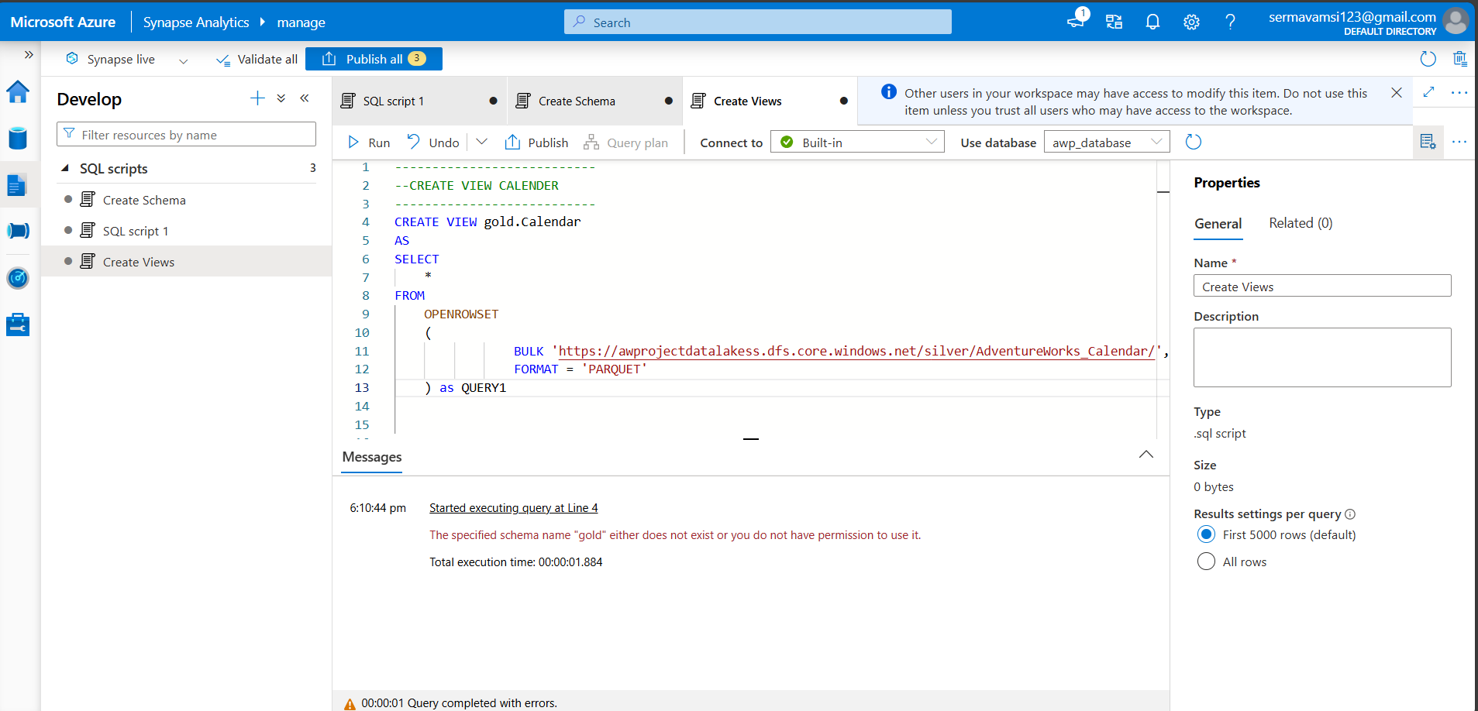

Ref Script:

---------------------------

--CREATE VIEW CALENDER

---------------------------

CREATE VIEW gold.Calendar

AS

SELECT

    *

FROM

    OPENROWSET

    (

                BULK 'https://awprojectdatalakess.dfs.core.windows.net/silver/AdventureWorks_Calendar/',

                FORMAT = 'PARQUET'

    ) as QUERY1

---------------------------

--CREATE VIEW CUSTOMERS

---------------------------

CREATE VIEW gold.customers

AS

SELECT

    *

FROM

    OPENROWSET

    (

                BULK 'https://awprojectdatalakess.dfs.core.windows.net/silver/AdventureWorks_Customers/',

                FORMAT = 'PARQUET'

    ) as QUER1

---------------------------

--CREATE VIEW PRODUCTS

---------------------------

CREATE VIEW gold.products

AS

SELECT

    *

FROM

    OPENROWSET

    (

                BULK 'https://awprojectdatalakess.dfs.core.windows.net/silver/AdventureWorks_products/',

                FORMAT = 'PARQUET'

    ) as QUER1

---------------------------

--CREATE VIEW RETURNS

---------------------------

CREATE VIEW gold.Returns

AS

SELECT

    *

FROM

    OPENROWSET

    (

                BULK 'https://awprojectdatalakess.dfs.core.windows.net/silver/AdventureWorks_Returns/',

                FORMAT = 'PARQUET'

    ) as QUER1

---------------------------

--CREATE VIEW Sales

---------------------------

CREATE VIEW gold.Sales

AS

SELECT

    *

FROM

    OPENROWSET

    (

                BULK 'https://awprojectdatalakess.dfs.core.windows.net/silver/AdventureWorks_Sales/',

                FORMAT = 'PARQUET'

    ) as QUER1

---------------------------

--CREATE VIEW Subcategories

---------------------------

CREATE VIEW gold.Subcategories

AS

SELECT

    *

FROM

    OPENROWSET

    (

                BULK 'https://awprojectdatalakess.dfs.core.windows.net/silver/AdventureWorks_Subcategories/',

                FORMAT = 'PARQUET'

    ) as QUER1

---------------------------

--CREATE VIEW Territories

---------------------------

CREATE VIEW gold.Territories

AS

SELECT

    *

FROM

    OPENROWSET

    (

                BULK 'https://awprojectdatalakess.dfs.core.windows.net/silver/AdventureWorks_Territories/',

                FORMAT = 'PARQUET'

    ) as QUER1

Execute separately :

After Execution:

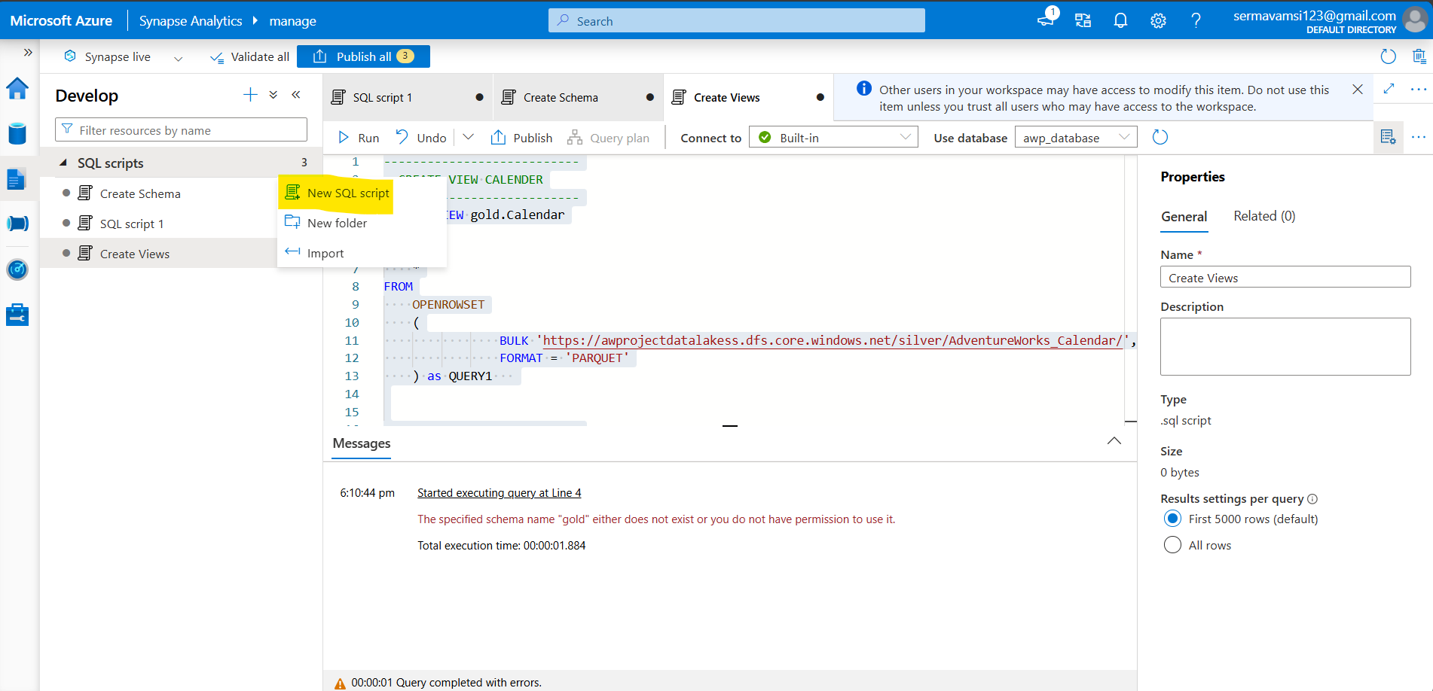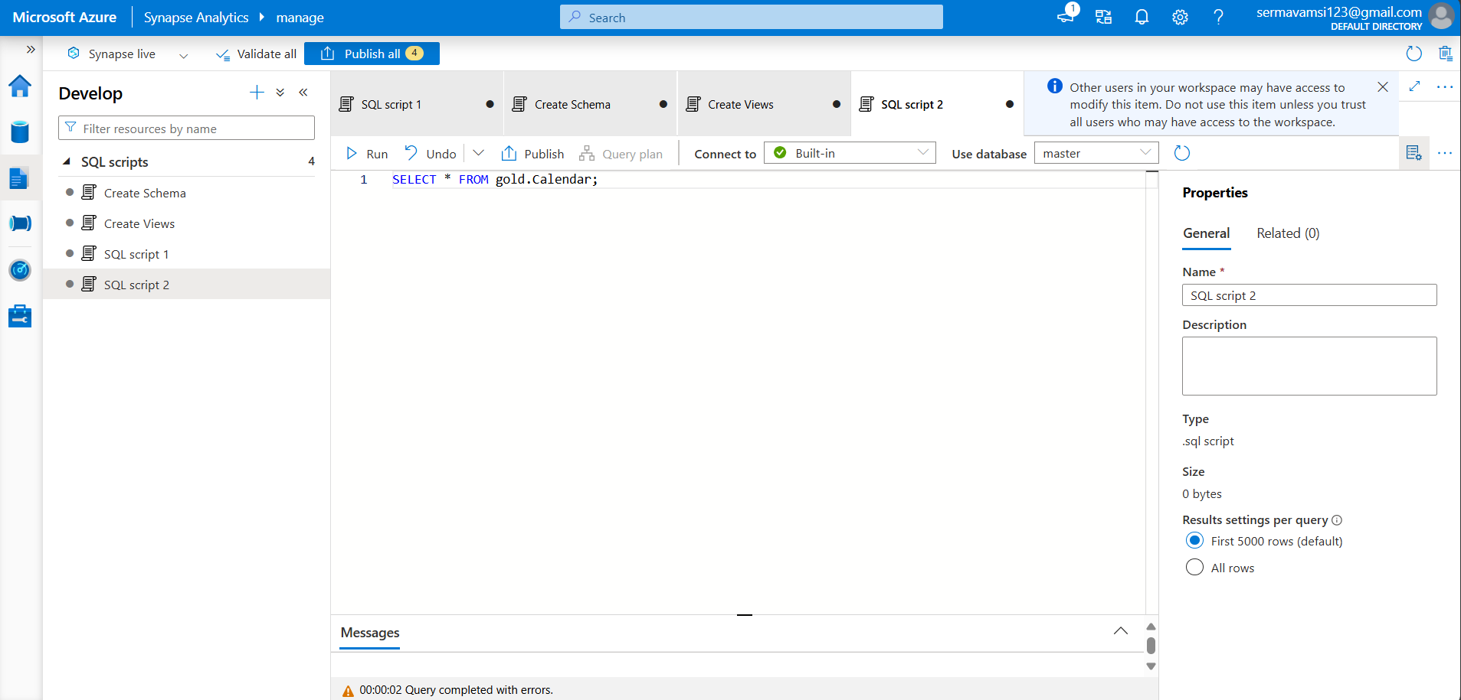

Check the Each and Every thing all the tables:

CREATE EXTERNAL TABLES: Prerequisites:

CREDENTIALS, EXTERNAL DATA SOURCE, EXTERNAL FILE FORMAT

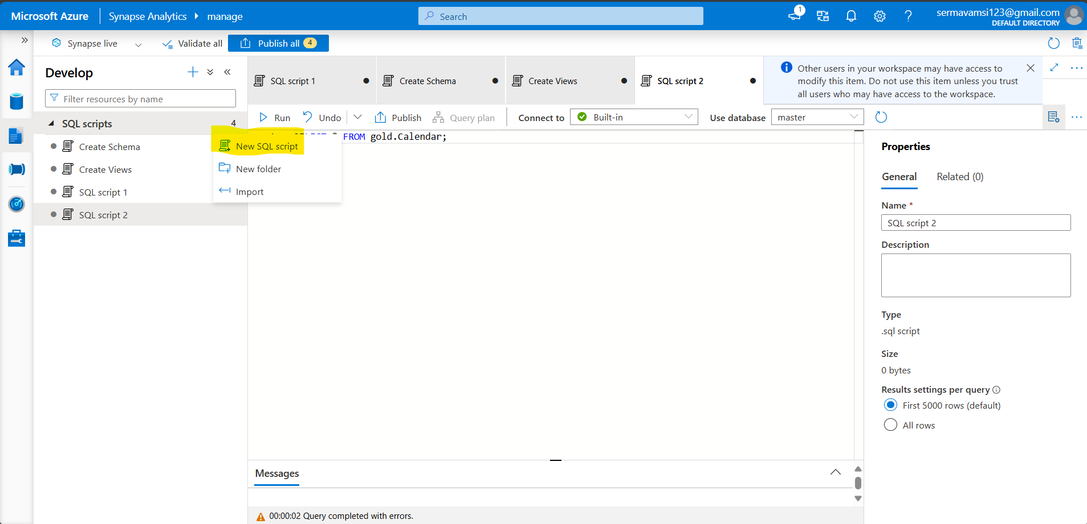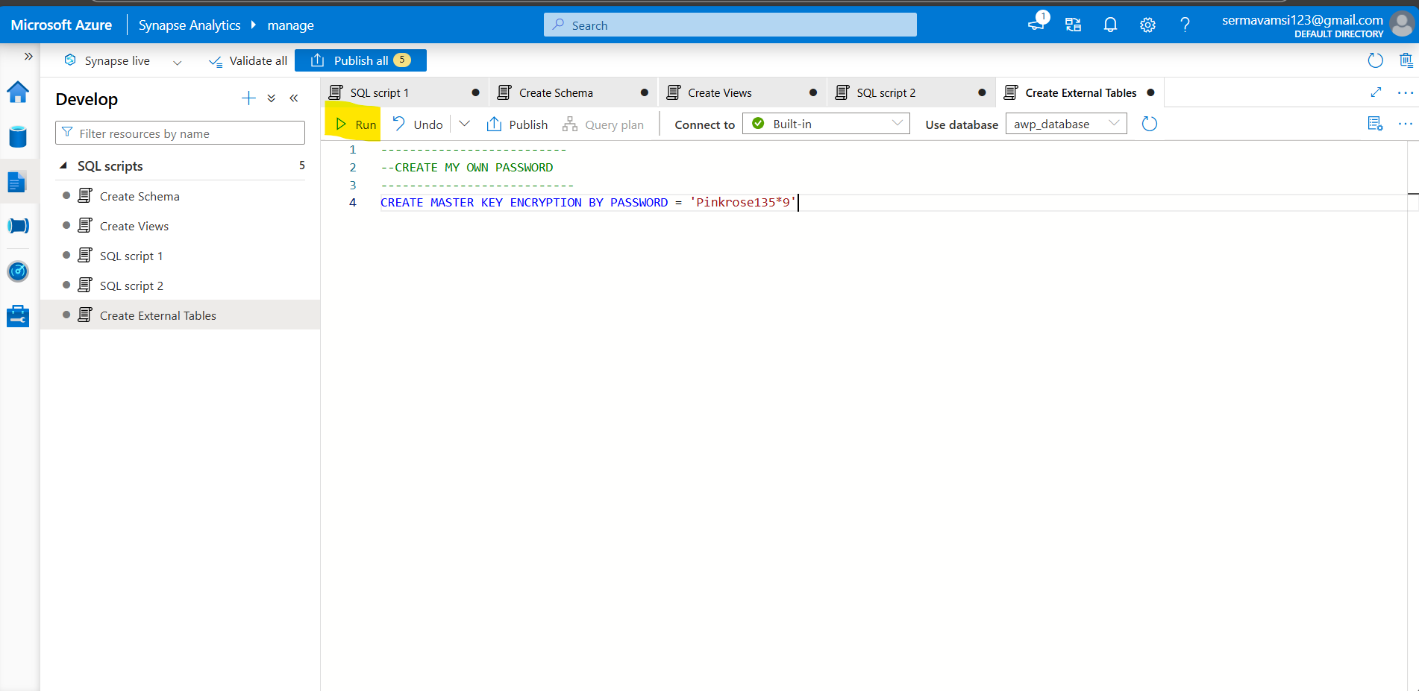

Ref:https://learn.microsoft.com/en-us/sql/t-sql/statements/create-master-key-transact-sql?view=sql-server-ver16

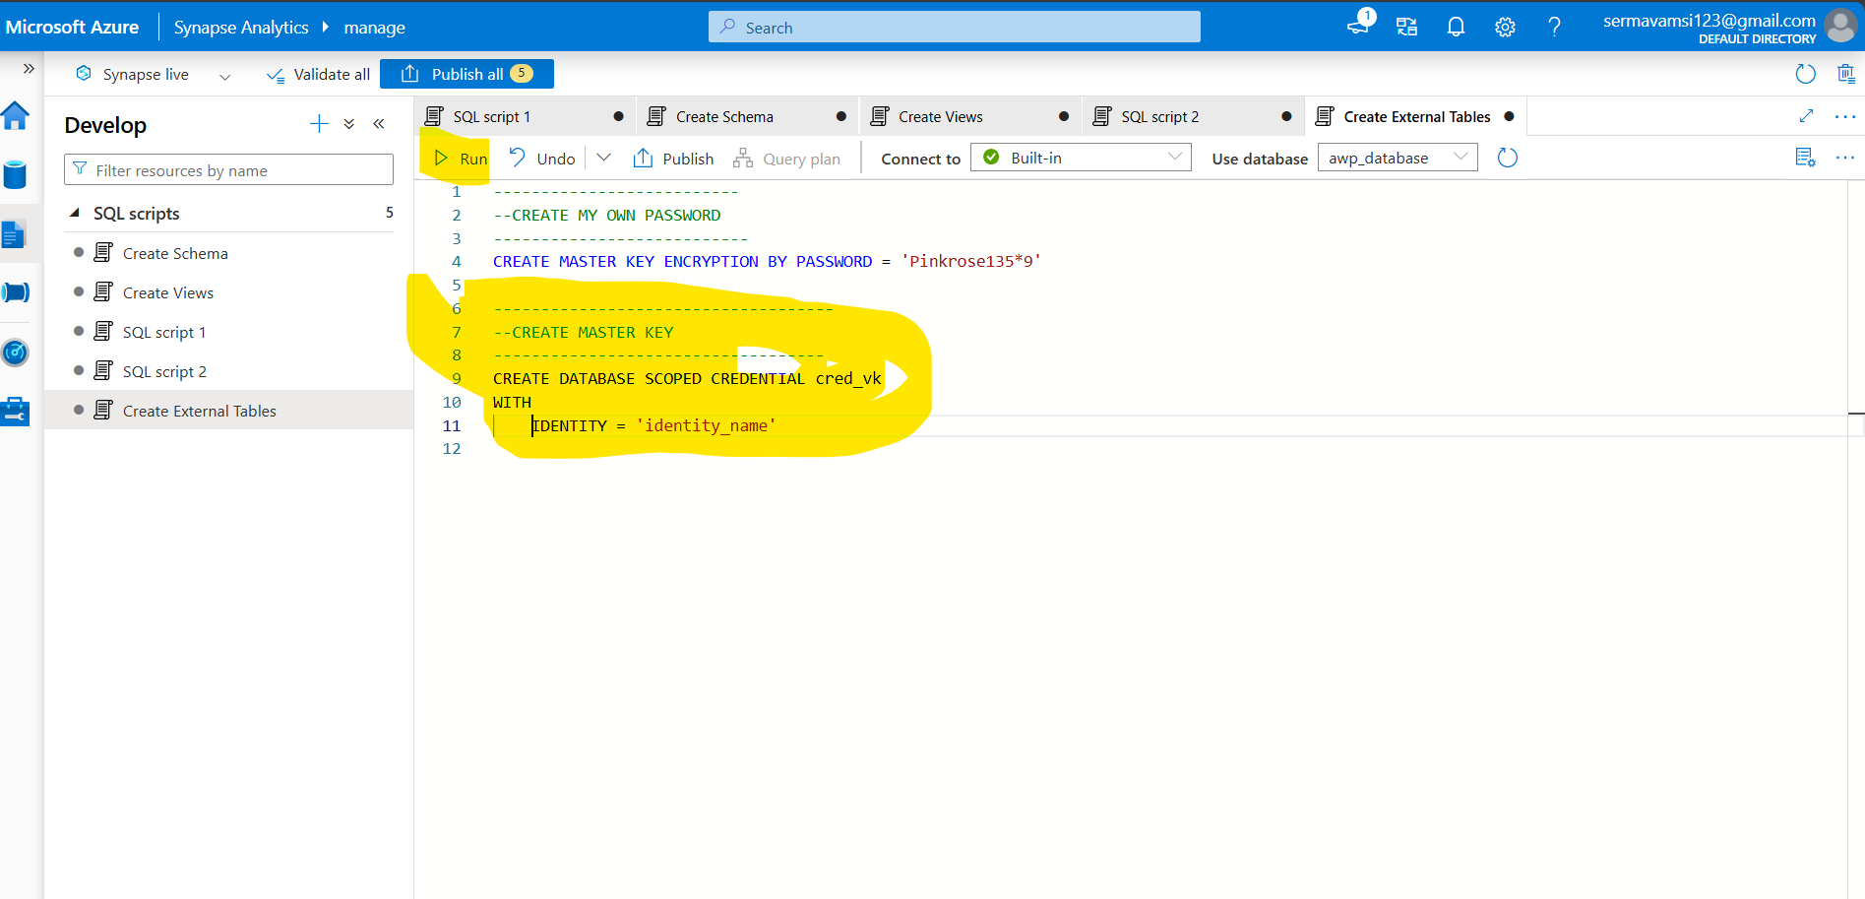

Ref: <https://learn.microsoft.com/en-us/sql/t-sql/statements/create-database-scoped-credential-transact-SQL?view=sql-server-ver16>

## Simply execute separatly silver and gold containers

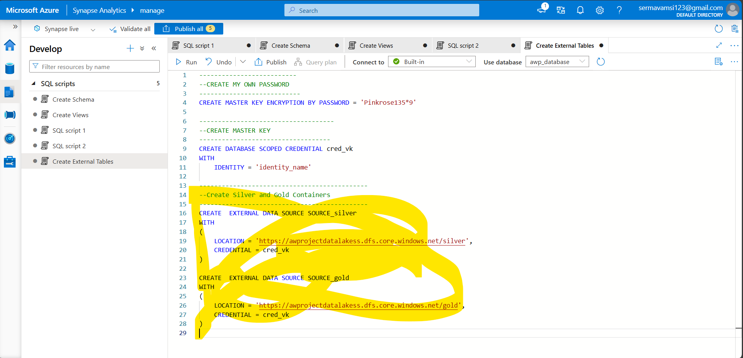

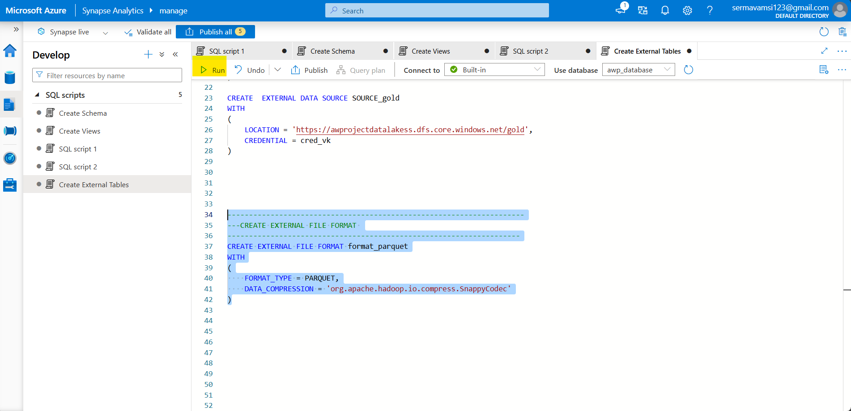



Views ext_table

CEATS



## CETAS: “CREATE EXTERNAL TABLE AS SELECT”

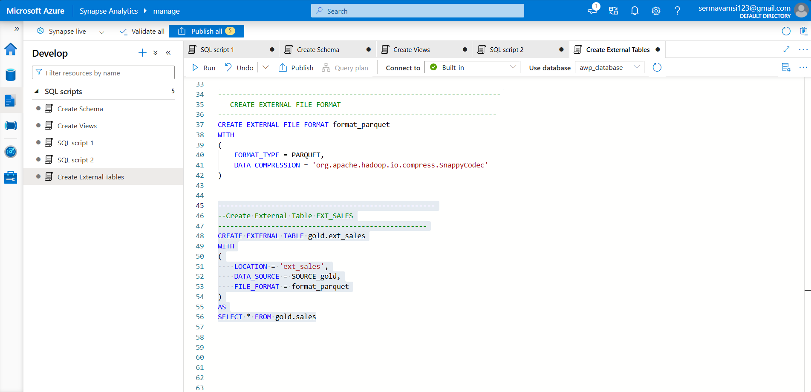

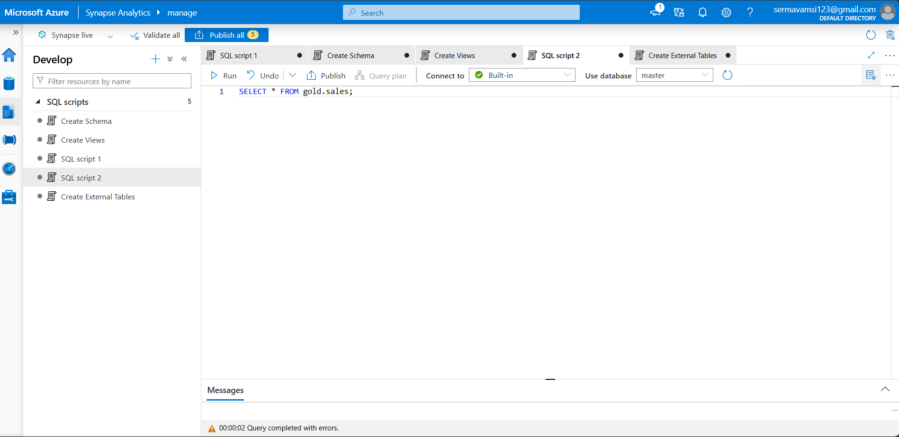

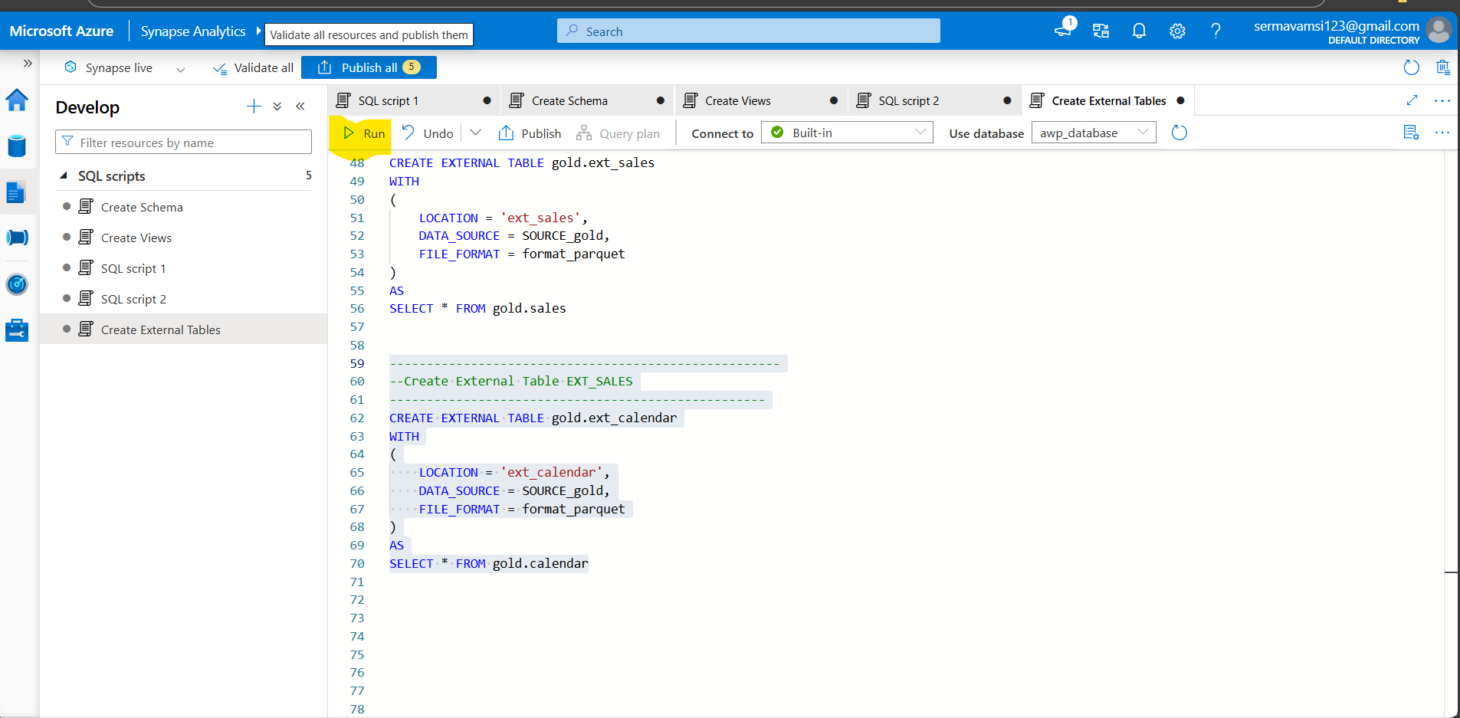

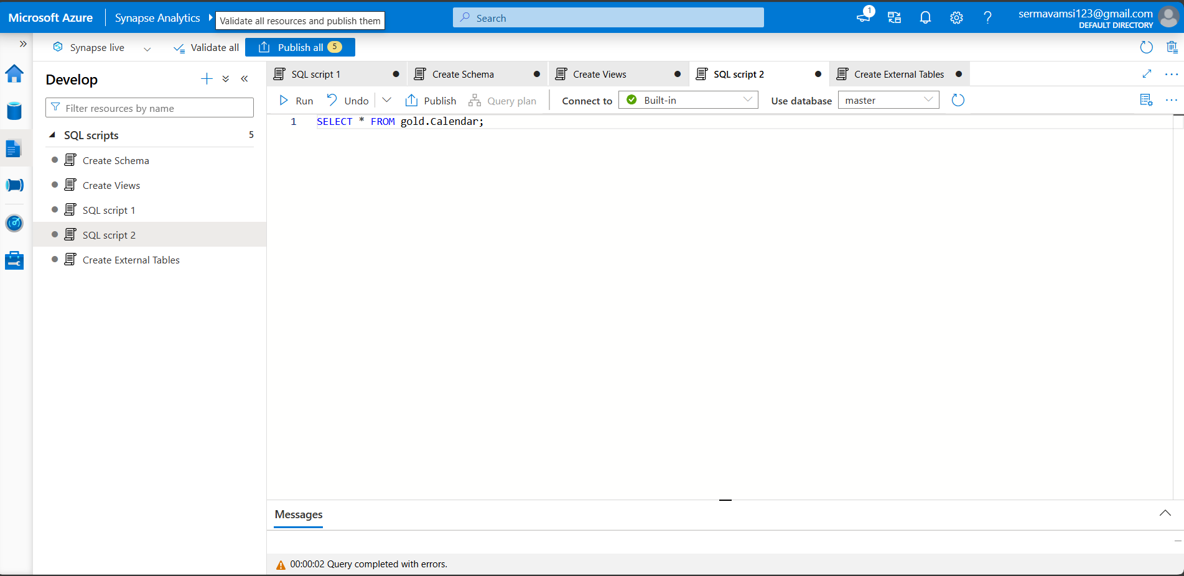

You can see the gold layer you files are there or not

Go to Azure portal >> storage account >> AWSproject data lakess>> Data storage >> containers >> click the gold >> check files >> open calendar file

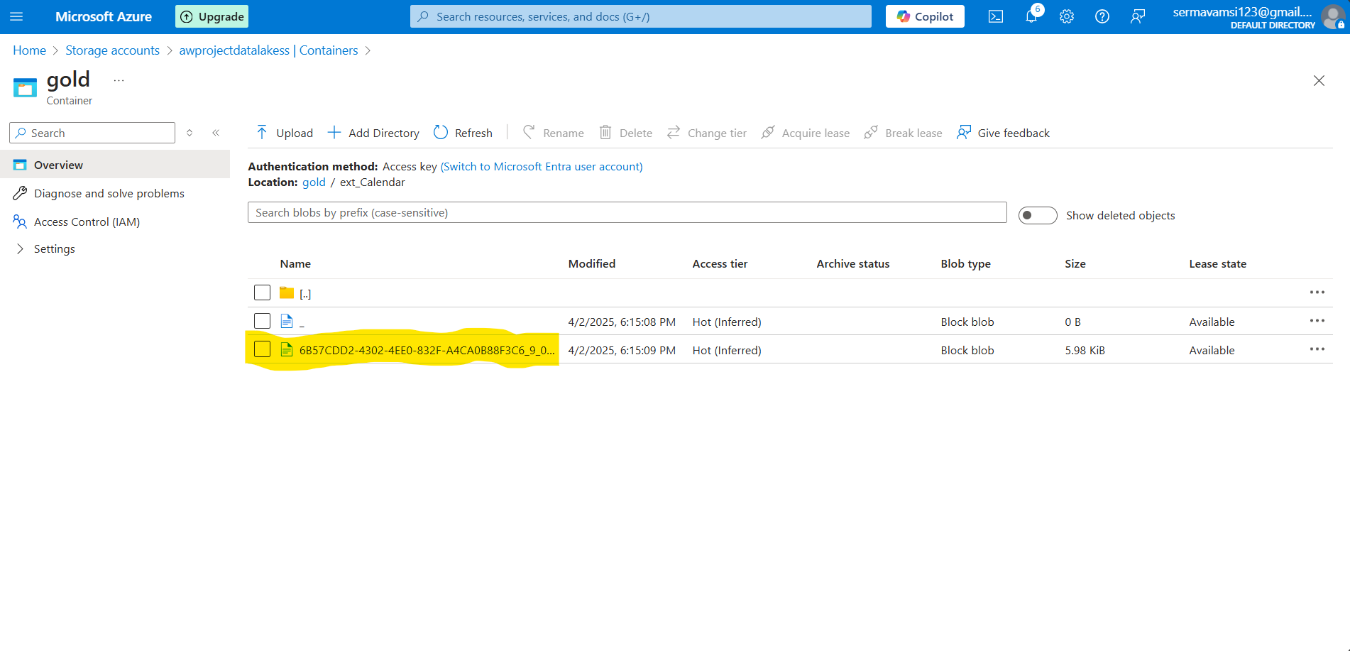

Then you can load this external table end point to PBI Report tool:

Go to Azure Portal >> Synapse Workspace >>Able see the details

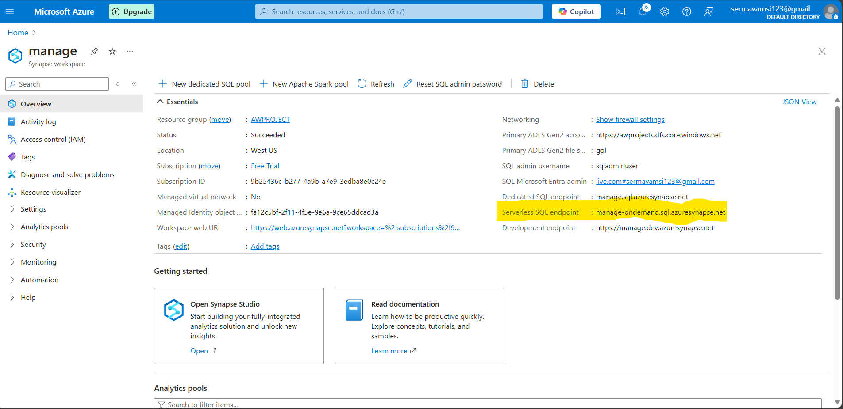

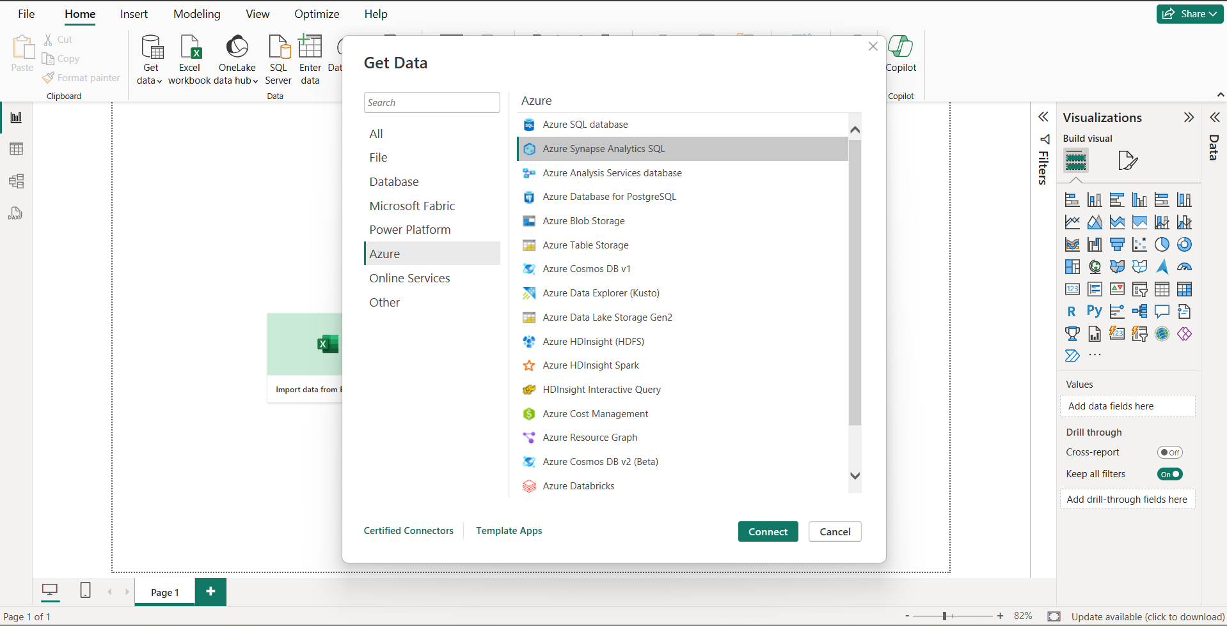

Sign in with current Microsoft account

